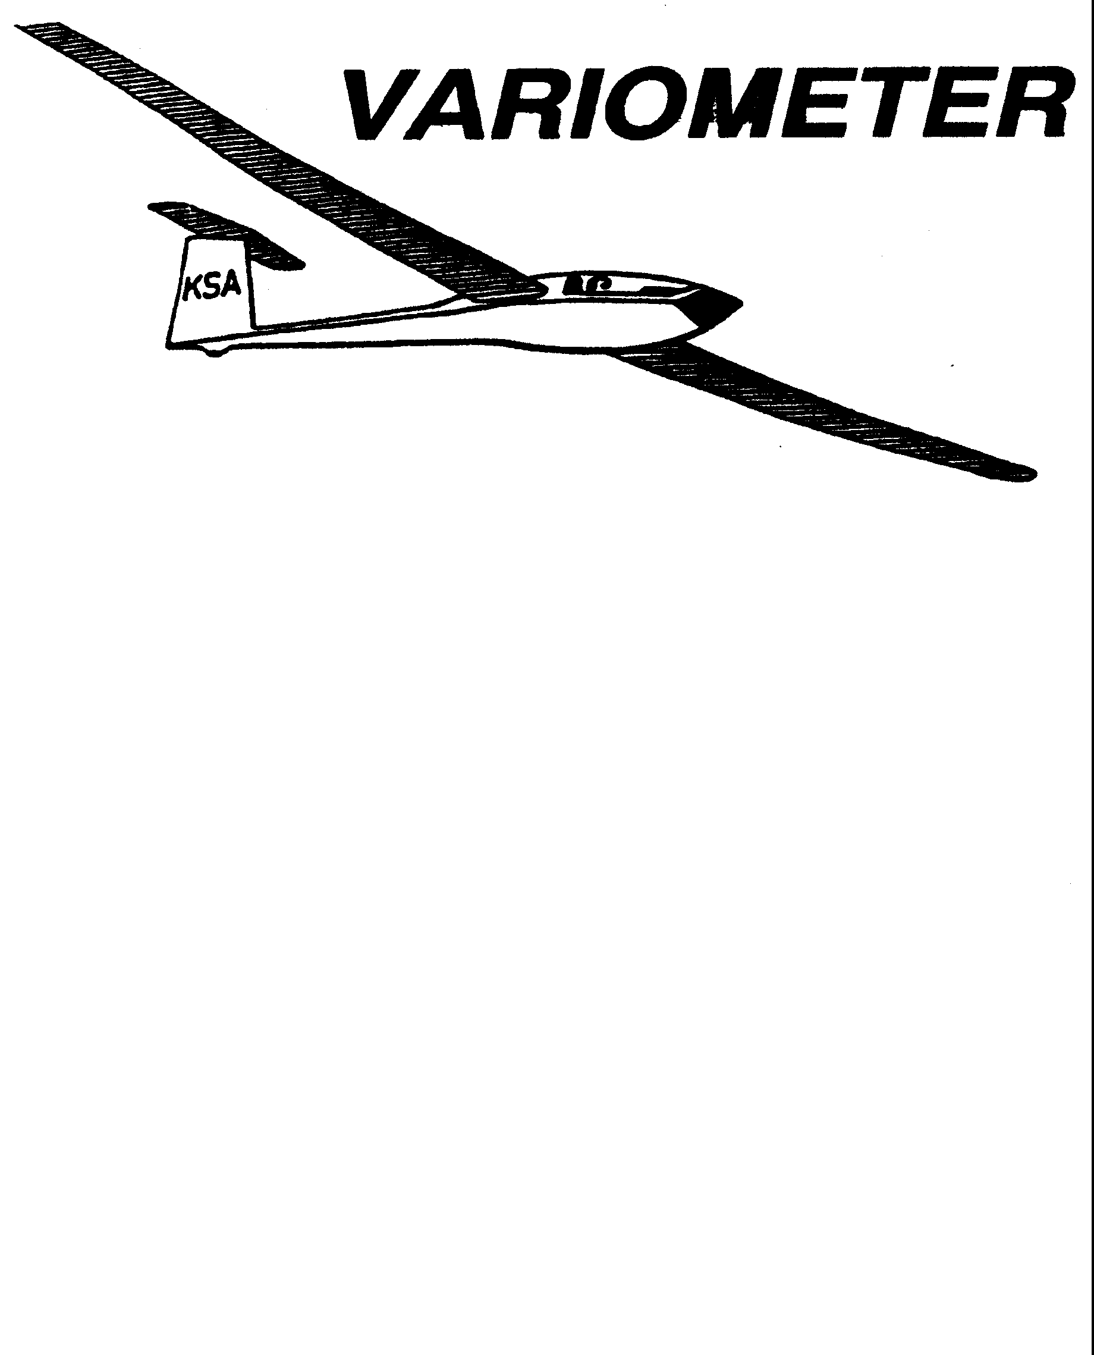

PRESIDENT – K. C. ALEXANDER (2007-2008)
SECRETARY - TREASURER – NEALE EILER (2007-2008)
VICE PRESIDENT EAST – RAY GIRARDO (2007-2008)
VICE PRESIDENT WEST – ED NEIDERT (2007-2008)
TOW PLANE MANAGER – STEVE LEONARD (2007-2008)
DIRECTORS: BERNIE MOHR (PAST PRESIDENT)

NEAL PFEIFFER(2007-2008)
DAVE WILKUS (2007-2008) PUBLISHED TO RECORD
ANDREW PETERS (2008-2009) THE UPS AND DOWNS
FRANK O’DONNELL (2008-2009) OF THE RAY SHARP -EDITOR
KANSAS SOARING ASSOCIATION

APRIL, 2008

From the Pres

The thunderstorms last week can only mean one thing, the soaring season is here!
Everyone needs to attend the annual safety meeting this week if at all possible. Like we have said before, you can never be too safe or know too much about safety processes.

Sunflower needs quite a bit of work to get ready for summer. Saturday, April 19th, is our annual workday at Sunflower to try and get things fixed up. There are a huge number of tree limbs which came down during the ice storm last winter. If you have a chain saw please bring it. Dennis Brown, Al Alexander and I overhauled all four of the toilets in the bathrooms last week, but there is still lots of prettying up that could be done. The power line to the fuel pump is down. Ski is planning to weld some new poles and supports on the shelter. As always everything we own is dirty. My intent was to get more people lined up on specific jobs, but a death in the family really impacted my available time for the last couple of weeks. I will attempt to contact some of you before the 19th about specific needs, but if you know about something that needs done, and would like to tackle it, just let me know. Otherwise just show up willing to help. We need and appreciate your help.
Important Dates For the Balance of 2008:

April 12th : Annual KSA Safety Meeting at WSU hosted by Frank O’Donnell
April 19th : Annual KSA workday at Sunflower
May 10th : Meeting at WSU or Wichita Glider Port
May 26th : Glider Camp at Sunflower Starts
June 14th : Cook-out at Sunflower after day of flying
July 12th : Cook-out at Sunflower after day of flying
July 19th : Kansas Kowbell Klassic
Aug. 9th Cook-out at Sunflower after day of flying
Sept. 13^{t}: Cook-out at Sunflower after day of flying
Oct. 11th : Meeting at WSU
Nov. 8th : Meeting at WSU
Dec. 13th : Meeting at WSU

WSA GLIDER CAMP PLANNING FOR 2008

FRANK O’DONNELL
Chief Instructor

We are seeking an expression of interest from potential students who wish to attend a training camp in 2008. We are considering our first camp on 26 through 30 May, 2008. The usual group of instructors, ground crew, and tow pilots will be available, so we are starting the publicity early to reach the most prospects. If you have friends who “…always wanted to fly a glider, but ….” perhaps the possibility of an intensive week-long training camp would get them started. The camps are primarily intended for those seeking their first FAA pilot rating, but power pilots wishing to add the glider rating are also welcome, as are licensed pilots who have not flown for several years and who wish to resume flying.

We restrict camp sign-ups to four per instructor, or a maximum of eight. The 2-22 and 2-33 are available for campers, and at least two instructors, a tow pilot, and an experienced ground crew will assist. Informal ground school and training materials are offered. There is no extra charge for the camp-just the usual tow fees and glider rental.

We have heard four expressions of interest, and need seven to continue. We all have unexpected happenings which change plans, so need to make an allowance for those in setting up the camp.

Call Ray Sharp (684-1986) or Frank O’Donnell (788-3224) now, if you have interest in the camps. Also call if you are a CFIG, tow pilot or ground crew expert and would like to assist with the camps. We will provide monthly updates of camp status in the Variometer.

CFI RENEWAL
FRANK O’DONNELL
Chief Instructor

I attended a two-day CFI Refresher Clinic in January, put on by Aviation Seminars. The local instructor was Dale Bleakney, a CFI and DPE who works for Cessna as the flight test pilot on the C-162.

The clinic covers a variety of subjects, and is oriented toward powered airplanes. There was a quiz at the end of each day, and I accomplished an 8710 application for renewal of my CFI which will be valid until 28 Feb. 10.

FAA recognizes several ways to renew a CFI certification, including a flight check, presenting evidence of sufficient successful training activity, or attending an approved refresher clinic.

The SSA provides a CFIG refresher at the annual convention; I have never attended, but hope to do so. Any FAA-approved renewal serves to update all of one’s CFI qualifications, so, attending the SSA refresher would update my SEL and II credentials also. Unfortunately, the CFI renewal doesn’t count as a Flight Review unless its also a flight check.

ED NOTE: We requested the above, and include the following note , to give a small glimpse of the efforts our instructors must go to to be able to maintain our privilege of flight. Perhaps we can publish a similar note from Mr. Pate next month.

In March at Sunflower there was a renewal exercise pertaining to Bob Park’s CFI credentials. He chose to demonstrate to the examiner (Charles Pate) his procedure for introducing a “student” to ground launch (auto tow) operations. Darin Liby, was the student, although an experienced pilot, he had not been involved in this type of launch. Support for the operation was provided by Bill Ashley, Dennis Brown Max Liby, Sue McNay, ”Sandy” Mackenzie, and Ray Sharp. Several launches were performed using a one thousand foot rope,(light breeze) to demonstrate not only the procedure, but how to recognize maximum attainable altitude with this type of launch. (700 feet on the rope, with kinetic energy for another hundred foot “zoom”).
It was an informative and enjoyable flying day for the entire support team, even without thermals.

A Note of Thanks – Marisa Levitt
Sunday morning the 10th of September arrived much like any other gorgeous summers day. Up in the sky beautiful cumulus clouds appeared, holding promise of a great soaring day. The Levitt family packed their car and set off for Sackville gliding club. Upon arrival, it was clear that other club members shared their enthusiasm.
Syndicate gliders were rigged and, amazingly, even the club machines got washed! One pilot, who had been looking for a partner to buy a share in his Phoebus C, saw this day as the day when he would succeed in convincing a potential buyer. The would-be partner was briefed on the handling and characteristics of the Phoebus. The decision was made that he would go up and if he felt comfortable with the glider and conditions , he would go off to Husbands Bosworth (50km).
So the Phoebus went up first, the Mucha second and I went third with the Ka8b. I was not planning on a goal flight, but just having a good cross-country flight. On this day though the tuggie towed me to a nice looking cu and I released at 1200 ft agl. Finding the lift not too good I moved off a little distance to where the Phoebus was thermalling. I joined in the thermal below him turning in the same direction.
The lift was good and I climbed steadily up to 2000 ft keeping a good look out. At around 2500 ft I lost sight of the Phoebus. I looked for him for a further 3 turns and then decided that the best course of action is to keep going around as I had been doing and he will see me where he expects to find me. Seeing as the lift was good, I did not mind staying where I was. Then a Dart joined the thermal 1000ft below me. I kept an eye on him one whilst still searching for the missing Phoebus. After another couple of turns I concluded the Phoebus must have left for I had not seen him for quite some time.
Then it happened! At 3000ft just as I was looking down at the Dart below, there was a loud bang and, from thermalling right, I found I was in a full left-spin. Out of the corner of my eye I saw the Phoebus falling away inverted to my right. As the Ka8 spun I also saw pieces of my left wing and a fully intact wing tip from the Phoebus falling away below.
My first thought was that I didn’t feel like dying and secondly, that I can’t jump as I was not wearing a chute! The third thought was, “What do I have to do to walk away from this?” This is where all the training from the CGC instructors came to my aide. When I subconsciously asked myself what I had to do the answers just came one at a time and as I needed them. Firstly, I did a normal spin-recovery, which worked and I got the glider back under control. Secondly, I found that I could keep it flying straight and keep a reasonable amount of control with about two-thirds rights aileron and lots of rudder to counter the yaw. Thirdly, keeping the speed up at 100-110km/h helped to improve control effectiveness.
Once control was established the next task at hand was to assess where I would land. To my relief, I had come out of my spin facing the airfield and about 6km out. I was however, still too high to land off a straight-in approach and I did not want to use the spoilers as the damage I could see was centered on the leading edge near the airbrake box. The idea of putting more stress on an already damaged wing was discouraging. As I got closer to the field I realized that once at the bottom of the field I could do a base leg and land comfortably. However, there was one main problem with this plan. If I chose to do a right-hand circuit it was possible that I may not successfully manage a right-hand turn as all my controls were already over to the right just to maintain straight flight. Similarly, if I were to do a left-hand circuit there was a risk of losing control close to the ground. The safest option was to land straight ahead, which I did, landing in a newly-ploughed field right next to the airstrip.
Once safe on the ground all I wanted to do was to get out of the glider as fast as possible as I found myself shaking from head to foot.
The Phoebus lost 5ft of its left wing, including 90% of the aileron. The pilot also managed to recover from the spin and found he could keep it level by flying at 200km/h with full opposite controls. He landed in a partially controlled crash in a set aside field with long grass, the subsequent ground-looped damaging the glider beyond repair.
We both walked away from this accident without a mark. I feel that at this point I need to say the one thing all glider pilots get tired of hearing, look out, look out and look out! If you do have radios make use of them!
However, thanks to the instruction I had received at CGC, I was able to make the correct decisions and deal with the situation successfully. Thanks to all the instructors at CGC who flew with me!
Oh, and by the way, the potential syndicate member declined to buy into the Phoebus!
The damage to the K8 wing !!
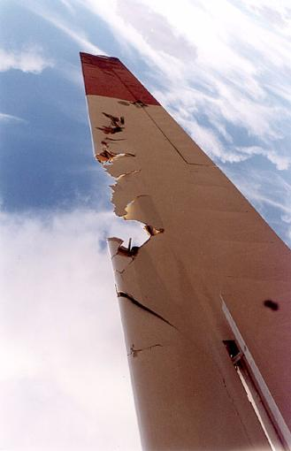

KSA Directory Info Needed

If you have not already turned in this information please do it asap. Either bring it to the
next meeting, e-mail it to Ray Sharp at the Variometer, (rayandginisharp@juno.com)
or snail mail it
to: K.C. Alexander
6515 University
Wichita, KS 67209
We intend to print in May, and distribution will be limited to contributers.
Thanks for your help in getting this directory done.

Name: Spouse:
Address:

City:

State:

Zip:

Home phone:

Cell phone:

Work phone:

E-mail:

Gliders owned:

Are you a WSA member? _____ Yes _____ No

Are you a Tow Pilot? _____ Yes _____ No

Are you an Instructor? _____ Yes _____ No

I (Pat Ensign) am happy to supply the KSA with a ride-on mower for the 2008 season. This is considered a loan since I need to take it back home at the end of the season to plow snow with in the winter. The primary use is to tow gliders between the staging area and the trailer area/far hangar. (I don’t always have a vehicle on the ground since I frequently fly down from KC). The secondary use is for the KSA to mow with. Some thoughts on its use:

If you desire to use it, just take it, its there for anyone and everyone. You don’t need to ask someone.
It’s to be kept in the hangar with the towplane so it can be locked up during the week.
Please start it OUTSIDE the hangar. Sometimes it smokes.
When you use it, please return it to the towplane hangar or staging area promptly for the next one to use. Don’t hog it.
Please don’t mow in the early or late afternoon when pilots want to use it. Mow in the mid-afternoon, morning or evening if you want to mow on the weekend.
The mower should be left full at the end of the weekend. No one will bother with it if it’s left empty.
Those of us that use it should take turns chipping in for gas, as can the KSA when it’s used for mowing.
If it breaks, please TELL ME. I can’t fix it if I don’t know it’s broke. I will be responsible to keep it going.

Thanks, Pat

The SSA requires club dues be submitted to Hobbs, NM by June 6th. So, anyone who does not have their dues in to me by May 31st will not be in the normal KSA/SSA renewal cycle and will get deleted from the KSA roster effective June 30. You will receive a final notice if I do not have your payment by May 31st.

MEMBERSHIP FEES (One year membership)

Regular Youth Family
(Under age 22) (each addl. person)
Soaring Society of America $64.00 $36.00 $36.00
Kansas Soaring Association* $16.00 $16.00 $16.00
Total $80.00 $52.00 $52.00

* If you are already a member of the SSA and will not be renewing your SSA Membership through KSA, your total payable KSA Membership fee is $20.

So- one check to KSA for the grand total of all you are renewing, addressed to KSA at the address above. I will handle the SSA dues, unless you choose not to renew your SSA membership through KSA. Then I will be in touch with SSA to insure you are current, as equipment usage requires current SSA membership.

Thank you for your understanding.

Sincerely,
Neale Eyler
Secretary/Treasurer KSA

KSA VARIOMETER
1950 S WEBB ROAD #112
WICHITA, KS 67207
rayandginisharp@juno.com

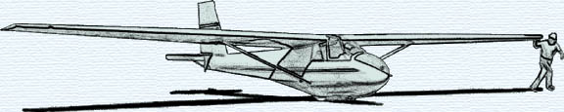

THE APRIL 2008 KSA MEETING

IS
SATURDAY, APRIL 12, 2008, 7:30 PM

AT THE NIAR BUILDING
ON THE WICHITA STATE UNIVERSITY CAMPUS

PROGRAM WILL BE THE ANNUAL SAFETY LECTURE BY FRANK O’DONNELL
WHICH WILL SERVE FOR THE LECTURE PORTION OF YOUR REQUIRED BIANNUAL FLIGHT REVUE. BRING YOUR LOG BOOK

