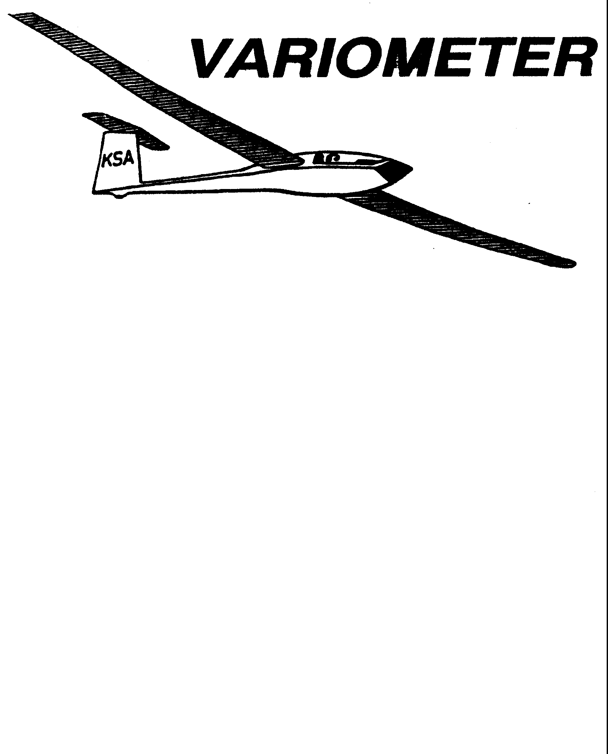

PRESIDENT – K. C. ALEXANDER (2007-2008)
SECRETARY - TREASURER – NEALE EILER (2007-2008)
VICE PRESIDENT EAST – RAY GIRARDO (2007-2008)
VICE PRESIDENT WEST – ED NEIDERT (2007-2008)
TOW PLANE MANAGER – STEVE LEONARD (2007-2008)
DIRECTORS: BERNIE MOHR (PAST PRESIDENT)

NEAL PFEIFFER(2007-2008)
DAVE WILKUS (2007-2008) PUBLISHED TO RECORD
ANDREW PETERS (2008-2009) THE UPS AND DOWNS
FRANK O’DONNELL (2008-2009) OF THE RAY SHARP -EDITOR
KANSAS SOARING ASSOCIATION

MAY, 2008

From the Pres
In this issue of the Variometer you will fmd a copy of the new 2008 KSA directory. We did our best to keep it accurate, but given my typing skills and the penmanship some of you have ( or don't have) there could be errors. Please check your data to make sure it is correct. If you find any problems just let me know and I will correct it in the next revision, which may be real soon if there are very many corrections needed.
A special thanks to all of you who showed up to help out on the annual work day. We accomplished quite a bit. Hundreds of downed tree limbs were cleared away. The hangers were cleaned up a little, and some waterproofing was applied to part of the long hangers roof. The power line to the gas pump was put back up. One of the support poles on the shelter was replaced. Many of the tie downs on the ramp were marked with paint circles. The towplane and some of the gliders got baths. The engine on our new sprayer got its carburetor and fuel tank cleaned. A large area on the ramp and runway got swept. Several areas were mowed. The bathrooms got some sprucing up. I know I'm missing other items, but you should get the idea. All in all we accomplished a lot. Thanks!
During the last three or four weeks there have been major projects undertaken to improve the infrastructure at Sunflower. The first was the acquisition of our own sprayer so we can keep the weeds on the runway and ramp areas under control. It has a five horsepower motor, sprays a twenty foot wide path and has a two-hundred gallon tank. It will allow us to spray whenever we need to for significantly less money. Thanks to Ed Neidert in Ulysses for his efforts in locating this item. Shurley and I drove out and picked it up.
The second item is the brand new John Deere Gator with a ten horsepower sweeper on the front which Bill Seed purchased. Bill is allowing the club to use this for runway and ramp sweeping to remove the sand and chat from these areas. The JD is kept in the locked hanger. You must be checked out by Bill or a club officer prior to using it. This will be a huge help in protecting our propellers and gliders. Thanks Bill!

The third item is the loan of a riding mower by Pat Ensign. It is also kept in the locked hanger. It will be used primarily for moving gliders during periods of flying, but can be used for mowing at other times. With a mower always up there we should be able to keep up with the grass and weed mowing since we won't have to drag one up from Wichita all the time. Thanks Pat!
The fourth item was the hiring of a paving contractor to grind off over four-hundred linear feet of buckles and bumps on the runway. This job was finished last Monday. Many of the areas where the buckles were removed now have a small hole. I need some volunteers to help fill and pack these with some asphalt patch. If you can drive or run a shovel please give me a call.
The fifth, and most significant item, is some new coating for the runway. Two years ago we got an area forty feet by twenty-five hundred feet coated. We couldn't afford the good stuff, so we went with a lower priced alternative which we were told would work okay for a low traffic surface such as our runway. It didn't. This time we are going to use the real stuff. If you have landed at Strother Field in the last three years you have been on the stuff we will be using. After three years and numerous snow plowings it still looks great. Bill Seed has stepped up and offered to pay for an area sixty feet by five-thousand feet to be coated with this material. This new surface will be applied around the first week of June. We can not say thank you to Bill enough to cover all he does for us, but here goes. Thank You Bill!!!!!

Important Dates For the Balance of 2008:

May 10th : Meeting at WSU
May 26th : Glider Camp at Sunflower Starts
June 14th : Cook-out at Sunflower after day of flying
July 12th : Cook-out at Sunflower after day of flying
July 19th : Kansas Kowbell Klassic

Aug. 9th Cook-out at Sunflower after day of flying
Sept. 13^{t}: Cook-out at Sunflower after day of flying
Oct. 11th : Meeting at WSU
Nov. 8th : Meeting at WSU
Dec. 13th : Meeting at WSU

2008 GLIDER CAMP UPDATE

There is enough interest in the Glider Camp to go ahead and schedule it for 26 May through 30 May, 2008.

Information about the camp will be sent to all participants by the middle of May. We may be able to accommodate one more student, but anyone interested needs to call Ray Sharp (684-1986) or Frank O’Donnell (788-3224) right away.

 |  | 2008 LAUNCH LINE MANAGER SCHEDULE
Date | Name | Phone Number |  | Date | Name | Phone Number
MAY |  |  |  | JUNE
10 | Steve Leonard | 729-0356 |  | 1 | Ashok Chathbai | 516-9581
 | Dan Blair | 838-1108 |  |  | Dave Woody | 682-1895
11 | Neal Pfeiffer | 686-4306 | I | 7 | David Wilkus | 788-0932
 |  |  |  |  | Ray Girardo | 942-0638
17 | Jerry Boone | 620-662-5330 |  | 8
 | John Bender | 816-296-7453 |  |  | Everette Gould | 620-662-0838
18 | Steve Carlson | 21 0-414-3809 |  | 14 | Rich Stone | 612-2008
 | Doud Wilson | 733-5537 |  |  | Brad Sharp | 684-1986
24 | Neale Eyler | 729-06592 |  | 15 | Doug Wilson | 733-5537
 | Scott Dimick | 733-5678 |  |  | Gary Trimpe | 620-656-7381
25 | John Peters | 620-367-3711 |  | 21 | Neale Eyler | 729-0659
 | Darren Liby | 620-665-0035 |  |  | John Bender | 816-296-7453
26 | Leon Cziske | 733-0822 |  | 22 | Steve Leonard | 729-0356
 | Jacob Duerksen | 283-5430 |  |  | Aaron Waters | 755-0701
31 | David Wilkus | 788-0932 |  | 28 | Bryan Pate | 524-8829
 | Dakota Harms | 282-6000 |  |  | Linda Pate | 524-8829
 |  |  |  | 29 | Harry Clayton | 744-2389
 |  |  |  |  | Darren Liby | 620-665-0035

 |  | 2008 LAUNCH LINE MANAGER SCHEDULE
Date | Name | Phone Number | I | Date | Name | Phone Number
JULY |  |  |  | AUGUST
5 | John Peters | 620-367-3711 |  | 2 | Everette Gould | 620-662-0838
 | Jacob Duerksen | 283-5430 |  |  | Gary Trimpe | 620-656-7381
6 | Ashok Chathbai | 516-9581 |  | 3 | Ashok Chathbai | 516-9581
 | Doug Wilson | 733-5537 |  |  | Jacob Duerksen | 283-5430
12 | Brad Sharp | 684-1986 |  | 9 | Brad Sharp | 684-1986
 | John Bird | 620-728-1341 |  |  | Steve Carlson | 21 0-414-3809
13 | Neal Pfieffer | 686-4306 |  | 10 | Neale Eyler | 729-0659
 |  |  |  |  | Christian Maude | 620-532-3608
19 | Bryan Pate | 524-8829 |  | 16 | John Bird | 620-728-1341
 | Linda Pate | 524-8829 |  |  | Aaron Waters | 755-0571
20 | Eathan Beale | 650-7547 |  | 17 | Bob Blanton | 683-9759
 | Ray Girardo | 942-0638 |  |  | Ray Girardo | 942-0638
26 | Rich Stone | 612-2008 |  | 23 | Dakota Harms | 282-6000
 | Jerry Boone | 620-662-5330 |  |  | Michael Harrington 652-9287
27 | Harry Clayton | 744-2389 |  | 24 | John Bender | 816-296-7453
 | Christian Maude | 620-532-3608 |  |  | Christain Maude | 620-532-3608
 |  |  |  | 30 | Dave Woody | 682-1895
 |  |  |  |  | Eathan Beale | 650-7547
 |  |  |  | 31 | Harry Clayton | 744-2389
 |  |  |  |  | Darren Liby | 620-665-0035

 |  | 2008 |  |  | KSA |  | Directory
MME | ADDRESS |  | SPOUSE | HOME |  | £ELL. |  | WORK | E:MML | GLIDER | WSA | IID.Y | INSTR
Alexander, AI | 1925 W37thN | Wichita, KS 67204 | Esther | 316-832-1395 |  |  |  |  |  |  | y | N | N
Alexander, K.C. | 6515 University | Wichita, KS 67209 | Shurley | 316-943-7641 |  | 316-943-7641 |  | 316-943-7641 |  | P1K-20D | N | Y | N
Bender, John | 17919 Baxter Rd. | Lawson, MO 64062 | Dorris | 816-296-7453. |  | 816-686-8689 |  | 816-891-4504 | i hnbendialnetscaoe. net | Ka-6CR | Y | Y | N
Bird, Brian | 1506 Brookwood | Hutchinson, KS 67502 | Lori | 620-728-1341 |  | 620-664-7844 |  | 620-665-3410 | b I iacdgialsbcglobaL!lev |  | y | y | y
Blanton, Bob | 7535 Oxford Ct. | Wichita, KS 67226 | June | 316-683-9759 |  | 316-644-8397 |  | 316-291-3024 | JuneBlanton@hotmai l.com |  | y | N | N
Boone, Jerry | 505 East Ave. A | Hutchinson, KS 67501 | Lyn | 620-662-5330 |  | 620-474-4177 |  | 620-728-4109 | k,rrv. boone@antech.biz |  | y | N | N
Carlson, Steve | 1446 N. Brookfield | Wichita, KS 67206 |  | 316-685-5453 |  | 316-676-1193 |  | 210-414-3809 | sloiet45ialvahoo.com
Chathbai, Ashokanand 1726 N. Roosevelt Ct. Wichita, KS 67208 |  |  |  |  |  | 316-516-9581 |  | 316-299-0268 | ashokanand.chathbaiialairbus.com |  | y | N | N
Clayton,Harry | 11701 E. 69th St. N. | Wichita, KS 67226 | Susan | 316-744-2389 |  | 316-644-9117 |  | 316-978-8231 | hclayton@pixius.net | Cirrus | y | N | N
Cole, Becky | 528 E. Sherman St. | Hutchinson, KS 67501 |  | 620-662-1383 |  | 620-960-3390 |  | 620-665-6394 | bcoleialksio.net
Cziske, Leon | 14349 S.w. Phyllis Rd. Rose Hill, KS 67133 |  | Janet | 316-733-0822 |  | 316-253-8239 |  |  | skicziskeialvahoo.com |  | Y | N | N
Dimick, Scott | 15499 S>W> 140th St. Rose Hill, KS 67133 |  | Gail | 316-733-5678 |  | 316-461-8196 |  | 316-299-0219 | essvdialoixus.net
Ensign, Pat | 719 NE 115th Terrace | Kansas City, MO 64155 Leslie |  |  |  | 816-835-6580 |  |  | iensign2(ajkc.rr.com |  | N | y | N
Eyler, Neale | 2114 N. Shefford | Wichita, KS 67212 | Doreen | 316-729-0659 |  |  |  | 316-517-7488 | n evlerialhQtmail. com |  | Y | N | N
Girardo, Ray | P.O. Box #12408 | Wichita, KS 67277 | Donna | 316-942-063~ |  | 316-648-5451 |  | 316-517-6351
Gould, Everette | 202 E. 17th | Hutchinson, KS 67501 Tracey |  | 620-662-0838 |  | 620-728-9332 |  | 620-663-8307 | everette gialhotmail.com
Hall, Bob | 2407 Kipling Place | Hutchinson, KS 67502 | Sue | 620-663-9577 |  | 620-727-1273 |  | 620-662-6661 | bhall(ajarkvalev.com |  | Y | Y | N
Harms, Dakota | 2617 S. East Lake Rd | Newton, KS 67114 |  | 316-282-6000 |  | 316-558-0916 |  |  | kota593ialgmail.com |  | Y | N | N
Holliday, Bob | 522 E. Crestline Rd | Andover, KS 67002 | Ruth | 316-733-5403 |  | 316-641-6178 |  | 316-685-4545 |  | Ventus 2B
Kirkland, Richard | 5914 E Oakwood Dr | Wichita, KS 67208 | Darlene | 316-682-7814 |  | 316-518-6845 |  |  | r -d. Kirklandialsbcglobal. net | Dart | y | y | N
Leonard, Steve | 11117 Westlawn St | Wichita, KS 67212 |  | 316-729-0356 |  |  |  | 316-517-1227 | zuni228ialvahoo.com | Zuni II

Liby, Darren | 2750 West 43,d | Hutchinson, KS 67502 Sachiko |  | 620-665-0035 | 620-899-1543 |  | full. stall.1anding(Qlgmail. com | Zuni
McNay, Sue | 1615 Alta | Wichita, KS 67216 |  | 316-524-6203 | 316-258-9706 |  |  | 1-26 | y | N | N
Mills, Tonk | 52 Via Verde | Wichita, KS 67230 | Jayne | 316-733-1343 |  | 316-265-0849 | 2tonkcox.net | Skylarks | N | N | N
Mohr, Bernard | 1408 Elm | Andover, KS 67002 | Rose Mary | 316-733-4524 |  |  |  |  | N | Y | N
Neidert, Ed | 3850 W. Rd. 8 | Ulysses, KS 67880 | DarIa | 620-356-5169 |  | 620-356-2471 | ulsair@pld.com | 1-26 | Y | Y
O'Donnell, Francis | 301 S. Rock Rd. #100 | Wichita, KS 67037 | Sally' | 316-788-3224 | 316-253-3587 |  | sally frank@juno.com |  | y | y | y
Park, Robert | 402 NE 100 Rd. | Harper, KS 67058 |  | 620-896-2252 | 620-740-0037 |  |  | Grob 103 | Y | Y | Y
Pate, Charles | 1714 S Mission Rd | Wichita, KS 67207 |  | 316-685-5695 | 316-665-4058 | 316-831-3440 | ccpatela\hotmail.com | Lark | Y | Y | Y
Peters, Andrew | 5101 E 27th St N | Wichita, KS 67220 |  | 316-682-4287 | 316-393-2261 | 316-517-0378 | apsoarsla\vahoo.com | LS-3 | Y | Y | Y
Peters, John | 3015 NE 96th | Walton, KS 67151 | Ruth | 620-367-3711 | 620-755-3161 |  | iohn. petersla\mcpherson.com |  | Y | N | N
Pfeiffer, Neal | 36 Laurel Drive | Wichita, KS 67206 | Karen | 316-686-4306 | 316-641-9928 | 316-676-6775 | Neal Pfeiffer@sbcglobal.net | Ka-6 | Y | N | N
Rowe, Kraig | 250 W Douglas #2003 | Wichita, KS 67202 |  |  | 785-608-3421 | 316-978-6712 | kmr60813la\aol.com |  | y | N | N
Seed, William | 10915 S Halstead | Hutchinson, KS 67501 |  |  | 620-664-8521 |  | kansasbillla\webtv .net | DG-600
SeItman, Jack | 7824 Dublin | Wichita, KS 67206 | Jane | 316-636-4218 |  |  | iack se1tmanla\sbcg1obal.net |  | N | y | N
Seibel, Steven | PO Box 2787 | Corvallis, OR 97339 |  | 316-684-073 0 | 541-990-4633 |  | steves@aeroexperiments.org | Hang | Y | N | N
Sibley, Gerry | 4819 N Hedgerow Ct | Bel Aire, KS 67220 |  | 316-744-7894 |  |  | Gerry sibla\prod.igy.net |  | Y | N | N
Stone, Richard | 8822 E Denker Cir | Wichita, KS 67210 | Myra | 316-612-2008 | 316-371-2850 |  | rich-mvraia\cox.net |  | y | N | N
Wells, John | 900 Saint James | Wichita, KS 67206 | Sandy | 316-685-1043 |  |  |  | ASW-20
Wi1kus, David | 1246 N Buckner | Derby, KS 67037 | Susan | 316-788-0932 | 316-706-9261 | 316-831-3872 | dwilkusla\sbcg1obal.net | Diamate

2008 WSA INSTRUCTOR SCHEDULE AT SUNFLOWER
GLIDERPORT, 31 MAY-13 SEPTEMBER
(All Saturdays)

31 May - Frank O’Donnell 5 July- Andrew 9 August - Brian Bird
7 June - Brian Bird 12 July-Brian 16 August- Mike
14 June- Andrew Peters 19 July – Mike 23 August- Frank
21 June- Mike Westemeier 26 July- Frank 30 August- Andrew
28 June- Frank 2 Aug.- Andrew 6 Sept.- Brian
13 Sept.- Mike

Substitutes: Mark Schlegel, Aaron Martin

WSA DUTY-INSTRUCTOR GROUND RULES (2008)

Every Saturday, 31 may-13 Sept. (16 days)

Duty day: Noon to 5 PM (nominal)

Instructor will supervise as necessary moving the 2-33/22 from the hanger by the student(s) .

Instructor is released if no students arrive by 1 PM.

Instructor presence doesn’t confer glider usage priority.

Instructor arranges own subs, by swaps or calling Mark or Aaron.

If the instructor believes the weather is unsuitable for training he will call the towpilot and a line manager.

Being assigned as duty-instructor does not imply that any instructor is unwelcome on any day, nor does it imply any special authority or responsibility for operations.

Instructors are encouraged to advise the following instructor of student progress and needs.

Students are always encouraged to call instructors before proceeding to Sunflower.

WICHITA SOARING ASSOCIATION, INC.
Wichita, Kansas
Membership Application Form
Name:_____________________________________ Age:__________ Date:_______________
Address:________________________________________________________________________
City:_________________________________________ State:_________ Zip:________________
Phone: Home:___________________________
Business:_________________________
Place of Business:_______________________________________________________________
Pilot Ratings:______________________________ Airman Cert. No. :______________
Flight Experience: (hours of flight time; flight schools you have been associated with,
either as student or instructor; any other similar information (give dates and locations).
If possible, give name of one person in the local area who has knowledge of your flight experience).
_________________________________________________________________________________________
_________________________________________________________________________________
Have you any known physical defect which would require your flying on a waiver?
_____________________ Describe:__________________________________________________
I have read, or had explained to me, the Constitution and the Operating
Proceedures for the Wichita Soaring Association, and I agree to abide by these. I
also understand that the club can offer flying at minimum cost only because the
work os maintaining the aircraft and running the flying operation is performed by
club members. I agree to share in this work.
Signed:_________________________________________________________________
Return application to:
Harry Clayton
11701 E. 69th St. N
Wichita, KS 67226
_________________________________________________________________________________
For WSA use only:
Date Application Approved:
Directors:
___________________________________
___________________________________
___________________________________
___________________________________

KANSAS SOARING ASSOCIATION
MEMBERSHIP INFORMATION

PERSONAL HISTORY DATE:____________

Name:___________________________________________
Address:
Street:__________________________________________________________
City:____________________________________________________________
State:______ Zip:_______________
Phone:____________________________
Birth Date:(only required for Youth Memberships)__________________
Occupation:______________________________________________________
Are you currently a member of the Soaring Society of America?____________
If yes, please provide your membership number and expiration date:________________
How did you find out about KSA?___________________________________________

FLYING EXPERIENCE

Pilot Ratings:
Power:___________________________ Total flight time:_________________________
Glider:___________________________ Total flight time:_________________________
Other:____________________________ Total flight time:_________________________

Please return the completed membership form, along with the appropriate fee (check or money order payable to Kansas Soaring Association) to:
Neale Eyler
Secretary/Treasurer, KSA
2114N Shefford
Wichita, KS 67212

MEMBERSHIP FEES (One year membership)

Regular Youth Family
(under age 22) (each addl. person)
Soaring Society of America $64.00 $36.00 $36.00
Kansas Soaring Association* $16.00 $16.00 $16.00
Total $80.00 $52.00 $52.00
* If you are already a member of the SSA and will not be renewing your SSA membership through KSA, your total payable KSA membership fee is $20. This is the normal fee plus the rebate that KSA would receive from SSA for being a chapter of SSA.

The SSA requires club dues be submitted to Hobbs, NM by June 6th. So, anyone who does not have their dues in to me by May 31st will not be in the normal KSA/SSA renewal cycle and will get deleted from the KSA roster effective June 30. You will receive a final notice if I do not have your payment by May 31st.

MEMBERSHIP FEES (One year membership)

Regular Youth Family
(Under age 22) (each addl. person)
Soaring Society of America $64.00 $36.00 $36.00
Kansas Soaring Association* $16.00 $16.00 $16.00
Total $80.00 $52.00 $52.00

* If you are already a member of the SSA and will not be renewing your SSA Membership through KSA, your total payable KSA Membership fee is $20.

So- one check to KSA for the grand total of all you are renewing, addressed to KSA at the address above. I will handle the SSA dues, unless you choose not to renew your SSA membership through KSA. Then I will be in touch with SSA to insure you are current, as equipment usage requires current SSA membership.

Thank you for your understanding.

Sincerely,
Neale Eyler
Secretary/Treasurer KSA

KSA VARIOMETER
1950 S WEBB ROAD #112
WICHITA, KS 67207
rayandginisharp@juno.com

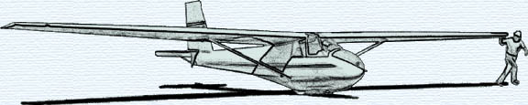

THE MAY 2008 KSA MEETING

IS
SATURDAY, MAY 10, 2008, 7:30 PM

AT THE NIAR BUILDING
ON THE WICHITA STATE UNIVERSITY CAMPUS

PROGRAM: PULLEY ASSISTED AUTO TOWS
(Near winch performance with auto tow simplicity)
&
AVIATION RELATED SWAP MEET
(just like we had one year ago)

