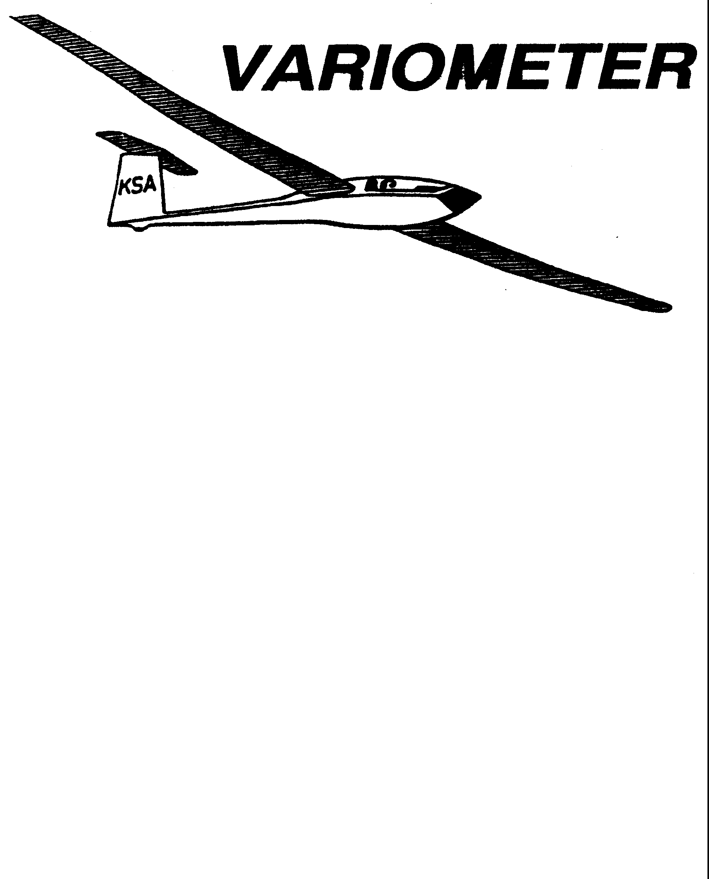

PRESIDENT – K. C. ALEXANDER (2007-2008)
SECRETARY - TREASURER – NEALE EILER (2007-2008)
VICE PRESIDENT EAST – RAY GIRARDO (2007-2008)
VICE PRESIDENT WEST – ED NEIDERT (2007-2008)
TOW PLANE MANAGER – STEVE LEONARD (2007-2008)
DIRECTORS: BERNIE MOHR (PAST PRESIDENT)

NEAL PFEIFFER(2007-2008)
DAVE WILKUS (2007-2008) PUBLISHED TO RECORD
ANDREW PETERS (2008-2009) THE UPS AND DOWNS
FRANK O’DONNELL (2008-2009) OF THE RAY SHARP -EDITOR
KANSAS SOARING ASSOCIATION

JUNE, 2008

Important Dates For the Balance of 2008:

June 14th : Cook-out at Sunflower after day of flying
July 12th : Cook-out at Sunflower after day of flying
July 19th : Kansas Kowbell Klassic
Aug. 9th Cook-out at Sunflower after day of flying
Sept. 13^{t}: Cook-out at Sunflower after day of flying
Oct. 11th : Meeting at WSU
Nov. 8th : Meeting at WSU
Dec. 13th : Meeting at WSU

ELEVENTH ANNUAL KSA/WSA
GLIDER TRAINING CAMP (13th camp)

The camp was scheduled for26-30 May 08, but we experienced the worst weather ever at this camp. We assembled at 10 AM Monday and flew one pattern-tow flight under a low overcast with each of the seven students. As the overcast lowered we hangered the gliders and eventually cancelled flying after a short ground school. We cancelled flying on Tuesday due to forecasted low ceilings, although in hindsight the actual conditions may have allowed some flying. The forecast for Wednesday was encouraging, so we assembled but were stopped by a low ceiling that never lifted; ground school filled another frustrating hour. The Thursday forecast suggested a workable flight window between the morning overcast and the afternoon winds, but the actuals closed the window so we cancelled at 8:30 AM. Finally, Friday was flyable all day, and we generated 28 dual training flights, and three first solos. K.C. Alexander flew 42 tows (!). The final results were:

First Glider Solo: Richard Duerksen
Nicolas Neidert
Shea Zuckerman

Good progress: Ashok Chathbai
Ethan Catlett
Jacob Duerksen
Alex Lutz

The towplane and gliders performed flawlessly again. (Thanks, Steve Leonard and Harry Clayton). The camp crew included Ray Sharp, Leon Cziske, Al Alexander, Richard Kirkland, K.C. Alexander, Brian Bird and Frank O’Donnell; thanks again to this faithful group, most of whom have supported the camp project since it began in 1997.

One or more of the original camp supporters recognize their need to reduce or end their future participation in the camp. Continuation of the camp project requires that new, younger leaders and supporters volunteer to take over for 2009. Call Ray Sharp (684-1986) or Frank O’Donnell (788-3224) if you feel the calling.

2008 WSA INSTRUCTOR SCHEDULE AT SUNFLOWER
GLIDERPORT, 31 MAY-13 SEPTEMBER
(All Saturdays)

31 May - Frank O’Donnell 5 July- Andrew 9 August - Brian Bird
7 June - Brian Bird 12 July-Brian 16 August- Mike
14 June- Andrew Peters 19 July – Mike 23 August- Frank
21 June- Mike Westemeier 26 July- Frank 30 August- Andrew
28 June- Frank 2 Aug.- Andrew 6 Sept.- Brian
13 Sept.- Mike

Substitutes: Mark Schlegel, Aaron Martin

WSA DUTY-INSTRUCTOR GROUND RULES (2008)

Every Saturday, 31 may-13 Sept. (16 days)

Duty day: Noon to 5 PM (nominal)

Instructor will supervise as necessary moving the 2-33/22 from the hanger by the student(s) .

Instructor is released if no students arrive by 1 PM.

Instructor presence doesn’t confer glider usage priority.

Instructor arranges own subs, by swaps or calling Mark or Aaron.

If the instructor believes the weather is unsuitable for training he will call the towpilot and a line manager.

Being assigned as duty-instructor does not imply that any instructor is unwelcome on any day, nor does it imply any special authority or responsibility for operations.

Instructors are encouraged to advise the following instructor of student progress and needs.

Students are always encouraged to call instructors before proceeding to Sunflower.

TOWPILOT SCHEDULE 2008

DATE | DAY | NAME | PHONE NUMBER
JUNE 1 | SUN | Jack Seltman | 316-636-4218
7 | SAT | K.C. Alexander | 316-943-7641
8 | SUN | K.C. Alexander | 316-943-7641
14 | SAT | Bob Hall | 620-663-9577
15 | SUN | Bob Hall | 620-663-9577
21 | SAT | Aaron Martin | 316-776-2287
22 | SUN | Jack Seltman | 316-636-4218
28 | SAT | Charles Pate | 316-685-5695
29 | SUN | Dennis Brown | 316-722-8351
JULY 4 | FRI | Bernie Mohr | 316-733-4524
5 | SAT | Bob Hall | 620-663-9577
6 | SUN | Richard Kirkland | 316-682-7814
12 | SAT | Ben Sorenson | 316-655-0257
13 | SUN | Frank O’Donnell | 316-788-3224
19 | SAT | Charles Pate (Kowbell) | 316-685-5695
20 | SUN | Mark Schlegel | 316-680-3263
26 | SAT | Brian Bird | 620-422-3875
27 | SUN | K.C. Alexander | 316-943-7641
AUG 2 | SAT | Aaron Martin | 316-776-2287
3 | SUN | Bob Hall | 620-663-9577
9 | SAT | Andrew Peters | 316-682-4287
10 | SUN | Richard Kirkland | 316-682-7814
16 | SAT | Pat Ensign | 816-835-6580
17 | SUN | Jack Seltman | 316-636-4218
23 | SAT | Ben Sorensen | 316-655-0257
24 | SUN | Dennis Brown | 316-722-8351
30 | SAT | K.C. Alexander | 316-943-7641
31 | SUN | Frank O’Donnell | 316-788-3224
SEPT 1 | MON | Bob Hall | 620-663-9577
6 | SAT | Bernie Mohr | 316-733-4524
7 | SUN | Jack Seltman | 316-636-4218
13 | SAT | Andrew Peters | 316-682-4287
14 | SUN | Bob Holliday | 316-733-5403
20 | SAT | Ben Sorensen | 316-655-0257
21 | SUN | Aaron Martin | 316-776-2287
27 | SAT | Mark Schlegel | 316-680-3263
28 | SUN | Dennis Brown | 316-722-8351

TOWPILOT SCHEDULE 2008

I would like to extend a hearty Thank You in advance to all the towpilots. Without your efforts, none of us would be able to enjoy our hobby as we do. If I have scheduled you for a date you cannot make, I am terribly sorry. I try to contact all the towpilots and try to work up a schedule to avoid conflicts. But, I don’t always get it right, and sometimes your schedules change after we have talked. I can help with trying to get fill-ins or trades, but it easier without me being a middle man. It is not required, but if you do make a change with someone, could you please let me know. This way, we can keep up to date as to who will be towing on what day. I will also make sure the towpilot and line manager lists are in the hangar at the field. For those I did not get a chance to speak with, if you cannot tow at all this summer, let me know and I will get others to take the days I assigned to you. If I just picked days that turn out to not work for you, I would appreciate it very much if you could try to work out trades.

For those that are interested, the current insurance requirement is 500 hours total power time, with 100 hours in similar gear configuration (in our case, fixed tricycle), 10 takeoffs and landings in type, and at least 10 flights while towing sailplanes. Interested in towing? It is a rare opportunity. You get to fly The Worlds Oldest Cessna 182. And for the duty it pulls, it is in pretty good shape. If you don’t meet the insurance total time or time in type, we can investigate having named pilots added on a case by case basis. If you are interested in being a towpilot, let me know. If you don’t yet have the hours, we can still get you trained in how we like to have the towplane operated, and see about getting you on the reserve list.

Notes to the towpilots: Let’s keep the tows in close. Nothing glides well in sink. If you are getting tired and need to take a break, tell the line manager. Your safety needs to be our top priority. If you need a break, let the line manager know, and we will try to get one to fill in for a few tows. Also, try and give the line manager a heads up a tow or two before you need to get gas for the towplane. The fuel is much closer to the runway, so we should be able to get more help for fueling. Line Managers, keep an eye on the towpilot. It is VERY HOT in there. He needs breaks and water, too.

Towpilots, please make notes of things that need fixing on the back of any tow ticket for the day. I see the backsides as well as the front sides. If I don’t know what is broken, I cannot get it taken care of. You can also tell me by phone (316-729-0356) or e-mail, zuni228@yahoo.com. I try to give the towplane a once-over every day I am up there, but I cannot see or tell everything. Those of you that are operating the towplane see first hand what is wrong. Please let me know so I can get it fixed. Thanks.

Also note: I try to get the tow bills mailed out and to you by the 10th, and I am requesting payment by the 20th. You can pay via check, cash, or even via PayPal if you like. But please note: My PayPal account will not accept credit card payments. The PayPal account is my e-mail address. Just put “Tow Bill” somewhere on the invoice, and I will transfer it to the towplane account.

Steve Leonard
KSA Towplane Manager

 |  |  | 2008 LAUNCH LINE MANAGER SCHEDULE
Date | Name |  | Phone Number |  |  |  | Date |  | Name |  | Phone Number
MAY |  |  |  |  |  |  | JUNE
10 | Steve Leonard |  | 729-0356 |  |  |  | 1 |  | Ashok Chathbai |  | 516-9581
 | Dan Blair |  | 838-1108 |  |  |  |  |  | Dave Woody |  | 682-1895
11 | Neal Pfeiffer |  | 686-4306 |  | I |  | 7 |  | David Wilkus |  | 788-0932
 |  |  |  |  |  |  |  |  | Ray Girardo |  | 942-0638
17 | Jerry Boone |  | 620-662-5330 |  |  |  | 8
 | John Bender |  | 816-296-7453 |  |  |  |  |  | Everette Gould |  | 620-662-0838
18 | Steve Carlson |  | 21 0-414-3809 |  |  |  | 14 |  | Rich Stone |  | 612-2008
 | Doud Wilson |  | 733-5537 |  |  |  |  |  | Brad Sharp |  | 684-1986
24 | Neale Eyler |  | 729-06592 |  |  |  | 15 |  | Doug Wilson |  | 733-5537
 | Scott Dimick |  | 733-5678 |  |  |  |  |  | Gary Trimpe |  | 620-656-7381
25 | John Peters |  | 620-367-3711 |  |  |  | 21 |  | Neale Eyler |  | 729-0659
 | Darren Liby |  | 620-665-0035 |  |  |  |  |  | John Bender |  | 816-296-7453
26 | Leon Cziske |  | 733-0822 |  |  |  | 22 |  | Steve Leonard |  | 729-0356
 | Jacob Duerksen |  | 283-5430 |  |  |  |  |  | Aaron Waters |  | 755-0701
31 | David Wilkus |  | 788-0932 |  |  |  | 28 |  | Bryan Pate |  | 524-8829
 | Dakota Harms |  | 282-6000 |  |  |  |  |  | Linda Pate |  | 524-8829
 |  |  |  |  |  |  | 29 |  | Harry Clayton |  | 744-2389
 |  |  |  |  |  |  |  |  | Darren Liby |  | 620-665-0035
 |  |  |  | 2008 LAUNCH LINE MANAGER SCHEDULE
Date |  | Name |  | Phone Number |  | I |  | Date |  | Name |  | Phone Number
JULY |  |  |  |  |  |  |  | AUGUST
5 |  | John Peters |  | 620-367-3711 |  |  |  | 2 |  | Everette Gould |  | 620-662-0838
 |  | Jacob Duerksen |  | 283-5430 |  |  |  |  |  | Gary Trimpe |  | 620-656-7381
6 |  | Ashok Chathbai |  | 516-9581 |  |  |  | 3 |  | Ashok Chathbai |  | 516-9581
 |  | Doug Wilson |  | 733-5537 |  |  |  |  |  | Jacob Duerksen |  | 283-5430
12 |  | Brad Sharp |  | 684-1986 |  |  |  | 9 |  | Brad Sharp |  | 684-1986
 |  | John Bird |  | 620-728-1341 |  |  |  |  |  | Steve Carlson |  | 21 0-414-3809
13 |  | Neal Pfieffer |  | 686-4306 |  |  |  | 10 |  | Neale Eyler |  | 729-0659
 |  |  |  |  |  |  |  |  |  | Christian Maude |  | 620-532-3608
19 |  | Bryan Pate |  | 524-8829 |  |  |  | 16 |  | John Bird |  | 620-728-1341
 |  | Linda Pate |  | 524-8829 |  |  |  |  |  | Aaron Waters |  | 755-0571
20 |  | Eathan Beale |  | 650-7547 |  |  |  | 17 |  | Bob Blanton |  | 683-9759
 |  | Ray Girardo |  | 942-0638 |  |  |  |  |  | Ray Girardo |  | 942-0638
26 |  | Rich Stone |  | 612-2008 |  |  |  | 23 |  | Dakota Harms |  | 282-6000
 |  | Jerry Boone |  | 620-662-5330 |  |  |  |  |  | Michael Harrington 652-9287
27 |  | Harry Clayton |  | 744-2389 |  |  |  | 24 |  | John Bender |  | 816-296-7453
 |  | Christian Maude |  | 620-532-3608 |  |  |  |  |  | Christain Maude |  | 620-532-3608
 |  |  |  |  |  |  |  | 30 |  | Dave Woody |  | 682-1895
 |  |  |  |  |  |  |  |  |  | Eathan Beale |  | 650-7547
 |  |  |  |  |  |  |  | 31 |  | Harry Clayton |  | 744-2389
 |  |  |  |  |  |  |  |  |  | Darren Liby |  | 620-665-0035

KSA VARIOMETER
1950 S WEBB ROAD #112
WICHITA, KS 67207
rayandginisharp@juno.com

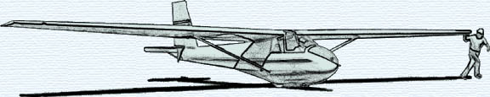

THE JUNE 2008 KSA MEETING

IS
SATURDAY, JUNE 14, 2008

AN INFORMAL MEETING AND
COOKOUT AT SUNFLOWER AFTER FLYING

BRING WHAT YOU WANT TO EAT AND TO SHARE
(INCLUDING FAVORITE STORIES)
FIRE WILL LIGHT ABOUT SEVEN

