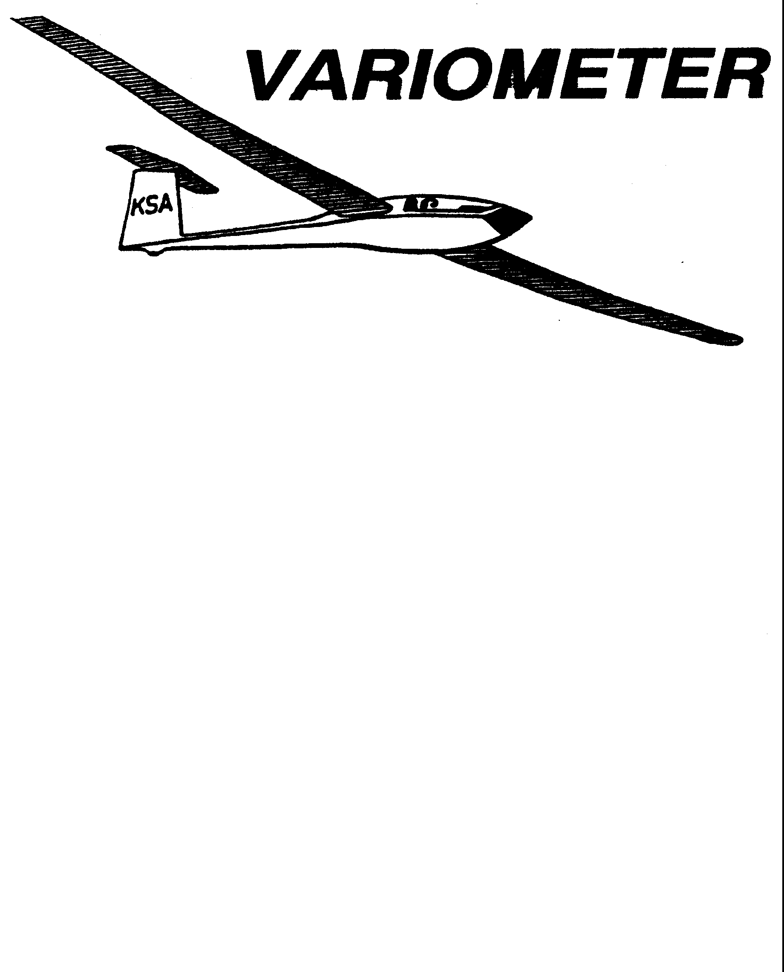

PRESIDENT – K. C. ALEXANDER (2007-2008)
SECRETARY - TREASURER – NEALE EILER (2007-2008)
VICE PRESIDENT EAST – RAY GIRARDO (2007-2008)
VICE PRESIDENT WEST – ED NEIDERT (2007-2008)
TOW PLANE MANAGER – STEVE LEONARD (2007-2008)
DIRECTORS: BERNIE MOHR (PAST PRESIDENT)

NEAL PFEIFFER(2007-2008)
DAVE WILKUS (2007-2008) PUBLISHED TO RECORD
ANDREW PETERS (2008-2009) THE UPS AND DOWNS
FRANK O’DONNELL (2008-2009) OF THE RAY SHARP -EDITOR
KANSAS SOARING ASSOCIATION

JULY, 2008

From the Pres

The runway at Sunflower is in better shape right now than it has been since the early eighties when I started flying there. All of the buckles and bumps have been ground off. All of the small trees and bushes along the West side of the runway have been cut down. The runway has been sprayed for weeds. The new power sweeper is allowing us to keep the chat, sand and dirt on the runway under control. The biggest improvement has been the coating of a five thousand foot long by sixty foot wide area with a high quality petroleum based coating which should prevent surface erosion for years. Come out and try the new and improved facility. Rumor has it that the new dark black coating on the runway is helping to generate one heck of a “house thermal” directly over the field. Remember to use the operation rules we established two years ago when we first applied a runway coating. Skid equipped gliders such as the 2-22 and 2-33 are not to take-off or land on the coated area. Take-offs for these gliders work well from the East side of the coated area, with landings on the West side. Immediately after landing get out of the glider and push it across the coated area before you fill out any paper work or debrief the flight. The area West of the coating must be kept open at all times for landing traffic.
Gliders without skids may land and takeoff from the coated area.
Other items still to be done include spraying all of the ramp and taxi ways for weeds, filling in some of the remaining holes on the edge of the runway, and overhauling the doors on the old hanger.

Kansas Kowbell Klassic
July 19, 2008

Only one week left until the forty-sixth running of the Kansas Kowbell Klassic. K.C. Alexander will be going for his third consecutive win to permanently claim the trophy, something that has never been done. Up to this point five different pilots have won back to back Kowbells: Bob Leonard in 66-67, Steve Doak in 74-75, Bob Park in 98-99, Steve Leonard in 00-01 and K.C. Alexander in 06-07. Launch is normally around noon so show up early if you want to see the kontestants head out on course to who knows where. Crew positions are usually available for those willing to help out. Don’t plan on making it home before midnight.

2008 WSA INSTRUCTOR SCHEDULE AT SUNFLOWER
GLIDERPORT, JULY--13 SEPTEMBER
(All Saturdays)

5 July- Andrew 9 August - Brian Bird
12 July-Brian 16 August- Mike
19 July – Mike 23 August- Frank
26 July- Frank 30 August- Andrew
2 Aug.- Andrew 6 Sept.- Brian
13 Sept.- Mike

Substitutes: Mark Schlegel, Aaron Martin

WSA DUTY-INSTRUCTOR GROUND RULES (2008)

Every Saturday, 31 may-13 Sept. (16 days)

Duty day: Noon to 5 PM (nominal)

Instructor will supervise as necessary moving the 2-33/22 from the hanger by the student(s) .

Instructor is released if no students arrive by 1 PM.

Instructor presence doesn’t confer glider usage priority.

Instructor arranges own subs, by swaps or calling Mark or Aaron.

If the instructor believes the weather is unsuitable for training he will call the towpilot and a line manager.

Being assigned as duty-instructor does not imply that any instructor is unwelcome on any day, nor does it imply any special authority or responsibility for operations.

Instructors are encouraged to advise the following instructor of student progress and needs.

Students are always encouraged to call instructors before proceeding to Sunflower.

TOWPILOT SCHEDULE 2008

DATE | DAY | NAME | PHONE NUMBER
JULY 4 | FRI | Bernie Mohr | 316-733-4524
5 | SAT | Bob Hall | 620-663-9577
6 | SUN | Richard Kirkland | 316-682-7814
12 | SAT | Ben Sorenson | 316-655-0257
13 | SUN | Frank O’Donnell | 316-788-3224
19 | SAT | Charles Pate (Kowbell) | 316-685-5695
20 | SUN | Mark Schlegel | 316-680-3263
26 | SAT | Brian Bird | 620-422-3875
27 | SUN | K.C. Alexander | 316-943-7641
AUG 2 | SAT | Aaron Martin | 316-776-2287
3 | SUN | Bob Hall | 620-663-9577
9 | SAT | Andrew Peters | 316-682-4287
10 | SUN | Richard Kirkland | 316-682-7814
16 | SAT | Pat Ensign | 816-835-6580
17 | SUN | Jack Seltman | 316-636-4218
23 | SAT | Ben Sorensen | 316-655-0257
24 | SUN | Dennis Brown | 316-722-8351
30 | SAT | K.C. Alexander | 316-943-7641
31 | SUN | Frank O’Donnell | 316-788-3224
SEPT 1 | MON | Bob Hall | 620-663-9577
6 | SAT | Bernie Mohr | 316-733-4524
7 | SUN | Jack Seltman | 316-636-4218
13 | SAT | Andrew Peters | 316-682-4287
14 | SUN | Bob Holliday | 316-733-5403
20 | SAT | Ben Sorensen | 316-655-0257
21 | SUN | Aaron Martin | 316-776-2287
27 | SAT | Mark Schlegel | 316-680-3263
28 | SUN | Dennis Brown | 316-722-8351

CARING FOR OUR TOWPLANE
Steve Leonard
KSA Towplane Manager

Since we seem to be getting a few more different people flying the towplane, and some that fly towplanes at other sites, I thought it might bee good to go over some things about our C-182 and our site. I am taking most of this from some notes I have from Bob Park that date back to 1981.

Before Flight: Oil level should be kept between 8 and 10 quarts, measured with the nose strut in a “normal” position (not fully extended). If it is below 9 at the start of the day, add one quart. If we go over 10, the oil temp runs higher, and we blow that oil onto the belly. Please do not overfill her!

Getting in and out: Best done through the right hand door. The latch and lock for the left door are in an awkward position. The door will close and latch with a gentle pull. Please do not be slamming it, as this will only break things.

Starting: If properly primed and readied for starting, she should start in just a few blades. If the motor turns a bit then stops, of course, release the start button and try again. If it won’t go through after three tries, turn everything off, get out, pull the prop past that compression and try again. Sometimes, inertia is needed to help get past a cylinder.

Taxiing: The airplane moves around very easily on pavement. You don’t have to advance the throttle much above idle to get her moving.

Run-up: Please do this pointed into the wind, away from any planes or people, and on the new blacktop surface. This are is free of rocks and other things that like to nick our prop.

Start of takeoff: Again, as with taxiing, it doesn’t take much throttle to make the plane taxi. Get it started, then bring the throttle back for taking up slack. When you are given the signal to go, look down the runway, and advance the throttle from idle to full in about 3 seconds. Maybe a bit slower if you at launching of the nose draggers. Don’t slam the throttle to the firewall, and don’t dawdle around. If the glider pilot has requested under 70 MPH, use one notch of flap for the entire tow. If the glider pilot has requested 70 MPH or higher, your choice as to using flap on takeoff, but once in the air (say, above 500 feet), flaps can be set to zero. All the way up on tow, the throttle, mixture, and prop controls should be full forward. For those of us that have been around a while, we can often tell if something is not set right on takeoff. We can tell if the towplane is happy or not!

Once the glider has released: If the flaps were down, get them up. Gradually reduce throttle and engine RPM to mid-green and descend using airpseed. The goal here is to not shock cool the engine. And the way we have found to not shock cool the engine is to GRADUALLY reduce the power. If you come back quickly, even if the airspeed is low, cylinders will crack and nobody will be happy. Airspeed of 110 to 120 MPH should net you about a 500 ft/min descent at mid to low green arcs on the throttle (manifold pressure) and RPM (prop control) A bit more speed won’t hurt, but we like you to stay in the green arc. Once down to about 1500 feet (assuming the glider stayed on to 2000), you can bring the throttle and RPM down to the bottom of the green. As you get closer to pattern entry, you can reduce the throttle a bit more. If you use the carb heat during the descent, consider also leaning just a bit (Maybe a third to half of what it took to get to peak RPM during your run-up. Did you check the mixture during your run-up?), as the carb heat makes the engine run rich, and this can foul the plugs. It is best for the engine to make the final throttle reduction about the time you are turning downwind to base leg.

Pattern: Please fly your pattern high and outside where the gliders will likely be. This will give you visibility into the traffic pattern. If you were carrying extra airspeed and throttle in getting to the pattern, don’t forget this plane has an 80 MPH airspeed limit with any flap. Be sure to slow down appropriately before lowering the flaps. Base leg or once wings level on final is a good time to do this. Also, fly your pattern such that if the engine should for some reason die, you can glide back to and land on the runway. The entire descent is a matter of Energy Management. Gradual throttle reductions to keep the engine from cooling to quickly, and airspeed and flight path management will get you around and ready for the next tow. And remember: There are those of us that can tell if the towplane is not happy when it is being flown!

Landing: If we are operating to the south, there is roughly 2800 feet of runway between the approach end and the first glider to be towed. Please plan your pattern so you don’t have to use the brakes. Also be aware of the electric fence along the east side of the runway. And oh yes, the trees at the north end. Fly your approach so as to not drag the rope through either of these obstructions.

Getting the next tow: The tanks hold about 50 gallons. If we are operating efficiently (glider pilots are all ready to go when the towplane arrives, everyone gets off at or below 2000 feet and we don’t have people hanging on to 2500 feet), the towplane will burn between one and one and a half gallons of gas per tow. So, if the tanks were full when you started, there should be enough for at least 25 tows before you need to get gas. Keep an eye on the fuel gauges, and if one gets down to about ¼, that is a good time to stop and fill ‘er up. And don’t’ be surprised when they don’t come down evenly. DO NOT switch from the BOTH setting to try and burn from the fuller tank. Let the line manager know when you will need to stop for gas, or if you need to take a break. The last thing we want to do is have you get sick when flying the towplane. For those that haven’t done it, it is hot, tiring, hard work. Especially when we get busy.

Before you start the next takeoff, make sure the carb heat is off, prop control is all the way forward, and mixture is full rich. Set flaps as desired, take a drink of water, and here we go again.

Remember, these are just guidelines. Use your judgement as to how to fly, and don’t do anything that makes you uncomfortable. I hope I have not mis-spoken too badly on the engine management. If I have, I will certainly post a correction and put it in the towplane! Thanks for your help in allowing us all to do what we enjoy doing!

 |  | LAUNCH LINE MANAGER SCHEDULE
Date | Name | Phone Number | I | Date | Name | Phone Number
JULY |  |  |  | AUGUST
5 | John Peters | 620-367-3711 |  | 2 | Everette Gould | 620-662-0838
 | Jacob Duerksen | 283-5430 |  |  | Gary Trimpe | 620-656-7381
6 | Ashok Chathbai | 516-9581 |  | 3 | Ashok Chathbai | 516-9581
 | Doug Wilson | 733-5537 |  |  | Jacob Duerksen | 283-5430
12 | Brad Sharp | 684-1986 |  | 9 | Brad Sharp | 684-1986
 | John Bird | 620-728-1341 |  |  | Steve Carlson | 21 0-414-3809
13 | Neal Pfieffer | 686-4306 |  | 10 | Neale Eyler | 729-0659
 |  |  |  |  | Christian Maude | 620-532-3608
19 | Bryan Pate | 524-8829 |  | 16 | John Bird | 620-728-1341
 | Linda Pate | 524-8829 |  |  | Aaron Waters | 755-0571
20 | Eathan Beale | 650-7547 |  | 17 | Bob Blanton | 683-9759
 | Ray Girardo | 942-0638 |  |  | Ray Girardo | 942-0638
26 | Rich Stone | 612-2008 |  | 23 | Dakota Harms | 282-6000
 | Jerry Boone | 620-662-5330 |  |  | Michael Harrington 652-9287
27 | Harry Clayton | 744-2389 |  | 24 | John Bender | 816-296-7453
 | Christian Maude | 620-532-3608 |  |  | Christain Maude | 620-532-3608
 |  |  |  | 30 | Dave Woody | 682-1895
 |  |  |  |  | Eathan Beale | 650-7547
 |  |  |  | 31 | Harry Clayton | 744-2389
 |  |  |  |  | Darren Liby | 620-665-0035
WSA NEWS
Rich Stone
WSA President
Greetings,
Here is some GOOD news for all the WSA members, THE KA-6 IS NOW IN A HANGER!
Weather was finally conducive enough to assemble and put it in the new hanger. This may not be its permanent home as there are others who have reserve spots for their gliders but have not yet taken possession of said spots. If you come with the intention to fly it and it is not behind the
Grob, then it is either already out or we've had to move it to the old hanger. Let me define behind, the Ka-6 goes into the hanger first followed by the Grob and then the Tow plane. Please do not try to change the order around. When you take it out of the hanger, be very attentive to the wing tips of all planes as they can easily be dinged on support columns or other equipment. If you end up putting the Grob back in the hanger at the end of the day please put the metal barriers around all the three of the wheels to keep the mice out.
Some more GOOD news is that students may now get checked out to fly it (Ka-6). I've included the requirements with this note so if Ray can get them in everyone will have a copy. Students, as you will read, this isn't an easy checkout, it requires time, effort and initiative on your part to get with the people to accomplish each of the tasks. A WSA instructor is not going to walk up to you and say "Would you like to start working on your K6 check, let's look at your log and see if we can?" You will need to seek them out.
Licensed pilots who have not checked out in the Ka6, we are working on the "new" rules and should have them in the 2nd quarter billing notices.
For those of you who are private glider rated and checked out in the Ka-6 here's the bad news; the trailer for the glider is not in real good shape. Before you think about taking it cross country where you will or may need to trailer it please get in touch we me (316) 371-2850 so I can inform you of the problems, and make sure you do a thorough inspection of the trailer before hand. There are some real rotten pieces of ply wood and the floor has started to sag behind the leaf spring attachment points.
The assigned instructor program initiated by Frank O'Donnell is working quite well. For those who don't know, most Saturdays there is an assigned instructor at the field to ply his/her trade. Over the last three Saturdays the students have been keeping them busy. Don't hesitate to continue to call the instructors, if you have some needs, to make sure one will be there and so they know you’re coming and what you need to do.
Just a little reminder and clarity of the WSA flying rules:
Plan your base turn no lower than 300 feet Roll out on final wings level at 200 feet AGL
And when others are waiting to fly the club gliders, flights will be limited to 1.5 hours.
Oh, and the question was ask of me this past Saturday if students have priority in the two place trainers? The answer is no, every person desiring to fly any of the club ships has the same priority. Courtesies go a long way!
Good Soaring and
Let all be safe out there!

Rich Stone
WSA President

KA-6 RULES FOR STUDENT PILOT CHECK OUT

These rules do not supersede any other part of the Wichita Soaring
Associations Hand Book except as pertaining to flight in the Ka-6

For a Student Glider Pilot to fly the WSA Ka-6 they must have a WSA
instructor endorsement for the Ka-6 in their log book. To receive that
endorsement they must:

1. Successfully complete 10 solo flights in either of the WSA trainers with at least 4 in each of the training gliders.
Student Glider Pilots who hold a powered rating require 6 solo flights in either of the WSA trainers with at least 2 in each trainer.
2. Fly a minimum of 3 flights with an instructor or highly experienced pilot in the KSA Grob. The student must ultimately demonstrate the ability to control the glider from takeoff to landing without assistance from the Safety Pilot. An instructor must fly the sign-off ride in the Grob.
* These flights are to "transition" the student to a different flyingsailplane yet still have someone of experience watching over them and to get the feel of takeoff and landing in a tail wheeled glider versus the trainers nose skid. The Ka-6 does not have a nose skid. These flights in No Way
authorize the student to fly the KSA Grob Solo.
3. Receive a "Normal" ground checkout in the Ka-6 from an instructor qualified to fly the Ka-6.
4. The first three flights will be directly observed by a WSA instructor. The first will be a pattern tow and the second two will be no longer than 30 mins. If the instructor is satisfied with the student's
ability he/she will then endorse the students log book for unrestricted solo flights in the Ka-6.

Students Pilots are not allowed to take the Ka-6 off station for flight and are not authorized to fly it cross-country. If the Ka-6 is taken off station by another member of WSA authorized to do so, a student with the appropriate endorsement may only fly the glider at the out station if a WSA instructor is present and available to supervise the solo flight, the same as if he were at Sunflower.
If the Ka-6 is in its trailer on the field at Sunflower, only persons who have been checked out in assembly and disassembly are authorized to assemble the glider. Students are encouraged to learn how to do this at the earliest opportunity.

KSA VARIOMETER
1950 S WEBB ROAD #112
WICHITA, KS 67207
rayandginisharp@juno.com

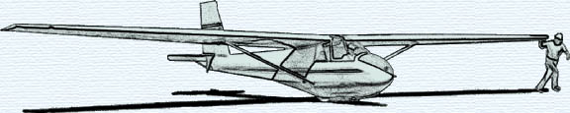

THE JULY 2008 KSA MEETING

IS
SATURDAY, JULY 12, 2008 @ 6PM

A COOKOUT AT SUNFLOWER
AFTER A DAY OF FLYING

BRING GOODIES TO COOK AND SHARE

