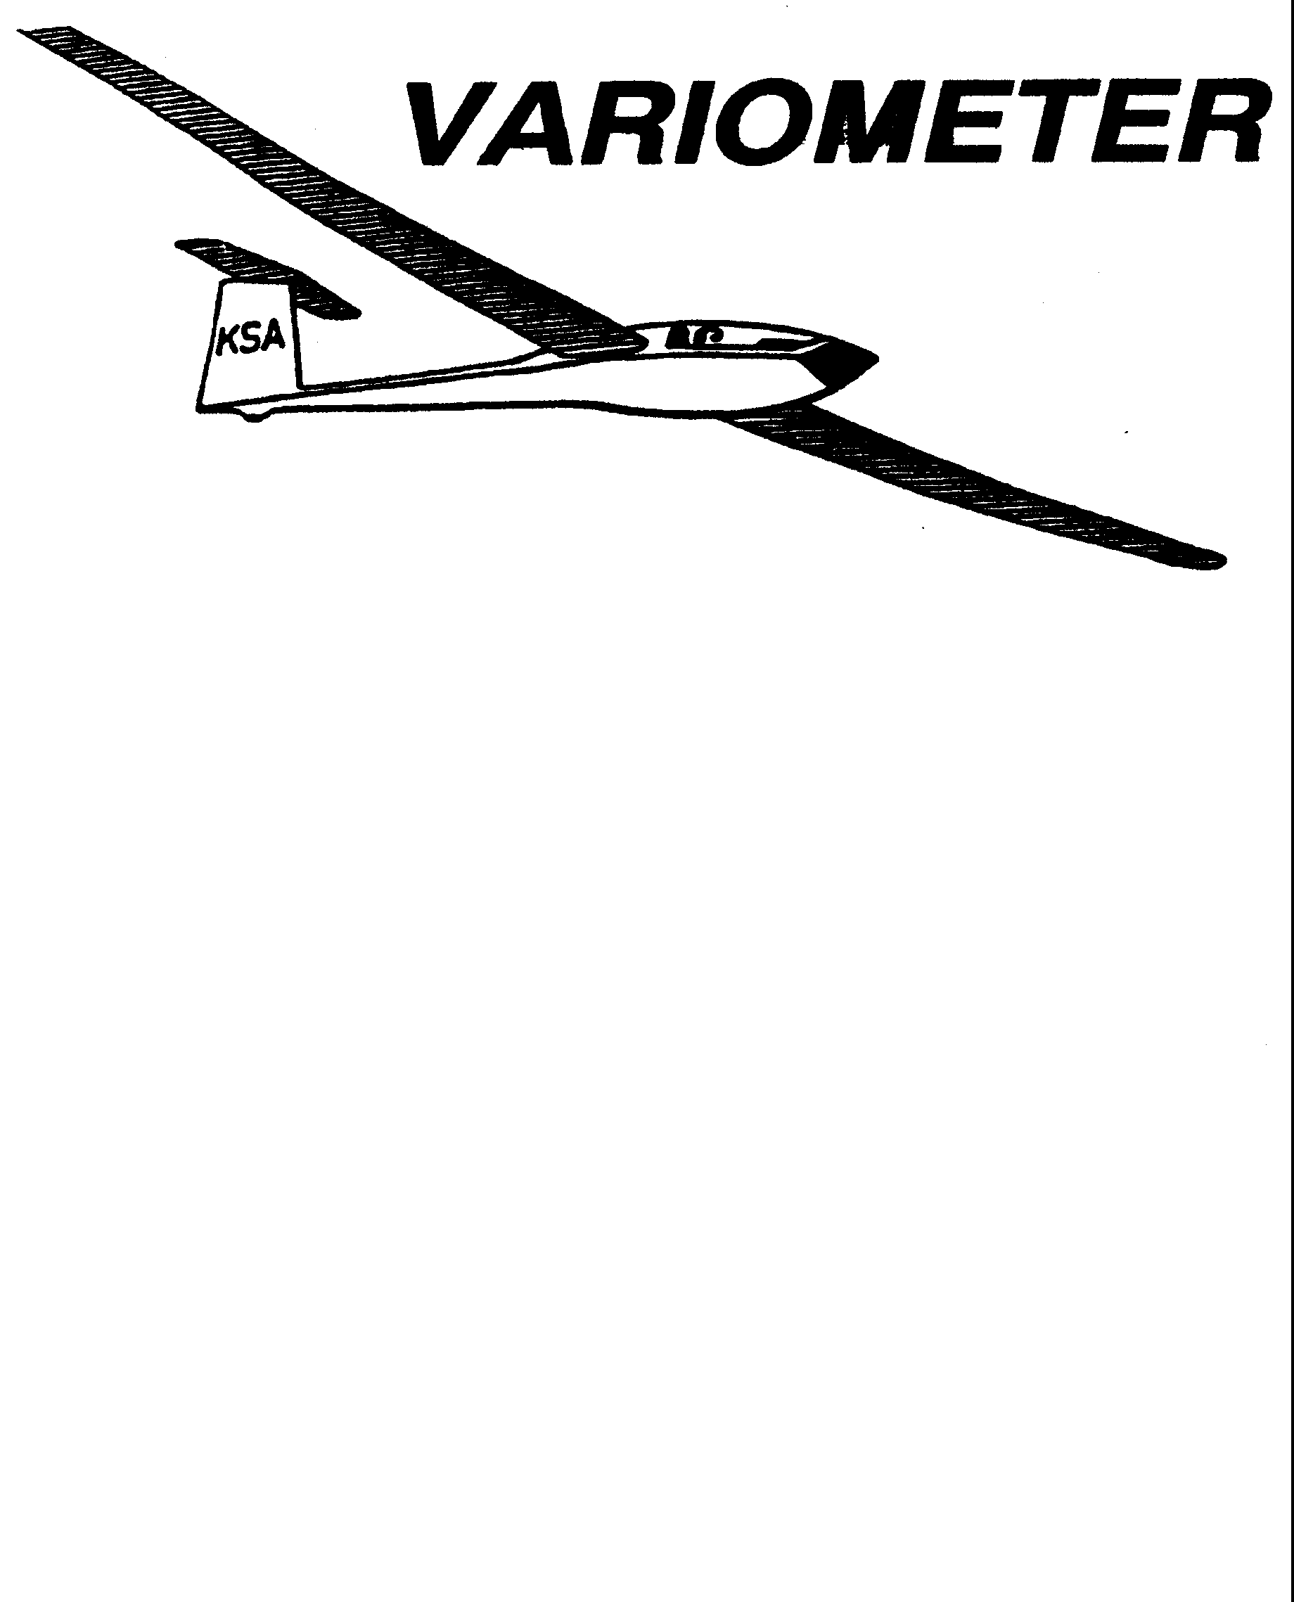

PRESIDENT – K. C. ALEXANDER (2007-2008)
SECRETARY - TREASURER – NEALE EILER (2007-2008)
VICE PRESIDENT EAST – RAY GIRARDO (2007-2008)
VICE PRESIDENT WEST – ED NEIDERT (2007-2008)
TOW PLANE MANAGER – STEVE LEONARD (2007-2008)
DIRECTORS: BERNIE MOHR (PAST PRESIDENT)

NEAL PFEIFFER(2007-2008)
DAVE WILKUS (2007-2008) PUBLISHED TO RECORD
ANDREW PETERS (2008-2009) THE UPS AND DOWNS
FRANK O’DONNELL (2008-2009) OF THE RAY SHARP -EDITOR
KANSAS SOARING ASSOCIATION

AUGUST, 2008

Kansas Kowbell Report

Wet ground, wind, and a cirrus overcast combined to make this the worst Kowbell in recent memory. Neal Pheiffer was the first to launch in his Ka-6. Neal managed to make it almost to Haven before encountering terra firma, for about six miles. K.C. Alexander launched next in his Pik-20. After struggling to stay up and not drift too far down wind for thirty minutes, he landed back at Sunflower to wait for things to improve. But things never did improve. They actually got worse. The next couple of contestants to launch almost beat the towplane back. There was talk of going home and letting Neal win. A few others discussed doing a dead glide downwind from release and landing at the Hutchinson airport. Bob Holliday decided to do the glide to the Hutchinson airport in his Ventus 2. This gave Bob 9.7 miles. Several other contestants considered duplicating Bob’s flight to Hutchinson to tie him. According to the rules all ties will be settled by Indian Wrestling, and several of the kontestants thought they could easily take Bob in a wrestling match. In the end everyone decided to just put up the gliders and just go home since it wasn’t a soarable day. Kongratulations to Bob for first place and Neal for second place.

The weather on Sunday for the Kowbell Konsolation was soarable but not much better.
Steve Leonard was the only kontestant able to complete his task. Steve won with a 71 mile flight to Kingman, Turon and return. Kongradulations Steve.

RANDOM NOTES
FROM THE TOWPLANE MANAGER.
Good news, Bad News, Good News. The good news is, the gas tank has been re-filled. The bad news is that it cost about $4.50 per gallon for 100LL fuel this year, and the last time I filled the tank, it was about $3.80 per gallon. The good news is that the increase in cost is still small enough that tow rates will remain as they are now, at $5 for a training rope break, $10 for a pattern tow, and $20 for a tow to 2000 feet. Just a reminder: We do not do 1500 or 2500 foot tows. If you request above 2000 feet (except for special circumstances, and normal training is NOT a special circumstance), you will not be pulled to above 2000 feet, and you will get waved off. We simply cannot afford the extra time it takes to haul you higher, and it is not very kind to any that may be waiting for the towplane to come back so they can go fly.

Glider pilots, and tow pilots, we can all do our part to help in keeping our costs from going up. I think all of our towpilots are doing a very good job of getting the gliders up and the towplane back in a safe, expeditious manner. Some of the gliderpilots could use a bit of a refresher. You really need to be getting strapped in when the glider in front of you is taking off. The towplane should NEVER have to wait for you to get ready. You have plenty of time to get strapped in, get your stuff situated, and go through your pre-flight checks, right up to hooking up the rope and closing the canopy before the towplane even gets back into the traffic pattern.

Line managers can also help out with the fuel consumption. With one person at the towplane, and one at the glider, we can stop the towplane such that there is minimal slack to be taken out before takeoff. The signaling system we have developed is to have the person at the towplane standing well in front of and off to the side of the towplane. Motion for the towplane to keep coming forward by holding your arms up, with your palms toward you, and move your hands towards and away from yourself, as if you are directing the plane towards you. Move to the side as required to see the line manager back at the glider.

Back at the glider, the line manager should stand out between the rope and the wing tip of the glider to be towed. When the rings are about 10 to 15 feet behind the glider to be towed, bend down. This is the signal for the line manager at the towplane to stop the towplane. Do this by stopping the motion of your arms, and turn your hands, palms towards the towplane. The line manager at the towplane must always keep the line manager at the glider in sight. Once the towplane has stopped, the towplane line manager can approach the towplane and hand over the tow ticket. It is also good to check on the towpilot, see if they need a drink, need a break, how the towplane is doing on gas, etc. My preferred approach is to walk towards the towplane outboard of the wingtip. Once at the tip, walk inboard, put a hand on the strut from behind the strut, and hand the ticket to the towpilot.

Once the glider is hooked up, we then use the standard signals that are used for taking up slack and taking off. It is good to have separate sets of signals, just as a reminder that we are positioning, and another set for when we are ready to start flying. For the signaling for takeoff, it is best to stand well in front of and to the side of the towplane. This way, the towpilot can be looking down the runway, and see you. If you try to stand right beside the towplane, this puts you in an awkward position for the towpilot to see your signals. Line managers, look around the pattern, and if you see a glider that might be a traffic conflict for the towpilot, point it out to the towpilot. If you point in the general direction, they can look there, see the plane, and will acknowledge seeing the traffic. Once in the air, the ahead visibility from the towplane is rather limited, so any help that can be given seems to be appreciated. Regardless of launch direction, the wing tip runner and towplane signaler must be on the same side of the planes. It is preferred that this signaling take place to the left of the airplanes. This is the side the towpilot is sitting on, and it seems to be better for their viewing to look slightly left of ahead. This is also the side with the mirror for them to be able to watch the glider on tow.

Parachute Packing

How many of you have not gotten your chutes packed yet? You know, the re-pack is only valid for 120 days, and to fly with a chute that is not current is a FAR Violation. Don Herbel has retired and moved to Oklahoma, but has turned over his businees to his good friend, Mark Follin. Mark can be reached at 945-3305, and at the Air Capito Drop Zone, at 776-1700. His address is 1957 North Gow. That is about 5 blocks east of West Street, north of the KAKE TV Studios. Mark charges $60 for a re-pack, and will do quick turns if needed.

COMBINATION DUTY SCHEDULE

Date | Towpilot | Instructor | Line Manager
August 2 | Aaron Martin  776-2287 | Andrew Peters  682-4287 | Everette Gould  620-662-0838  Gary Trimpe  620-656-7381
August 3 | Bob Hall  620-663-9577 |  | Ashok Chathbai  516-9581  Jacob Duerksen  283-5430
August 9 | Andrew Peters  682-4287 | Brian Bird  620-422-3875 | Brad Sharp  684-1986  Steve Carlson  210-414-3809
August 10 | Richard Kirkland  682-7814 |  | Neale Eyler  729-0659  Christian Maude  620-532-3608
August 16 | Pat Ensign  816-835-6580 | Mike Westemeir | John Bird  620-xxx-xxxx  Aaron Waters  755-0571
August 17 | Jack Seltman  636-4218 |  | Bob Blanton  683-9759  Ray Girardo  942-0638
August 23 | Ben Sorensen  665-0257 | Frank O’Donnell  788-322 | Dakota Harms  282-6000  Michael Harrington  652-9287
August 24 | Dennis Brown  722-8351 |  | John Bender  816-296-7453  Christian Maude  620-532-3608
August 30 | K.C. Alexander  943-7641 | Andrew Peters  682-4287 | Dave Woody  682-1895  Ethan Beale  650-7547
August 31 | Frank O’Donnell  788-3224 |  | Harry Clayton  744-2389  Darren Liby  620-665-0035
September 1 | Bob Hall  620-663-9577 |  | Looking for Volunteers!
September 6 | Bernie Mohr  733-4524 | Brian Bird  620-422-3875 | Bryan Pate  524-8829  Linda Pate  544-8829
September 7 | Jack Seltman  636-4128 |  | John Peters  620-367-3711  Ethan Beale  650-7547
September 13 | Ben Sorensen  655-0257 | Mike Westemeir | David Wilkus  788-0932  Michael Harrington  652-9287
September 14 | Bob Holliday  733-5403 |  | Bob Blanton  683-9759  John Bird  620-728-1341
September 20 | Andrew Peters  682-4287 |  | Dan Blair  838-1108  Dakota Harms  282-6000
September 21 | Aaron Martin  776-2287 |  | Steve Carlson  210-414-2809  Scott Dimick  733-5678
September 27 | Mark Schlegel  316-380-3263 |  | Rich Stone  612-2008  Jerry Boone  620-662-5330
September 28 | Dennis Brown  722-8351 |  | Steve Leonard  729-0356  Gary Trimpe  620-656-7381

KSA VARIOMETER
1950 S WEBB ROAD #112
WICHITA, KS 67207
rayandginisharp@juno.com

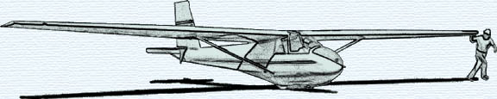

THE AUGUST 2008 KSA MEETING

IS
SATURDAY, AUGUST 9, 2008 @ 6PM

A COOKOUT AT SUNFLOWER
AFTER A DAY OF FLYING

BRING GOODIES TO COOK AND SHARE

