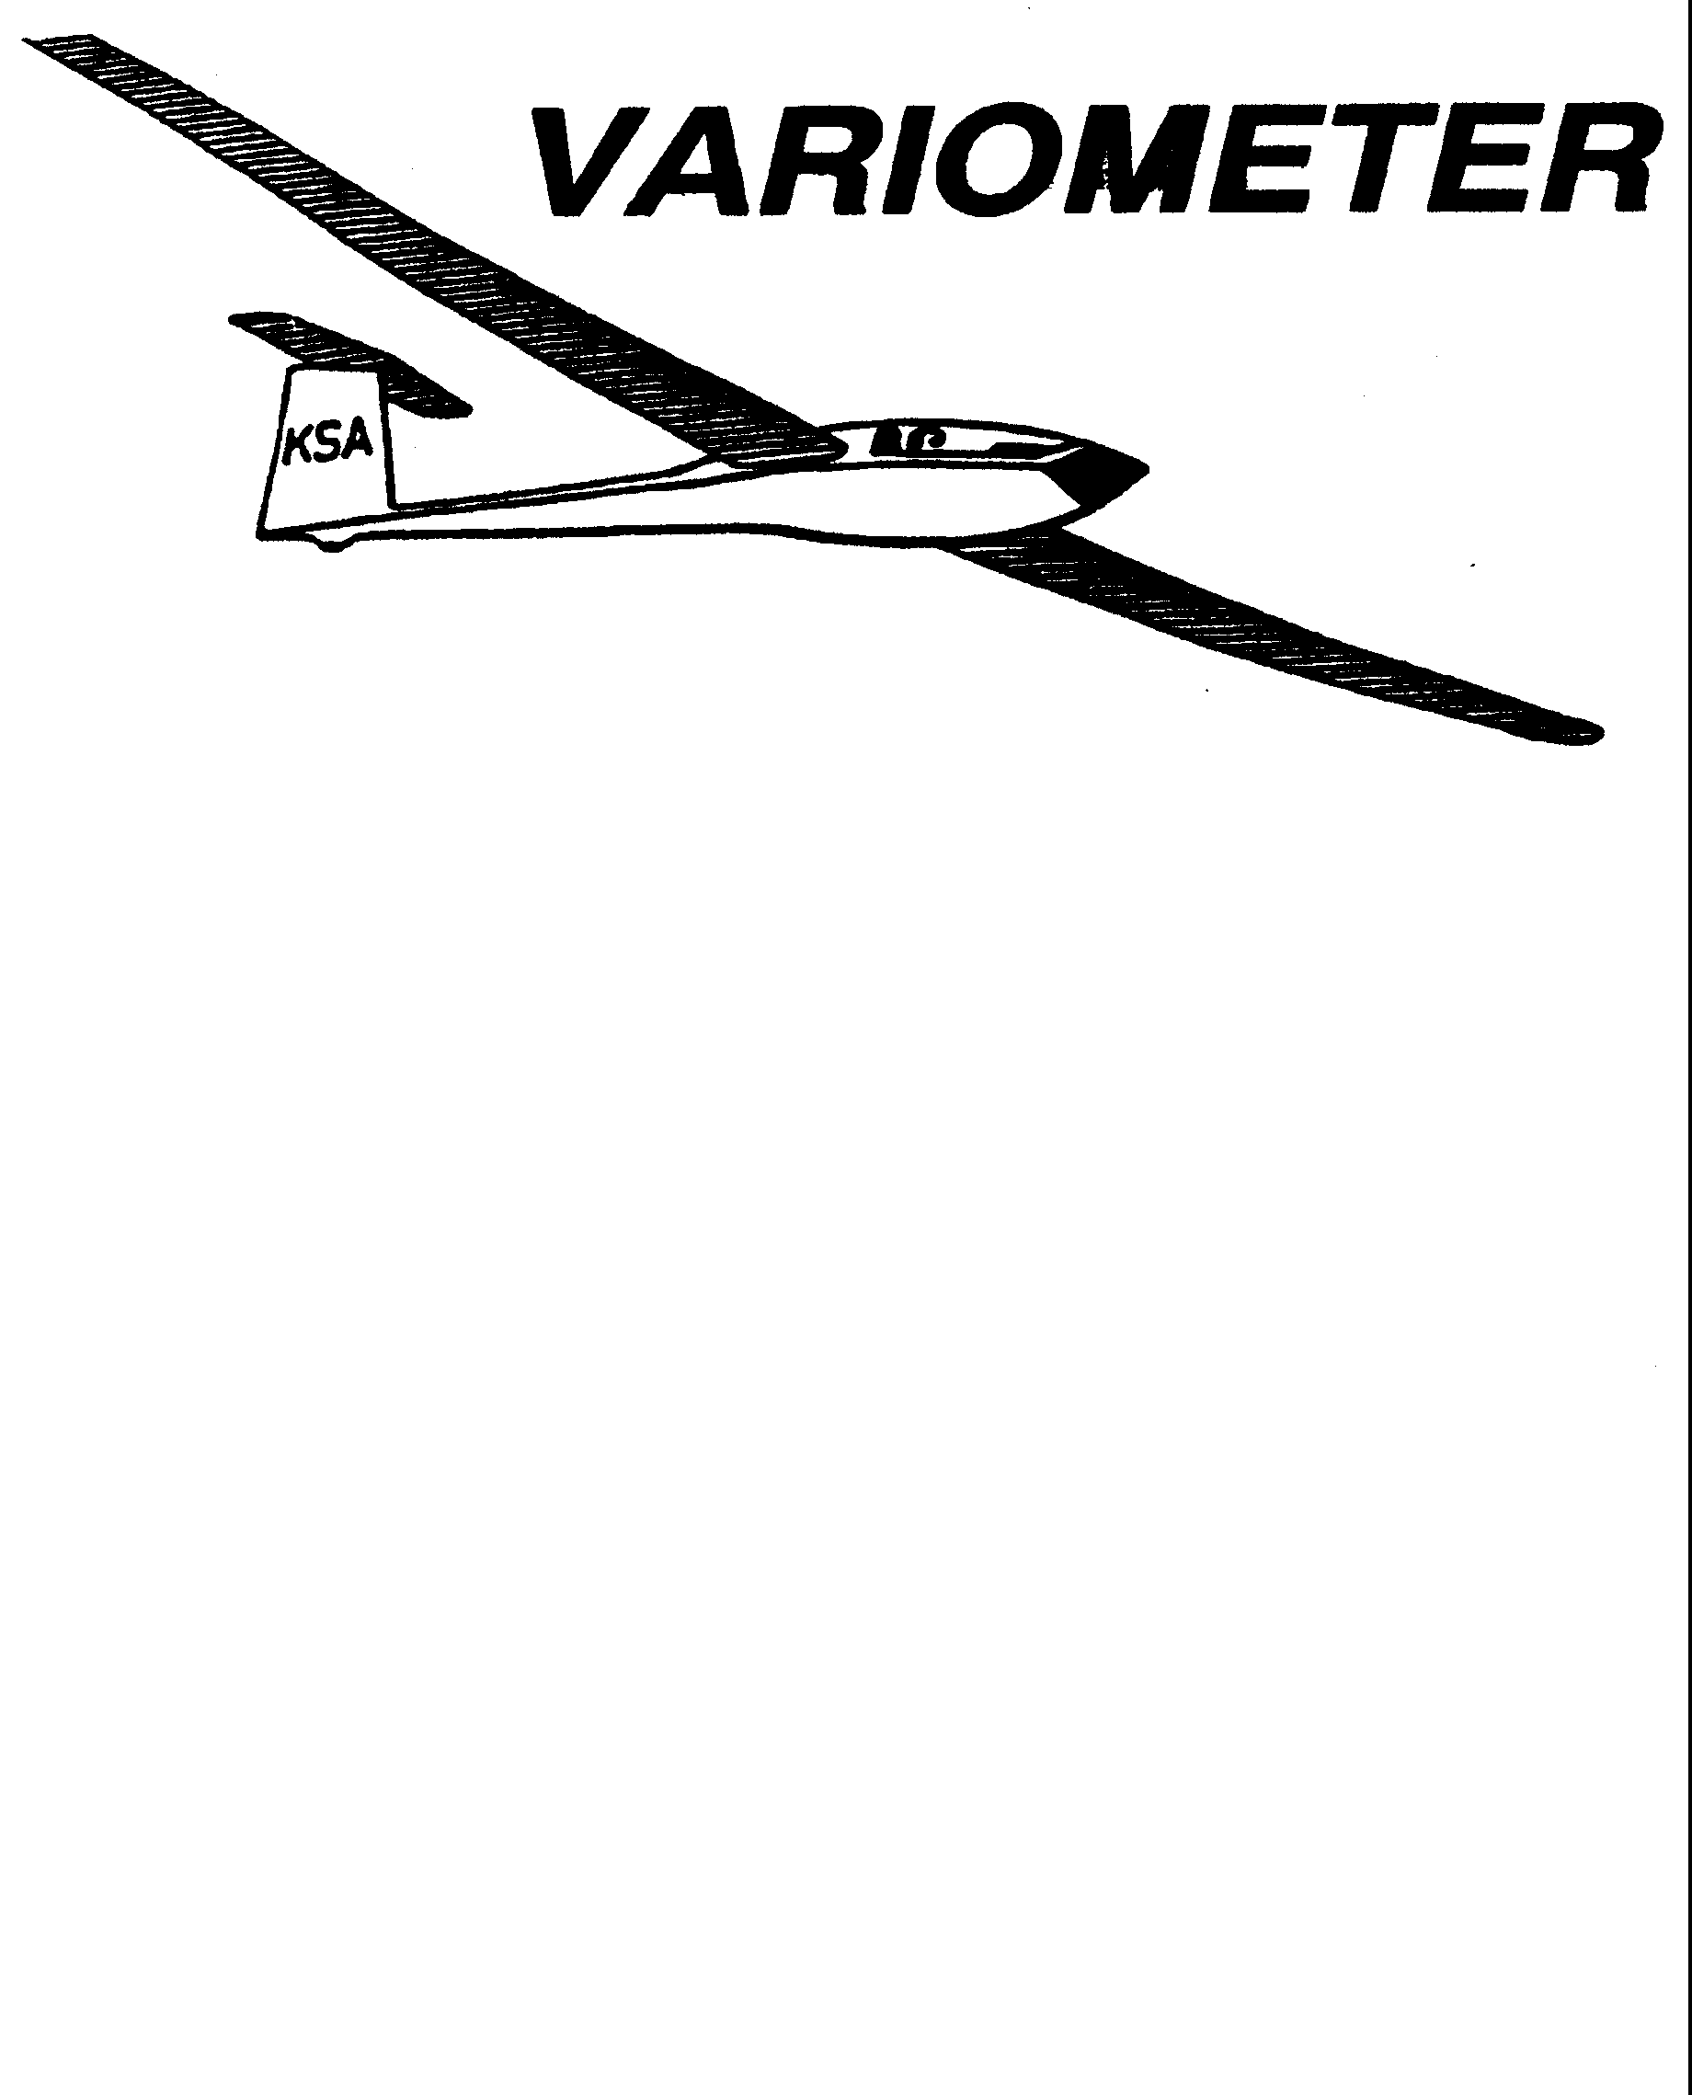

PRESIDENT – K. C. ALEXANDER (2007-2008)
SECRETARY - TREASURER – NEALE EILER (2007-2008)
VICE PRESIDENT EAST – RAY GIRARDO (2007-2008)
VICE PRESIDENT WEST – ED NEIDERT (2007-2008)
TOW PLANE MANAGER – STEVE LEONARD (2007-2008)
DIRECTORS: BERNIE MOHR (PAST PRESIDENT)

NEAL PFEIFFER(2007-2008)
DAVE WILKUS (2007-2008) PUBLISHED TO RECORD
ANDREW PETERS (2008-2009) THE UPS AND DOWNS
FRANK O’DONNELL (2008-2009) OF THE RAY SHARP -EDITOR
KANSAS SOARING ASSOCIATION

SEPTEMBER, 2008

From the Pres

There is an issue that we all need to think about and discuss. That issue is the exposure that we all have to lawsuits and liability as members of KSA, or any organization for that matter. Yes we have liability insurance on the towplane and twin Grob, but we have no insurance that covers the organization itself. There is also no insurance to my knowledge that covers Sunflower. If there was to be an incident at a KSA sponsored event which did not involve the towplane or the Grob we would have no coverage. Juries make some ridiculous awards these days, often for the wrong reasons. They may feel sorry for the injured person and feel that those rich airplane owners can afford it anyway, regardless of who was at fault. There are numerous legal precedence’s where organizations have lost lawsuits and the membership has had to pony up the dollars. Let’s put this in perspective with an example: If there was and incident and KSA lost the lawsuit and the plaintiff received a two million dollar award. KSA’s meager resources would most likely have been depleted by the legal defense, so the plaintiff’s attorneys would go after the assets of the clubs members to attain the two million dollars. With less than one-hundred members this means we would each owe over twenty-thousand dollars. Not a very pleasant thought is it. What can we do to prevent something like this from happening? One way would be to get some organization insurance. It would cost about $1,500 per year for KSA, or about $15 per member. The next question is how would we pay for this. One way would be to raise dues by that amount. Brainstorm on this topic and let myself or any of the Board of Directors know how you feel about this and if there are other alternatives we should be considering. One altenative would be to do nothing and keep rolling the dice. Some people are better gamblers than others.

Glider Drivers: Our good friend, Paul Fiebich, who was one of the many volunteers that made last weekend's Wichita Flight Festival at Jabara Airport happen, sent the below e-mail and three photos he had taken of the glider activity. I will add to Fiebich's appreciation to all of you who came and helped with the static display.
Harry Clayton and Susan Erlenwein, with their Standard Cirrus, were the mainstay of our sailplane representation at the Flight Festival. Harry Clayton and Paul Fiebich worked together to have our two sailplanes in, what I would say was, the key spot on the entire airport for maximum exposure of our gliders to those coming in the entrance gate to the Flight Festival. Our thanks to Harry for working this out. Harry and Susan were there all day Saturday and Sunday and had an excellent display of photos, pamphlets and contact information handouts of Glider Operations here in Kansas.
Saturday: Early Saturday morning, I towed CFI-G Dave Trousdale and his co-worker's pilot / father visiting from Texas in the Grob Acro from the Wichita Gliderport to Jabara. University students Erin Waggoner (ask her about her foot injury sometime) and John Bird, CFI-G's Dave McConeghey, Dave Trousdale and I helped with Grob G-103 cockpit check outs for the young and the older. Also helping at various times on Saturday, in talking to Festival Attendees, "working the crowds" handing out KSA, WSA and WSLSA information sheets and conducting cockpit show-and-tell in the WSLSA Grob Acro at the Sailplane Display area were: New Towpilot Gabe Morror; Student Glider pilots Kelly Jackson and Clay Speer; and Glider and Gliderport owner John McMaster. After the Saturday's events were over, Dave McConeghey towed in the 182D, John Bird crewed and I flew the Grob Acro back to the Gliderport with Gabe Morror on board.
Sunday : Shortly after 8 a.m. I launched from the Gliderport in the Grob Acro with Gabe Morror in the182D towplane. After my landing at Jabara, Paul Fiebich and a Festival volunteer helped me pull (see Paul's attached photo) the Grob to the Static Display area. Gabe Morrow returned the 182D to the Gliderport for some flying that was scheduled there later in the day and I went to Church. Several others were out Sunday to assist including Flight Safety Instructor in transition training to Glider pilot Charles Waters; towpilot Gabe Morrow and Diamant sailplane owner Dave Wilkus. After the Festival was over and the departing air traffic thinned out, Gabe Morrow went to get the towplane from the Gliderport and I found a willing Festival Attendee willing to fly with me in the Grob Acro back to the Gliderport.
Charles Pate, Wichita Kansas

2008 Wichita Flight Festival
By Susan Erlenwein

Harry and I took the Standard Cirrus to the festival again this year. We set up Friday night. This first involved finding anyone who knew where the pilot packets were kept and finding our location. Harry had asked for a location that would allow us to maneuver a trailer and give Charlie plenty of room for “taxiing” the Grob in. We were given a great location, the first planes in the static display in view of the entry gate. We had a lot of the public stop by Friday night and we handed out pamphlets to them. We have made a table display with pictures of the WSA sailplanes and other types of sailplanes to show the variety that is out there. Pictures also initiate good questions from the public. The air show Friday night was excellent. The aerobatic routines at dusk with the aircraft lights shining though the smoke were impressive.

Charlie Pate flew in the Sky Lark club’s Grob Saturday morning and set up next to the Cirrus. Then the rescue helicopter flew over us to land in front of our area. They gave us a few minutes of warning. Too bad the food vendor beside us had not been told to take his tent down. The helicopter did it for him. Aluminum poles should not be bent and twisted in that way.
Dave McConeghey, John Bird and Erin Waggoner helped a lot with the planes. Others from the various clubs also showed up and helped throughout the weekend. Charlie allowed kids to sit in the Grob, which was fun for them, but heavy lifting for those who hoisted the little bodies all day. Having an airplane that the kids can get in and “fly” while having pictures taken is a real crowd pleaser. There was a really good crowd at the air show on Saturday and we had a lot of interest in folks wanting to take rides or join one of the local clubs. Harry had made a multi-page handout on soaring and about how to join the local clubs. We only gave those to people who really wanted to join. We handed out 30 of those and then started taking emails to send more out.

Due to the weather forecast, we decided to put the Cirrus in the trailer Saturday night and Charlie took the Grob back to the Wichita Glider Port. He flew it back in Sunday morning and we reassembled the Cirrus. We had a nice pancake breakfast and a “show” in their food tent (tossing pancakes, jokes, etc. by the servers). All was nice until the rains hit. We waited it out in a covered area and then wiped down the planes. Charlie was not able to stay with the Grob Sunday morning, so we were a little short on help, but John Bird was able to get out and fill in until more help arrived. It was cooler on Sunday, which made it a little nicer to stand all day and greet the public. We again had a lot of interest in soaring.

We want to thank Charlie Pate and all of those who helped make this a great display. We think we introduced a lot of folks to the concept of soaring and helped dismiss some myths. This is a good venue to educate the public and obtain new members to the local soaring community.

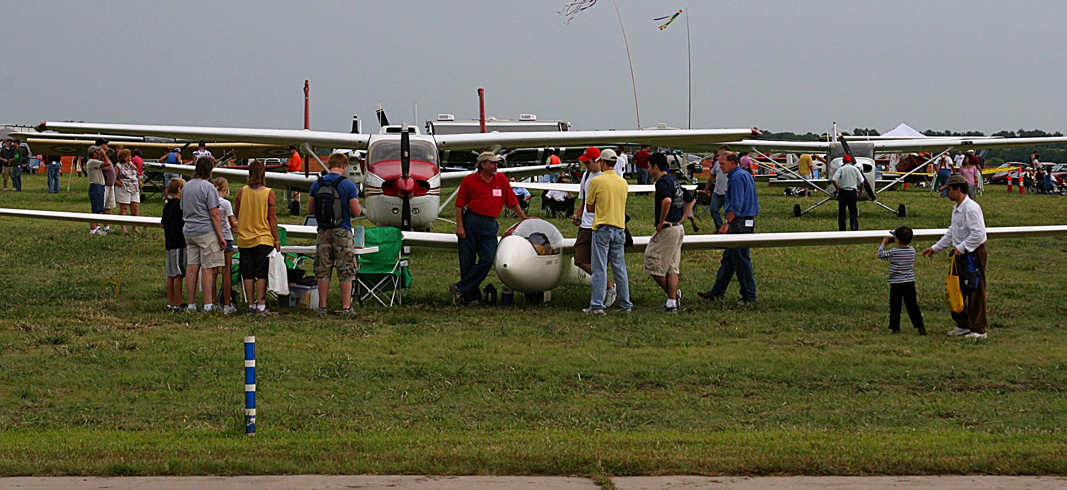

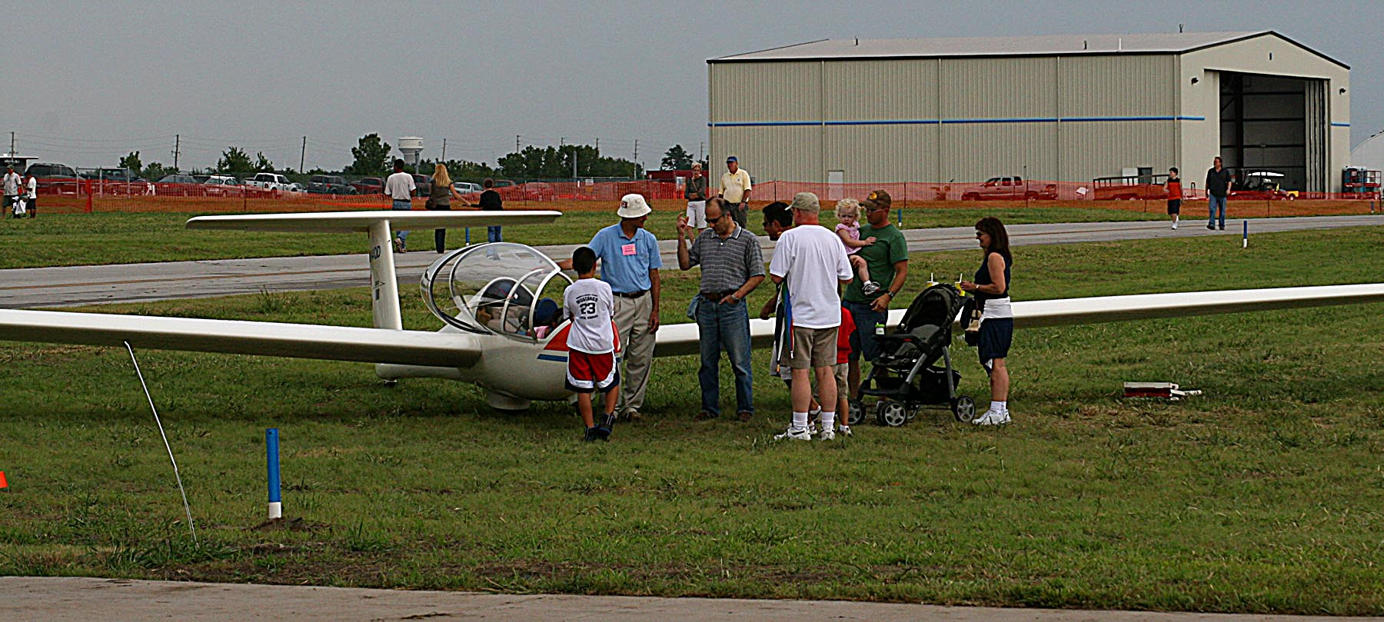

Barnaby Lecture

National Soaring Museum's 37th Annual Barnaby Lecture will be presented September 27th in Wichita at the Best Western Airport Inn. The speaker is Chip Garner, "The Evolution of Software in Soaring Instruments".
6PM Cash Bar/Reception
7PM Banquet
8PM Lecture

Tickets $45

For reservations, call NSM, 607-734-3128

See ad in August Soaring Magazine, p. 19.

Peter W. Smith
Director
National Soaring Museum
51 Soaring Hill Drive
Elmira, NY 14903
607-734-3128
Fax 607-732-6745
petersmith@soaringmuseum.org

Ed Note: This summer seems to have been more sore than soaring in Kansas. Conditions elsewhere have also not been exactly traditional. We spent most of two weeks at the Fifteen Meter / Open Class National contest at Uvalde, Texas (80 miles west/southwest of San Antonio, a thirteen hour drive from Wichita). Three out of ten scheduled contest days were cancelled, one of them because of actual rain. The assigned tasks for the seven contest days were all well over 200 miles, and over 300 five days for Open, and 2 days for Fifteen Meter. Steve Leonard represented KSA in Open, and Bob Holliday in Fifteen Meter. Both classes were hotly contested. Steve finished 12th of fifteen, with 6265 of a possible 7000 points, flying a 50:1 glider in a field dominated by 60;1 ships. (The winner scored 6941). Bob finished 24th of Thirty-five, with 5687 (the winner scored 6747), in a class of extremely skilled pilots from all over the country. Dave Leonard was second in the class (we like to claim him) with 6620 points.
KSA VARIOMETER
1950 S WEBB ROAD #112
WICHITA, KS 67207
rayandginisharp@juno.com

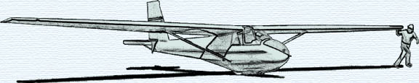

THE SEPTEMBER 2008 KSA MEETING

IS
SATURDAY, SEPTEMBER 13, 2008 @ 6:30 PM

A COOKOUT AT SUNFLOWER
AFTER A DAY OF FLYING

BRING GOODIES TO COOK AND SHARE

