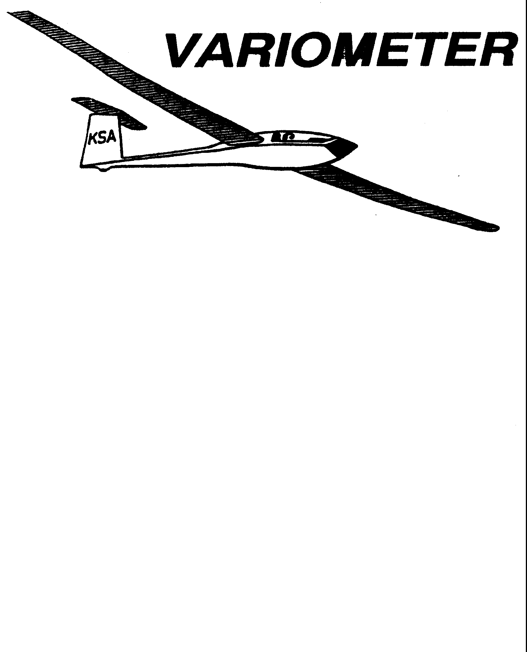

PRESIDENT – K. C. ALEXANDER (2007-2008)
SECRETARY - TREASURER – NEALE EILER (2007-2008)
VICE PRESIDENT EAST – RAY GIRARDO (2007-2008)
VICE PRESIDENT WEST – ED NEIDERT (2007-2008)
TOW PLANE MANAGER – STEVE LEONARD (2007-2008)
DIRECTORS: BERNIE MOHR (PAST PRESIDENT)

NEAL PFEIFFER(2007-2008)
DAVE WILKUS (2007-2008) PUBLISHED TO RECORD
ANDREW PETERS (2008-2009) THE UPS AND DOWNS
FRANK O’DONNELL (2008-2009) OF THE RAY SHARP -EDITOR
KANSAS SOARING ASSOCIATION

DECEMBER, 2008

From the Pres

This will be the last one of these articles you will see from me as president, at least for a few years. I am really ready for a break. The amount of work that goes on behind the scenes to keep this organization functioning is sometimes almost overwhelming. If you have not served as an officer, please consider volunteering to run for an office in the next election. We need your help! If it were not for people like Ray Sharp and Steve Leonard, who have held down two of the most demanding jobs in the club for over a decade without a break, this organization would not exist. A special thanks to not only Steve and Ray, but to all those who have given their time and effort as club officers, tow pilots, instructors, and workers to keep things going during my term.

GET YOUR REPORT OF MEMORABLE FLIGHTS IN TO K. C. ALEXANDER

2008 KSA AWARDS
INFORMATION SHEET

Pilot’s Name____________________________________ Date______________

AWARD | DATE  OF FLIGHT | SAILPLANE | SPECIFICS
Preying Mantis |  |  | (Nominate Someone)
Towing Operations |  |  | (Nominate Someone)
Club Maintenance |  |  | (Nominate Someone)
Wooden Wings |  |  | Distance Flown
Flying Horse Silver  (100 KM Speed Task) |  |  | Speed in MPH
Flying Horse Crystal  (200 KM Speed Task) |  |  | Speed in MPH
Flying Horse Gold  (300 KM Speed Task) |  |  | Speed in MPH
Charles Henning Memorial Award (two flights required) | Flight 1 Date  Flight 2 Date | Flight 1 Sailplane  Flight 2 Sailplane | Flight 1 Speed (and time)  Flight 2 Speed (and time)
Kansas Kowbell Klassic | Landing Location |  | Distance
Kansas Kowbell Klassic Konsolation | Pre-declared Task (must have been completed to count!) |  | Distance
Mamie Cup |  |  | Distance
Pilot of the Year by Handicap Score | Altitude  Duration  Speed*  Distance* |  | (feet)  (hours:minutes)  (MPH)  (Statute miles)
Rex Hamilton Memorial Award |  |  | (Nominate Someone)
Other Significant Accomplishments (First Solo, First soaring flight, FAI Badge Leg, completion of an FAI Badge, 100th flight, 1000th tow, etc.

Documentation required for all flights, per rules published in The Variometer.
*If you had disposable ballast on board at takeoff of the Speed or Distance flight for consideration, you must put a “B” next to your claimed speed or distance. This effects the handicap number used for evaluating you performance.

“I certify that all flight claims made above were launched in Kansas and are properly documented (does not apply to “Other Significant Accomplishments” category.

Signed__________________________________________

KANSAS SOARING ASSOCIATION

ANNUAL AWARDS BANQUET

SATURDAY, JANUARY 10, 2009
5:30 P.M. CONVERSATION
6:30 FOOD
WOODLAWN BAPTIST CHURCH FELLOWSHIP HALL

960 S Woodlawn

MENU:
Beef brisket, Potato casserole,
Fresh green tossed salad, Honey Muffins

Dessert
Hummingbird Cake, Chocolate Turtle Cake, Poppy Seed Cake
All for $11.00

Reservations Required by January 5 , 2009

Get reservations to Ray Sharp, preferably by email (address is in Variometer return)
Telephone acceptable
Bring check made out to KSA to Banquet

KSA VARIOMETER
1950 S WEBB ROAD #112
WICHITA, KS 67207
rayandginisharp@juno.com

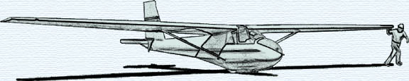

THE DECEMBER 2008 KSA MEETING
IS
SATURDAY, DECEMBER 13th @ 7:30PM

AT THE NIAR BUILDING
ON THE WICHITA STATE UNIVERSITY CAMPUS

PROGRAM: Christmas Fun Get Together
Bring some Christmas goodies to share

