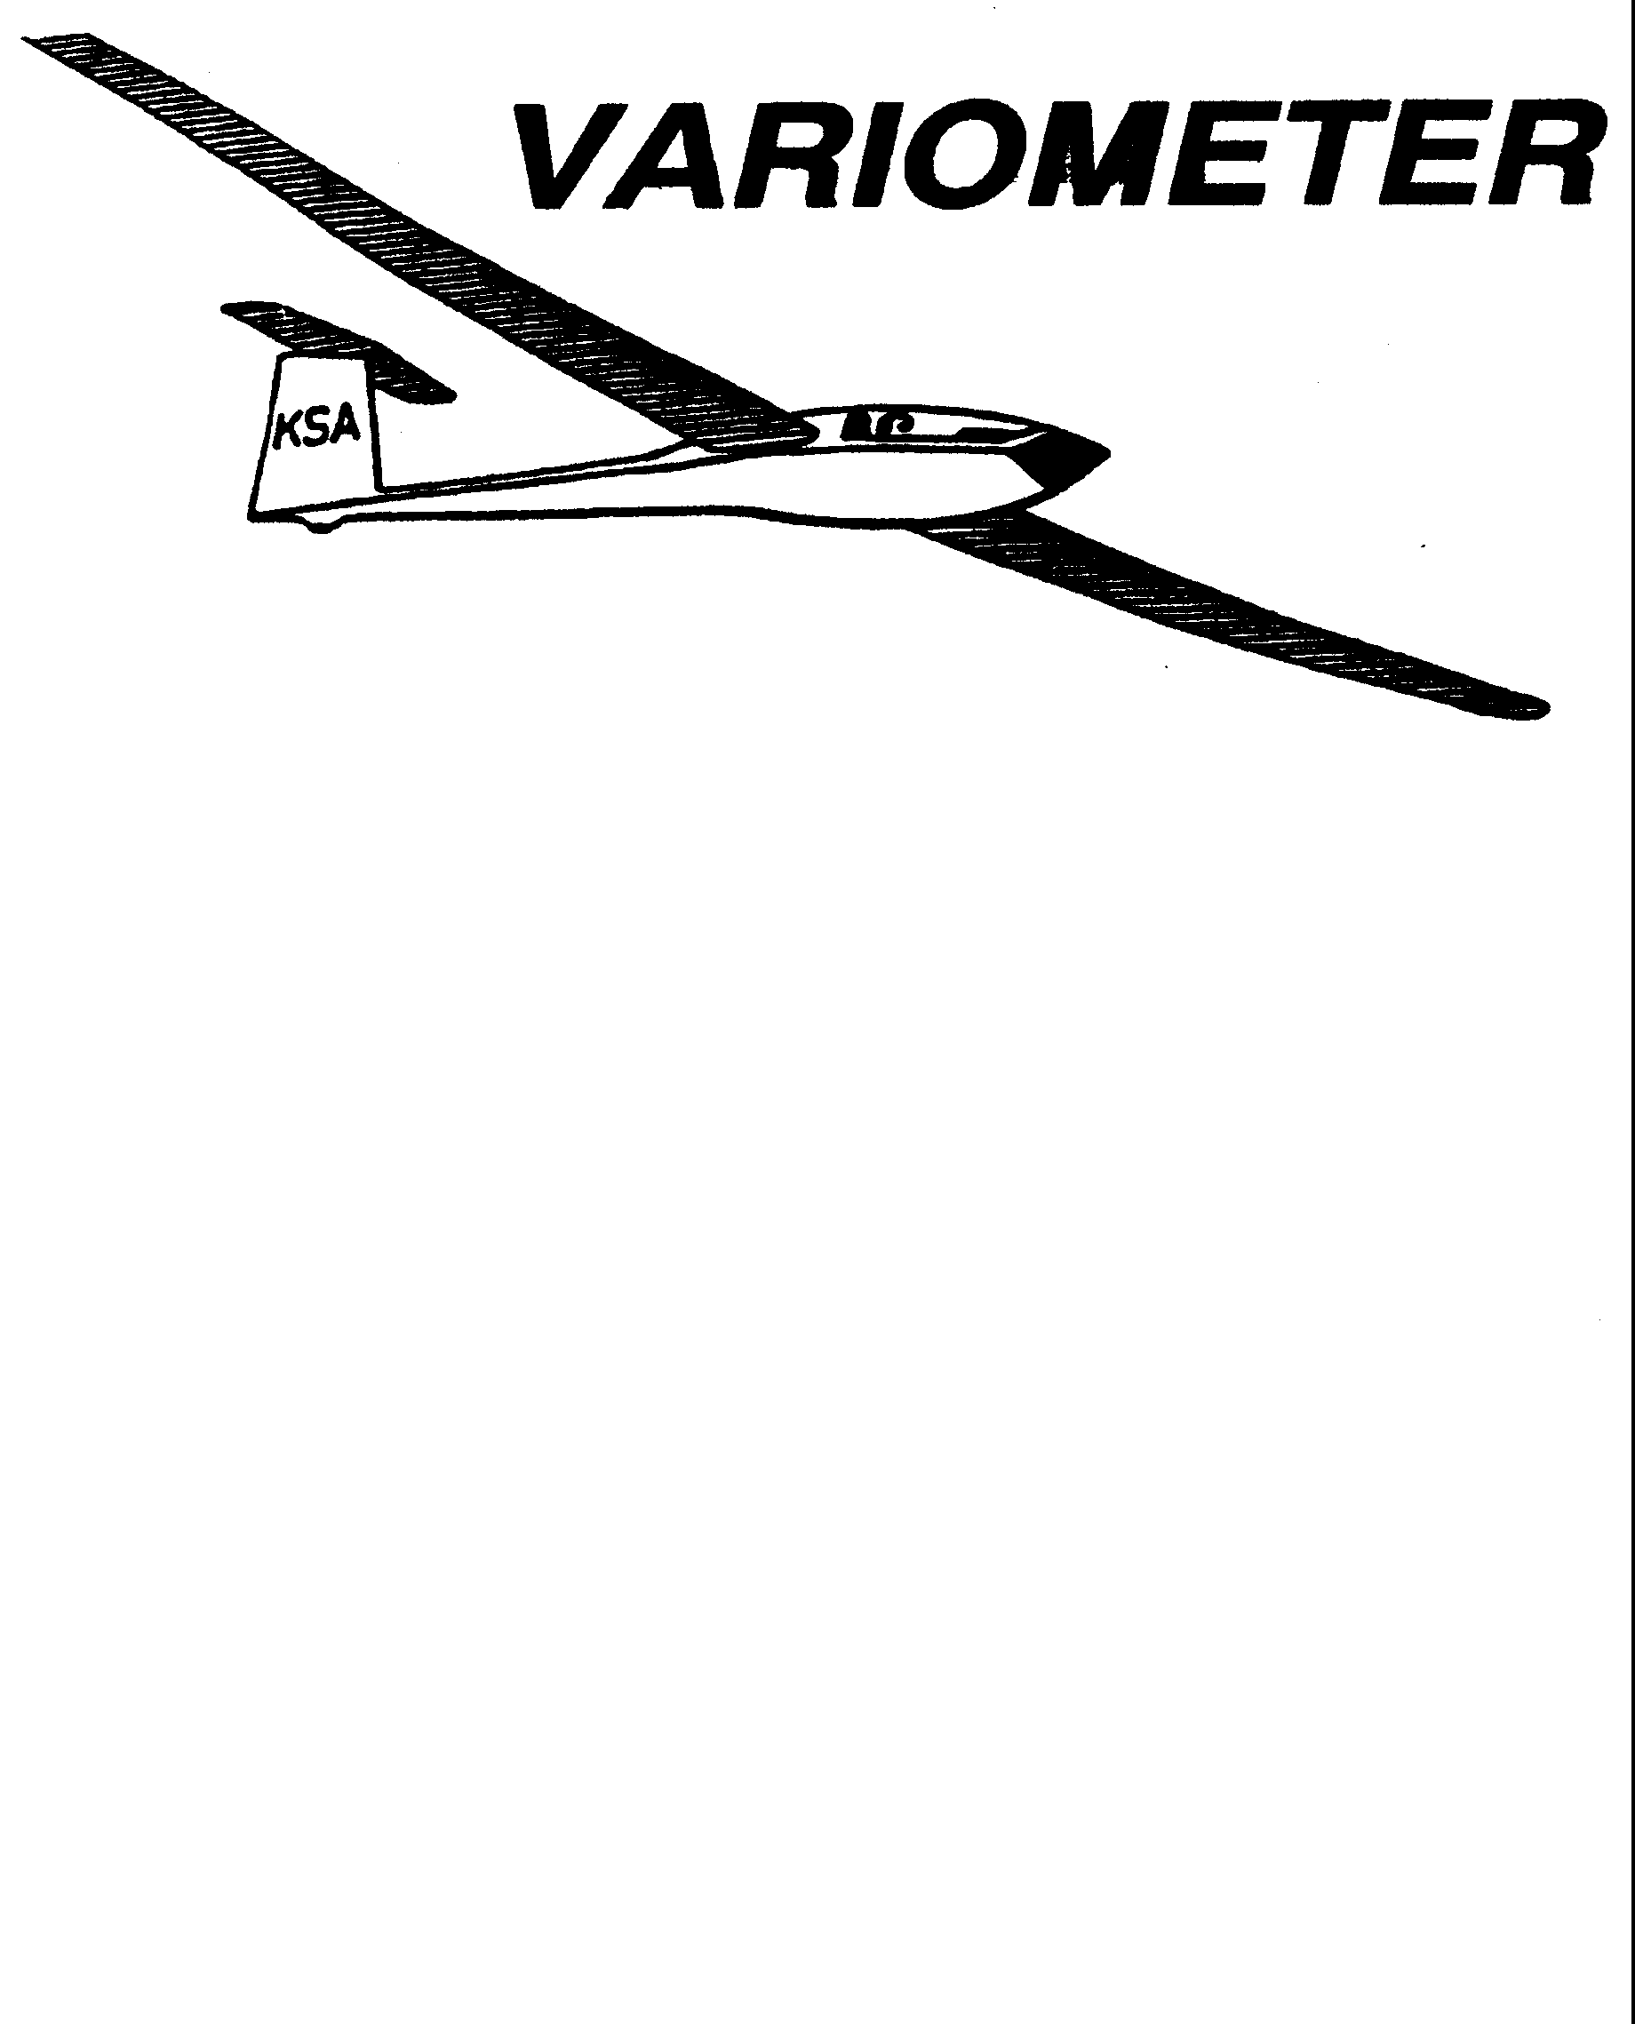

PRESIDENT – RAY GIRARDO (2009-2010)
SECRETARY - TREASURER – NEALE EILER (2009-2010)
VICE PRESIDENT EAST – BOB BLANTON (2009-2010)
VICE PRESIDENT WEST – BOB HALL (2009-2010)
TOW PLANE MANAGER – STEVE LEONARD (2009-2010)
DIRECTORS: K. C. ALEXANDER (PAST PRESIDENT)

NEAL PFEIFFER(2009-2010)
DAVE WILKUS (2009-2010) PUBLISHED TO RECORD
ANDREW PETERS (2008-2009) THE UPS AND DOWNS
FRANK O’DONNELL (2008-2009) OF THE RAY SHARP -EDITOR
KANSAS SOARING ASSOCIATION

FEBRUARY, 2009

NOTES FROM THE “NEW” PRESIDENT

It seems a bit unrealistic. After all the extra stuffed ballots, photocopied mail in votes and dozen or so recounts, I still ended up winning the KSA election for President. That’s OK. Last summer between moving to a new home, work and the weather I did not have time to spend at Sunflower. This year things are different. Time is available to spend at Sunflower and to KSA, and necessarily so. We have a lot on our plate. Between Sunflower up for sale, getting ready for the season and the upcoming calendar of events it will be busy. My intent is to work with the KSA Board of Directors and with the membership to address all of the things we face. Options for Sunflower are being explored by a focused Committee, a strong calendar of events is being put together that should encourage increasing participation for both existing and new members, and an interesting list of meeting programs is in work.
To highlight a couple of specific things; The Launch Line Manager List is in work and an open draft be at the February and March meetings. Please sign up for the days best suited for you. April will be the annual Safety Meeting so take particular note. Finally, if you are a bit optimistic like me, you can sense the weather is starting to change and get warmer, but don’t take off your “thermal” underwear just yet.

As always, input and suggestions from the membership are welcome. My number is in the KSA roster. RG
Hi Folks,
Just a quick reminder for members of WSA, elections for club officers will be held at the March annual meeting. The offices are; President, Vice President and Treasurer. All three current holders are or would like to move on to other things and we would like to get some new people involved a bit more with the club. We (Neal P. and Myself) have spoken to a few of you whom we have notice have a desire to be more involved about the offices, but if anyone is interested please call one of us and we'll be glad to give you some information on the duties.
The ballot will be mailed in the 4th quarter billing statements two weeks before the annual meeting, around the 1st of March.
Hope to see you then.

Rich Stone
WSA President
Neal Pfeiffer - 686-4306
Rich Stone - 316 371-2850

ED NOTE: We think the Awards Banquet was a great success, with entertainment for non-pilots and a great meal. Our hostess, Vonda Brecheisen, is a very efficient person whom we admire greatly. She might like feedback: send us emails about the banquet & we’ll show them to her.

WARNING

Bill Seed has notified us that a new tower has been erected at Krupper’s Korner. This tower does not yet show up on the new sectional. The tower is four miles Northwest of Sunflower for those of you unfamiliar with Krupper’s Korner. This could be a safety hazard for anyone making a long low final from the Northwest or for someone landing out in the Krupper’s Korner area. Be careful and stay alert.

KSA FLYING AWARDS, 2008

Preying Mantis
Awarded to the pilot who makes the most significant advance in his or her soaring ability during the calendar year. To be eligible for this award, the pilot must not yet have his or her Silver Badge at the beginning of the calendar year.
Donated by Curt McNay.

Richard Duerkson
----------------------------------------------------------
Towing Operations
Awarded to the person who made the most significant contribution to the towing operation during the calendar year.
Donated by Bob Leonard

Bob Parkl
---------------------------------------------------------------------

Club Maintenance
Awarded to the person who contributed the most to the maintenance of the club owned equipment.
Donated by Bob Leonard.

Pat Ensign
----------------------------------------------------------------------

Wooden Wings Award
Awarded for the longest flight in a wooden winged sailplane. The task may be free distance, or if turnpoint are to be used, they must be declared in advance of the flight and in the sequence to be used. The task declaration may be written or verbal. The turnpoints need not form a closed course. A remote finish point can be used.
Trophy donated by Bill Brown.

First Place: Rich Stone, Ka-6E, 32 Miles
---------------------------------------------------------------------
KANSAS KOWBELL KLASSIC
Donated by Mickey Jensen and Marshall Claybourn

First Place: Bob Holliday 9 miles
--------------------------------------------------------------------
KANSAS KOWBELL KLASSIC KONSOLATION
Donated by ?

Steve Leonard 71 miles

---------------------------------------------------------------------
KSA Flying Horse (Silver)
Awarded for the best speed achieved around a 100 KM pre-declared closed course with a maximum of two turnpoints.
Donated by Bill Brown

First Place: Steve Leonard, 39.6 MPH
----------------------------------------------------------------------

KSA Flying Horse (Crystal)
Awarded for the best speed achieved around a 200 KM pre-declared closed course with a maximum of two turnpoints.
Donated by Dennis Brown

----------------------------------------------------------------------
KSA Flying Horse (Gold)
Awarded for the best speed achieved around a 300 KM pre-declared closed course with a maximum of two turnpoints.
Donated by Bill Brown

First Place: Steve Leonard, 62.4 mph
----------------------------------------------------------------------

Mamie Cup
Awarded for the greatest distance flown from a Kansas departure. The task may be free distance, or if turnpoint are to be used, they must be declared in advance of the flight and in the sequence to be used. The task declaration may be written or verbal. The turnpoints need not form a closed course. A remote finish point can be used.
Donated by Bob Wilson.

First Place: Bob Holliday, 319 miles

---------------------------------------------------------------------
Cumulative Speed Trophy (Charles Henning Award)

1) The cross country task will be a Pilot Selected Task, or PST with a minimum time of 2 Hours.
- The winner will be determined by averaging the two best tasks of the year for each pilot. The averaging will be accomplished by adding the two speeds and dividing by 2.
Donated by Harry Clayton.

First Place: Steve Leonard

---------------------------------------------------------------------

KSA Handicap Score Trophy

Awarded for the best combined score in four tasks – Duration (not handicapped, but 6 hours max scored), Altitude Gain (not handicapped), Distance, and Speed. Distance and speed are handicapped per CH Handicaps or the KSA amended/added handicap. Departure point for all flights must be in Kansas. Data must be taken from four flights (i.e., one flight per task).
Donated by Curt McNay.

First Place: Steve Leonard
----------------------------------------------------------------------

Rex Hamilton Memorial Award
Awarded by the SSA Governor for the state of Kansas by criteria defined by the Governor. Past criteria have included, but are not limited to: 1) Most impressive flight based on the sailplane, conditions, and pilot experience, 2) Significant accomplishment in or contribution to soaring for that year or for a significant number of years.
Donated by Steve Leonard and Harry Clayton.

K. C. Alexander

Not Awarded

KSA VARIOMETER
1950 S WEBB ROAD #112
WICHITA, KS 67207
rayandginisharp@juno.com

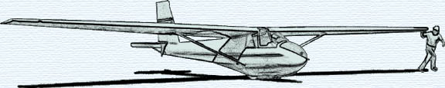

THE FEBRUARY 2009 KSA MEETING
IS
SATURDAY, FEBRUARY 14th @ 7:30PM

AT THE NIAR BUILDING
ON THE WICHITA STATE UNIVERSITY CAMPUS
PROGRAM: Aviation Photography
Junebug Clark
(Professional Photographer)

