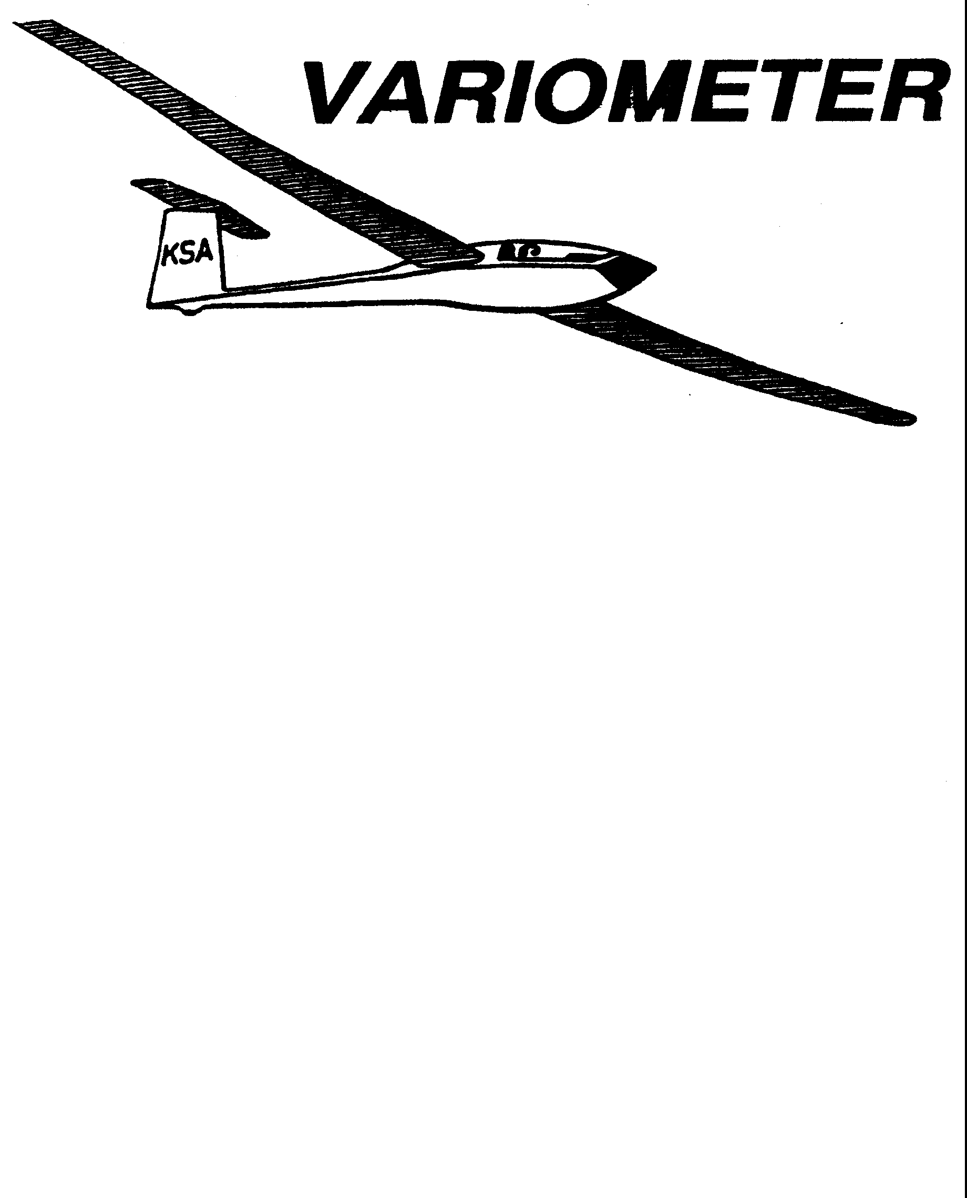

PRESIDENT – RAY GIRARDO (2009-2010
SECRETARY - TREASURER – NEALE EILER (20097-2008)
VICE PRESIDENT EAST – RAY GIRARDO (2007-2008)
VICE PRESIDENT WEST – ED NEIDERT (2007-2008)
TOW PLANE MANAGER – STEVE LEONARD (2007-2008)
DIRECTORS: K. C. ALEXANDER (PAST PRESIDENT)

NEAL PFEIFFER(2009-2010)
DAVE WILKUS (2009-2010) PUBLISHED TO RECORD
ANDREW PETERS (2008-2009) THE UPS AND DOWNS
FRANK O’DONNELL (2008-2009) OF THE RAY SHARP -EDITOR
KANSAS SOARING ASSOCIATION

MARCH, 2009

NOTES FROM THE PRESIDENT

We had a pretty good turnout in for the February Meeting, even though it was on Valentines Day. Not really sure what that means, but I suspect attendance cost a few of us more than we would have expected. It was great program, with a photographic slideshow and discussion from two professional aviation photographers. The warmer temperatures, higher humidity and stronger south winds are becoming more prevalent. The season is getting closer and I know you are planning and getting ready. The upcoming calendar of events is being finalized and as noted at last month’s meeting is geared towards participation of the membership. A few highlights to jot down:

March 12: KSA Board of Directors Meeting 630PM at Gander Mountain
March 14: Annual WSA Meeting (see meeting notice)
April 11: KSA Meeting will be the Annual Safety Meeting
April 18: Cleanup day at Sunflower
May 2: Kingman Fly In

Remember too that the Launch Line Manager List is in work, and will be available at the March Meeting. This gives you the opportunity to select the days you want rather than be assigned. It will be published in April and start May 9. Thanks,

RG

WSA GLIDER CAMP PLANNING FOR 2009

FRANK O’DONNELL
Chief Instructor

We are seeking an expression of interest from potential students who wish to attend a training camp in 2009. We are considering a camp on 15 through 19 June, 2009. The usual group of instructors, ground crew, and tow pilots will be available, so we are starting the publicity early to reach the most prospects. If you have friends who “…always wanted to fly a glider, but ….” perhaps the possibility of an intensive week-long training camp would get them started. The camps are primarily intended for those seeking their first FAA pilot rating, but power pilots wishing to add the glider rating are also welcome, as are licensed pilots who have not flown for several years and who wish to resume flying. Students must be 14 or older, and have a valid student permit.
We restrict camp sign-ups to four per instructor, or a maximum of eight. The 2-22 and 2-33 are available for campers, and at least two instructors, a tow pilot, and an experienced ground crew will assist. Informal ground school and training materials are offered. There is no extra charge for the camp-just the usual tow fees and glider rental.

Call Ray Sharp (684-1986) or Frank O’Donnell (788-3224) if you have interest in the camps. Also call if you are a CFIG, tow pilot or ground crew expert and would like to assist with the camps. We will provide monthly updates of camp status in the Variometer.

Greetings WSA members.

Hopefully most of you know this month is the election of Officers for the Wichita Soaring Association and the annual meeting conducted in concert with the Kansas Soaring Association meeting on the second Saturday of March. Please come and cast your ballot at the March meeting. If you cannot attend, mail your ballot to Neal Pfeiffer

RICH STONE
President, Wichita Soaring Association

KSA Directory Info Needed

If you have not already turned in this information please do it asap. Either bring it to the
next meeting, e-mail it to Ray Sharp at the Variometer, (rayandginisharp@juno.com)
or snail mail it
to: K.C. Alexander
6515 University
Wichita, KS 67209
We intend to print in May, and distribution will be limited to contributers.
Thanks for your help in getting this directory done.

Name: Spouse:
Address:

City:

State:

Zip:

Home phone:

Cell phone:

Work phone:

E-mail:

Gliders owned:

Are you a WSA member? _____ Yes _____ No

Are you a Tow Pilot? _____ Yes _____ No

Are you an Instructor? _____ Yes _____ No

KSA VARIOMETER
1950 S WEBB ROAD #112
WICHITA, KS 67207
rayandginisharp@juno.com

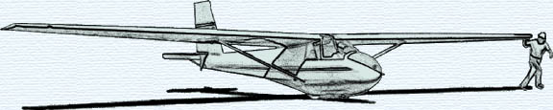

THE MARCH 2008 KSA MEETING

IS
SATURDAY, MARCH 14, 2009, 7:30 PM

AT THE NIAR BUILDING
ON THE WICHITA STATE UNIVERSITY CAMPUS

PROGRAM WILL BE THE ANNUAL MEETING OF
WICHITA SOARING ASSOCIATION

