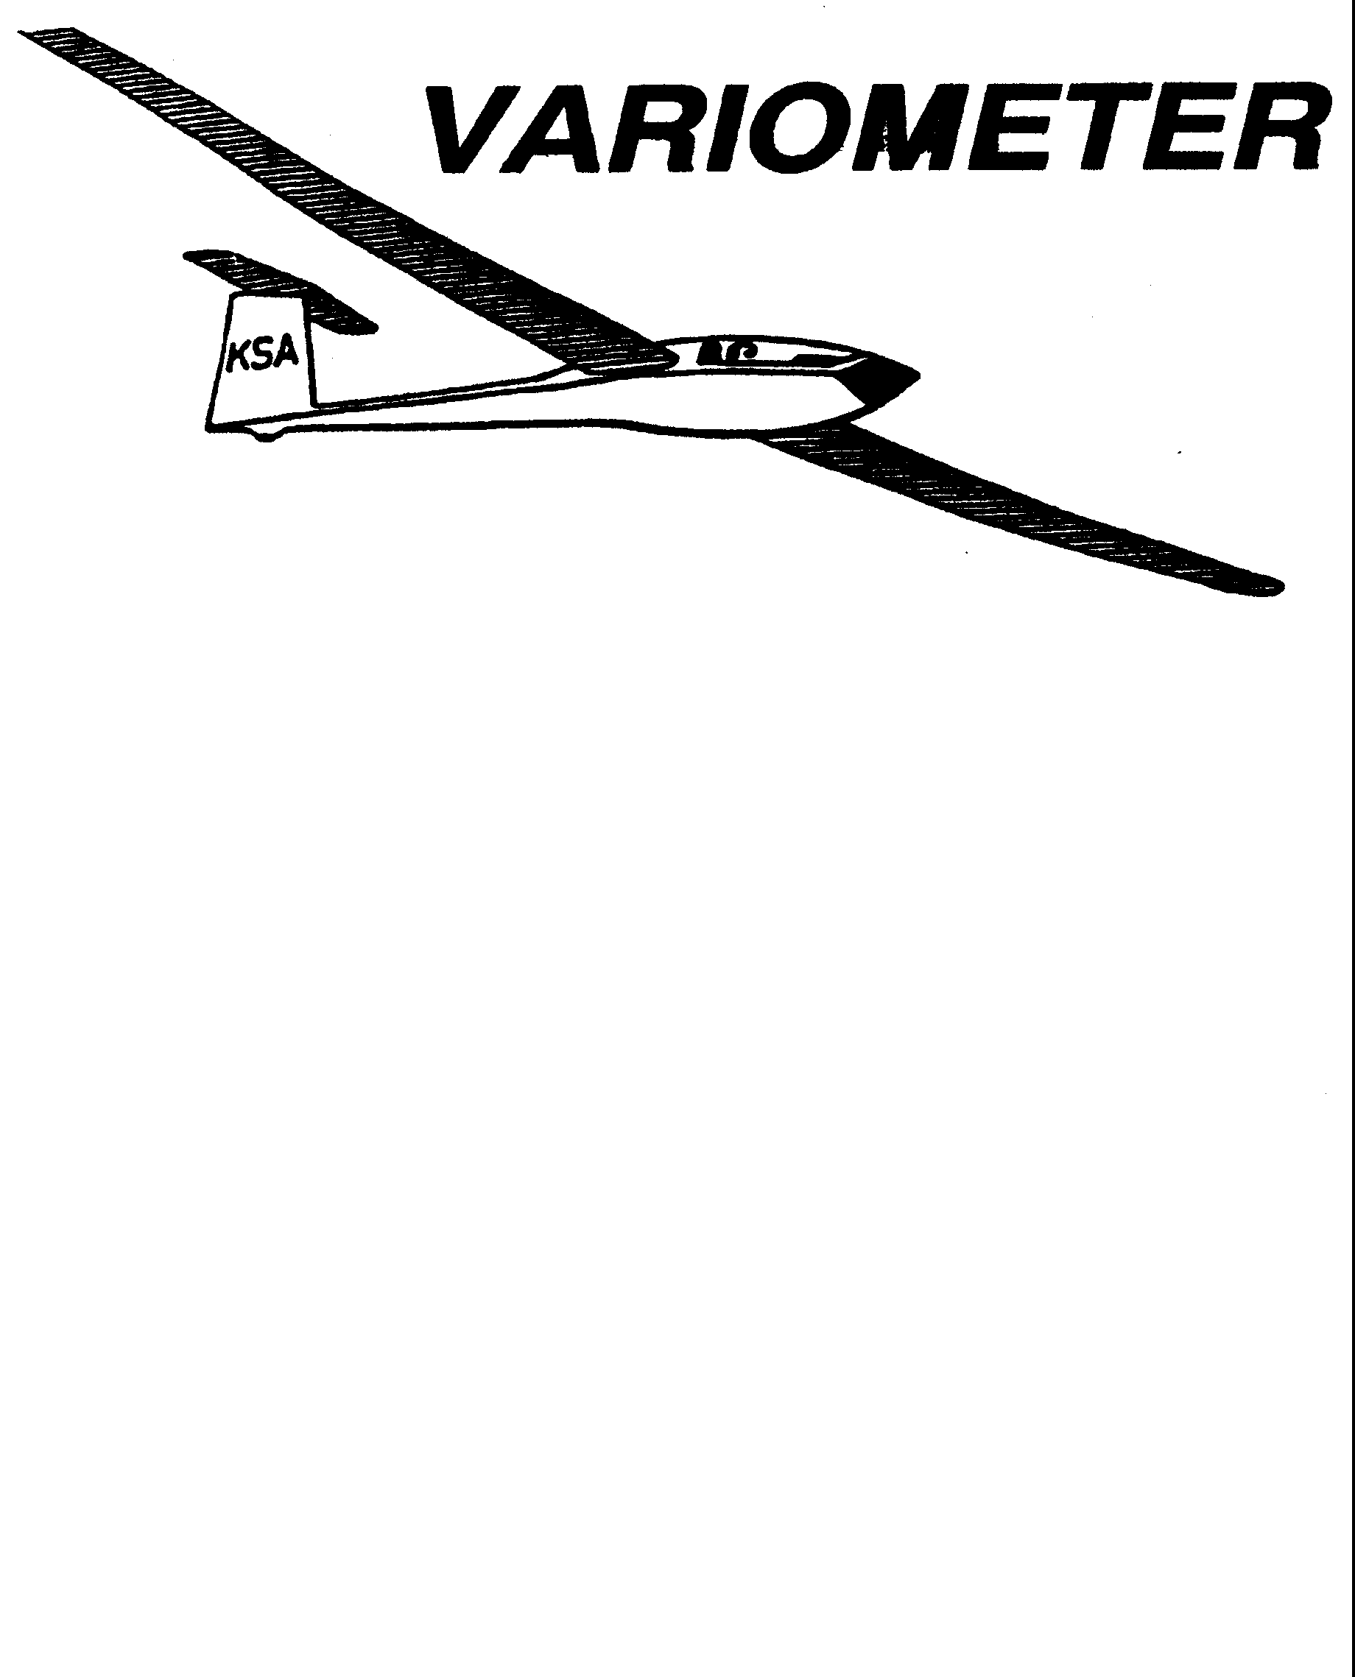

PRESIDENT – RAY GIRARDO (2009-2010
SECRETARY - TREASURER – NEALE EILER (2009-2010)
VICE PRESIDENT EAST – BOB BLANTON (2009-2010)
VICE PRESIDENT WEST – BOB HALL (2009-2010)
TOW PLANE MANAGER – STEVE LEONARD (2009-2010)
DIRECTORS: K. C. ALEXANDER (PAST PRESIDENT)

NEAL PFEIFFER(2009-2010)
DAVE WILKUS (2009-2010) PUBLISHED TO RECORD
ANDREW PETERS (2008-2009) THE UPS AND DOWNS
FRANK O’DONNELL (2008-2009) OF THE RAY SHARP -EDITOR
KANSAS SOARING ASSOCIATION

MAY, 2009

PRESIDENT’S MESSAGE
Ray Girardo
I apologize for being late this month. No excuses but things on all fronts have been extremely busy… unlike anything I’ve seen before. From time spent at work to a plumbing challenge, to a window breach during our recent storms with a lot of water where you don’t want it. Indoor swimming pools are not maintenance friendly. Lot’s of fun. But the weather will get better. As mentioned at last month’s KSA meeting, things are different this month for the KSA meeting. We will be spending the day, May 16 and by the way the third Saturday of this month, at the Kingman Airport supporting their fly –in. We will be giving rides, selling soaring and expounding on the benefits of being a KSA / WSA member. We will have time and a place to hold an informal meeting and cookout after the fly in so please plan to support and then stay to enjoy the festivities. Hopefully the weather will cooperate. We will have the at least one glider there and the towplane. I want to thank those who came to Sunflower to help with the clean up as well those helped on the following days. Aside from the May 16 event at Kingman, please don’t forget the upcoming events, especially Frank O’Donnell’s Soaring Camp the week of June 15. Finally the Launch Line List, Tow Pilots List and Instructor Roster are available. Please mark your dates. Remember if you can’t make your assigned dates, it is your responsibility to find a replacement. Thanks.

Move Questionnaire
K.C. Alexander
pikdriver@att.net

As you all know, Sunflower is for sale. It may sell next week, or it may not sell for years. When it sells the new owners may tell us to leave, or they may allow us to stay. If they do allow us to stay they will probably want significantly more money for hanger rent and facility use than we have been paying. We hope the new owners will love gliders and allow us to stay at prices close to what we are currently paying, but this may not be the case. We have to have a contingency plan in place in case we need to leave Sunflower or can not afford the new owners prices.

Where will we go? We have numerous options, each with it’s own set of plus’s and minus’s. We need to figure out as an organization what we really need, what we want, and what we can afford. I am asking everyone to please think over these issues and e-mail me your thoughts and ideas. Below is a list of topics which have come up in previous conversations. Please comment on these topics and suggest new ones for us to evaluate.

1.) Location - How far is too far?
2.) Availability of hanger space - Do you need it?
3.) Trailer tie downs or storage - Your needs.
4.) Fuel for tow plane - Buy gas from FBO or have our own.
5.) Runway type and length - Hard vs. soft, auto tow cap
6.) Co-exist with GA traffic or have a dedicated Glider Port
7.) Availability of bathrooms, air-conditioned office, phone
8.) Proximity to activities for non-flying family members
9.) Local businesses - Restaurants, hardware, gas stations, etc.
10.) Support of local community.
11.) Restricted Airspace too close
12.) Should KSA build our own hangers? Club house? Airport?
13.) Local Emergency Services
14.) Quality of Soaring Conditions
15.) Cost vs. everything above plus more?
16.) Everything else that ought to be on this list!

Date | Tow Pilot | Line Manager | Instructor
Saturday, May 9 | Jack Seltman  316-636-4218 | David Woody  682-1895  Jacob Duerkson  283-5430 | Frank O’Donnell  316-788-3224
Sunday, May 10 | Brian Bird  620-664-7844 | Neal Pfeiffer  686-4306  David Wilkus  788-0932
Sat. May 16 | Bob Hall  620-663-9577 | Steve Carlson  308-2839  John Bird  620-728-1341 | Mike Westemeir  316-729-2551
Sun. May 17 | Pat Ensign  816-835-6580 | Albert Kaltenbaeck  617-8018  John Bender  816-296-7453
Sat May 23 | Mark Schlegel  316-680-3263 | Scott Dimick  733-5678  Dakota Harms  282-6000 | Andrew Peters  316-393-2261
Sun May 24 | Aaron Martin  316-776-2287 | Doug Wilson  655-6700  Richard Duerksen  283-5430
Mon May 25 | Andrew Peters  316-393-2261 | Gary Trimpe  620-656-7381  John Peters  620-367-3711
Sat May 30 | Charles Pate  316-685-5695 | Bryan Pate  524-8829  Linda Pate  524-8829 | Aaron Martin  316-776-2287
Sun May 31 | K.C. Alexander  943-7641 | Harry Clayton  744-2389  Jerry Boone  620-474-4177
Sat June 6 | Bernie Mohr  733-4524 | Ray Girardo  942-0638  Tony Hebert | Ben Sorensen  316-655-0257
Sun June 7 | Bob Holliday  733-5403 | Steve Leonard  729-0356  Doug Wilson  655-6700

Date | Tow Pilot | Line Manager | Instructor
Sat June 13 | Dennis Brown  722-8351 | Albert Kaltenbaeck  617-8018  Doug Wilson  655-6700 | Brian Bird  620-664-7844
Sun June 14 | K.C. Alexander  943-7641 | David Woody  682-1895  Chris Black  648-4279
Sat June 20 | Richard Kirkland  682-7814 | Ron Blum  295-7812  Dan Camacho  733-0613 | Frank O’Donnell  316-788-3224
Sun June 21 | Frank O’Donnell  788-3224 | Everette Gould  620-662-0838  Gary Trimpe  620-656-7381
Sat June 27 | Ben Sorensen  655-0521 | Rich Stone  612-2008  John Bird  620-728-1341 | Andrew Peters  316-393-2261
Sun June 28 | Jack Seltman  316-636-4218 | Jerry Boone  620-474-4177  Neale Eyler  729-0659
Friday July 3 | Bob Hall  620-664-9577
Sat July 4 | Dennis Brown  722-8351 | David Wilkus  788-0932  Jacob Duerksen  283-5430 | Aaron Martin  316-776-2287
Sun July 5 | Richard Kirkland  682-7814 | John Bird  620-728-1341  Darren Liby  620-665-0035
Sat July 11 (Kowbell) | Pat Ensign  816-835-6580 | Bryan Pate  524-8829  Linda Pate  524-8829 | Ben Sorensen  316-655-0257
Sun July 12 | Bob Hall  620-664-9577 | Neal Pfeiffer  686-4306  John Bender  816-296-7453

Date | Tow Pilot | Line Manager | Instructor
Sat July 18 | Tony Condon  515-291-0089 | Bob Blanton  683-9759  Ron Blum  295-7812 | Brian Bird  620-664-7844
Sun July 19 | Bernie Mohr  733-4524 | Ray Girardo  942-0638  John Peters  620-367-3711
Sat July 25 | Ben Sorensen  655-0257 | David Woody  682-1895  Dan Camacho  733-0613 | Andrew Peters  316-393-2261
Sun July 26 | Brian Bird  620-664-7844 | Harry Clayton  744-2389  Steve Leonard  729-0356
Sat August 1 | Charles Pate  685-5695 | Bryan Pate  524-8829  Linda Pate  524-8829 | Mike Westemeir  316-729-2551
Sun August 2 | Mark Schlegel  680-3263 | Neale Eyler  729-0659  John Bird  620-728-1341
Sat August 8 | Bob Holliday  733-5403 | Jerry Boone  620-474-4177  Tony Hebert | Frank O’Donnell  316-788-3224
Sun August 9 | Frank O’Donnell  788-3224 | Steve Carlson  308-2839  Ray Girardo  942-0638
Sat August 15 | Brian Bird  620-664-7844 | Richard Duerksen  283-5430  Gary Trimpe  620-656-7381 | Aaron Martin  316-776-2287
Sun August 16 | Aaron Martin  776-2287 | Neal Pfeiffer  686-4306  Ron Blum  295-7812
Sat August 22 | Richard Kirkland  682-7814 | Ray Girardo  942-0638  Chris Black  648-4279 | Ben Sorensen  316-655-0257

Date | Tow Pilot | Line Manager | Instructor
Sun August 23 | Frank O’Donnell  788-3224 | Bob Blanton  683-9759  Everette Gould  620-662-0838
Sat August 29 | Mark Schlegel  680-3263 | John Bender  816-296-7453  Dakota Harms  282-6000 | Brian Bird  620-664-7844
Sun August 30 | Tony Condon  515-291-0089 | Harry Clayton  744-2389  Jerry Boone  620-474-4177
Sat September 5 | Ben Sorensen  655-0257 | Steve Carlson  308-2839  Darren Liby  620-662-0035 | Frank O’Donnell  316-788-3224
Sun September 6 | K.C. Alexander  943-7641 | John Wells  685-1043  Dakota Harms  282-6000
Mon September 7 | Bob Hall  620-664-9577 | David Woody  682-1895  Dan Camacho  733-0613
Sat September 12 | Aaron Martin  776-2287 | Ray Girardo  942-0638  Chris Black  648-4279 | Mike Westemeir  316-729-2551
Sun September 13 | Bernie Mohr  733-4524 | Steve Leonard  729-0356  Jacob Duerksen  283-5430
Sat September 19 | Dennis Brown  722-8351 | John Peters  620-637-3711  Bob Blanton  683-9759 | Andrew Peters  316-393-2261
Sun September 20 | Pat Ensign  816-835-6580 | Dave Wilkus  788-0932  John Bender  816-296-7453
Sat September 26 | Bob Holliday  733-5403 | John Bird  620-728-1341  John Wells  685-1043 | Aaron Martin  316-776-2287
Date | Tow Pilot | Line Manager | Instructor
Sun September 27 | Andrew Peters  393-2261 | Neale Eyler  729-0659  Everette Gould  620-662-0838
The preceding was the Duty Schedule for the upcoming summer. There are towpilots, and line managers, and instructors for the rest of the summer. This same schedule will also get loaded up for on-line viewing and editing at: http://my.calendars.net/ksa Please help us keep this schedule up to date so we can know who to call if our workers aren’t there!

Also please note. Most, if not all, of our instructors that signed up to assist with the weekend training are also towpilots. These guys are doing double duty, and we owe then a HUGE Thank you for all their efforts.

One thing that the rest of us can do to help in showing this gratitude is to help out with doing the simple things, like washing the windshield on the towplane, or offering to fuel the towplane while the pilot gets to stretch his legs. The gliders also spend a lot of time in the bugs and could use a good washing more often than the once a year they seem to get it.

Students, if you can, get to the field early some time and sit in the back seat of the trainers. Then figure out what you could do to help make life more pleasant for the instructors that spend their afternoons back there! Also, part of learning to fly gliders is learning to hook up ropes and run the launch line. If you are up there to fly, but it is not your turn in the plane, please don’t just sit in the shade. I know it is more comfortable there, but we need help out on the launch line. And that goes for the private owners, too. Nothing much more frustrating than seeing one plane about to launch, one on short final, one that just stopped well short, and another on downwind with half a dozen people sitting in the shade and talking.

And for the rest of us, lets all chip in and help keep the place clean. The bathrooms could always use a little help (I will be bringing some hand soap up there this weekend), the grass by the tower could usually stand to be mowed (Pat Ensign has graciously again provided us with a mower. Lets try to see to it that he doesn’t have to spend every Saturday morning riding it to mow that grass!). Have a few older bath towels at home? Would you consider bringing them to Sunflower for our bathroom? Take home and wash the towels that are there, and leave some others in their place.

2009 Flight Training Opportunities

Its been a long winter, and the Soaring Safety Foundation recognizes that means an increased risk as you returning to flying. Minimize that risk by doing your first flight of the year with a CFIG. The May 2nd First Flight day has been canceled, but we are planning on having several available CFIG's on May 9th.

Every Saturday this season, a CFIG will be available for your flight training needs. Frank O'Donnell, Andrew Peters, Mike Westemeir, Aaron Martin, Brian Bird and Ben Sorensen are here to help you complete the next rating, or brush up on some soaring skills. Duty day is from 1200 to 1700, but if there aren't any students by 1300, they may not stick around. Students, you can still arrange for flight training by calling one of the CFIG's before you plan to fly.

The Preflight
Harry Clayton
First a quiz:
Whose responsibility is it to determine if an airplane is airworthy?
a) The owner.
b) The AI who did the last annual inspection.
c) The last person who worked on the airplane.
d) The pilot who flies the airplane.
e) The pilot who flew the first flight of the day.

The correct answer is d. As with many of the FAR’s, the pilot has the final responsibility. Also consider who will have the worst day if something on the airplane is not airworthy. The pilot will have the honor of being first on the scene of an accident.

Now just what is a preflight inspection? Just what it sounds like, a thorough inspection of the aircraft prior to flight. A preflight should determine that there is no damage to the structure, all controls are connected and free, all pins and safeties are properly installed, and all legal paperwork is present.

Lets consider a typical preflight:

First check the cockpit. Make sure that the legal paperwork is present (the registration and airworthiness certificates). Assure that all controls are free (in a two-place sailplane, make sure that the other seatbelt is secure and out of the way). Check to make sure that there is not a grounded sign (club aircraft) and open the spoilers (if the aircraft has spoilers that will stay open). Then starting at the front of the aircraft (I start on the left side) check the tow release and skid. Look at the structure (fabric, wood, metal, etc.) for any sign of damage or deterioration. Now proceed out the left wing, is the structure OK? If struts are installed check them and the attaching pins. Are there any bends or dents? Are all of the safety pins installed? Are the wing tip skids or wheels attached properly and without sign of abuse? (You did grab it and try to wiggle it didn’t you?) Now proceed along the trailing edge. Are the aileron hinges in good shape? Look at the aileron control system (rods or cables); is anything loose? Are there any signs of wear? Note: Depending on the aircraft you may need to open inspection panels to see control linkages. Now is a good time to check the spoiler system. If the spoilers are not open have an assistant open them. Check all pivot bolts or hinges and look at the controls. Is everything where it should be with no sign of wear? From here proceed to the side of the fuselage and look for any signs of wear or damage. Now we can check the tail. Are all hinge pins installed and safetied? Are all control cables (pushrods) installed properly, without excess slop? If the tail is removable, check that all attachments are properly installed. Look at the tail wheel. Does it spin easily? Any sign of wear or abuse? Now proceed up the right side of the airplane checking all the same items that you checked on the left side. Any bolt that can rotate must have a positive safety device (cotter pin, safety wire, etc.). Always check that bolts in the control system have the appropriate safety devices attached.

During the preflight check the pitot and static tubes and assure that they are clear; a bug or piece if tape can ruin your day.

Did you notice that at several points we checked for abuse? In many cases damage can occur at locations remote from the location of abuse. If a wing tip strikes a fixed object it may suffer only minor damage, but the wing attach fittings can suffer major consequences. Remember, a 100 pound load at the tip can cause a 1000 pound load at the fittings (or more depending on the airplane). Same with the tail wheel. A hard strike may not show much damage at the wheel but may damage rudder hinges or other components in the rear of the airplane.

We have checked that the control surfaces are attached to the airplane, now we must check that they function correctly. This is called a positive control check. For this you need a helper, either to put control inputs into the cockpit controls or to restrain the control surfaces. Rule number one is to communicate with the helper in terms that can not be confused. If you are restraining the surfaces give instruction like “stick back”, if you are at the cockpit call “elevator trailing edge up”. I start at the left wingtip and check the aileron. Each control should be operated with moderate pressure (remember you are looking for bad connections). There are several designs where the controls will move but will come disconnected when force is applied. Now proceed to the left spoiler and put force against it in both the opening and closing directions. Now proceed to the elevator. Most rudders can not be disconnected, and thus can not be left unconnected, but you should check the rudder on occasion anyway. Now do controls on the right wing. Remember to note if the controls are moving in the correct direction. One recent accident involved an elevator that was cabled in reverse, even though the pilot was witnessed doing a positive control check prior to the (short) flight.

Does this sound like a lot of trouble? I have been flying at Sunflower since 1979. In that time I have seen: one case where a wing pin was left out (by good luck the pilot did not fly that day), one case of control disconnect in flight (no damage, just an outlanding), and three cases of disconnected elevators (major damage to each aircraft, but no injuries). This list shows that we have had very good luck in terms of injuries. Do we need to keep relying on luck?

This article can not cover every item on every airplane. Get to know the airplane you fly and learn what to check. The pilot’s operation handbook is a good place to start. Also if you see something that does not look correct on another aircraft tell the pilot, you may be doing him a big favor!

WSA GLIDER CAMP PLANNING FOR 2009

FRANK O’DONNELL
Chief Instructor

We are seeking an expression of interest from potential students who wish to attend a training camp in 2009. We are considering a camp on 15 through 19 June, 2009. The usual group of instructors, ground crew, and tow pilots will be available. If you have friends who “…always wanted to fly a glider, but ….” perhaps the possibility of an intensive week-long training camp would get them started. The camps are primarily intended for those seeking their first FAA pilot rating, but power pilots wishing to add the glider rating are also welcome, as are licensed pilots who have not flown for several years and who wish to resume flying. Students must be 14 or older, and have a valid student permit.
We restrict camp sign-ups to four per instructor, or a maximum of eight. The 2-22 and 2-33 are available for campers, and at least two instructors, a tow pilot, and an experienced ground crew will assist. Informal ground school and training materials are offered. There is no extra charge for the camp-just the usual tow fees and glider rental.

Call Ray Sharp (684-1986) or Frank O’Donnell (788-3224) if you have interest in the camps. Also call if you are a CFIG, tow pilot or ground crew expert and would like to assist with the camps. We will provide monthly updates of camp status in the Variometer.

KA-6 CLINIC
RICH STONE

On Saturday May 30th, I will conduct a Ka-6 assembly clinic for anyone who wishes to learn how or just get a refresher on assembling the glider. I will begin this clinic at 10:30 AM and will continue walking people through the assembly and dis-assembly process until everyone has had enough. If you wish to get checked out to fly the Ka-6 then you must go through this process with a knowledgeable person, so come out learn how its done and you'll be one step closer to flying a fun little ship.
Even though I am putting on this little clinic the plan for the Ka-6 will be similiar to last year, that is we will evaluate the weather conditions toward the middle of June and if things are looking good we will hanger it then, if not then on the 1st of July. This will be the clincher year for evaluating this process, if the glider gets alot more flying then we will continue doing this during the soaring season, if not, then next year we will leave it in the trailer.
All of the KSA club gliders were annualed this past weekend; thanks to Brian Bird, Scott Demick, Sue and Harry Clayton for their work and efforts to ensure the ships were ready to fly.
A reminder when you fly any of the club ships and notice or incur any damage please call one of the above mentioned people, Rich Stone or Steve Leonard and let us know the nature of the problem so that we can faciliate the necessary repairs.
Thanks and lets have fun out there

Andrew is planning a Last Chance Ratings Camp October 2-5. This will be for anyone that needs that last little push to complete a Private, Commercial or CFIG rating. Please contact him if you need more information or continue to read the variometer.

KSA VARIOMETER
1950 S WEBB ROAD #112
WICHITA, KS 67207
rayandginisharp@juno.com

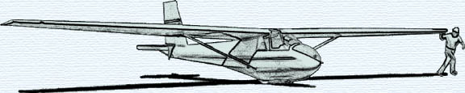

THE MAY 2009 KSA MEETING

IS
SATURDAY, MAY 16, 2009,

AT THE KINGMAN AIRPORT
KINGMAN, KANSAS
PROGRAM: RIDES, KINGMAN FLY-IN, GOODTIMES
with an OPPORTUNITY to ENJOY A COOKOUT in the EVENING

