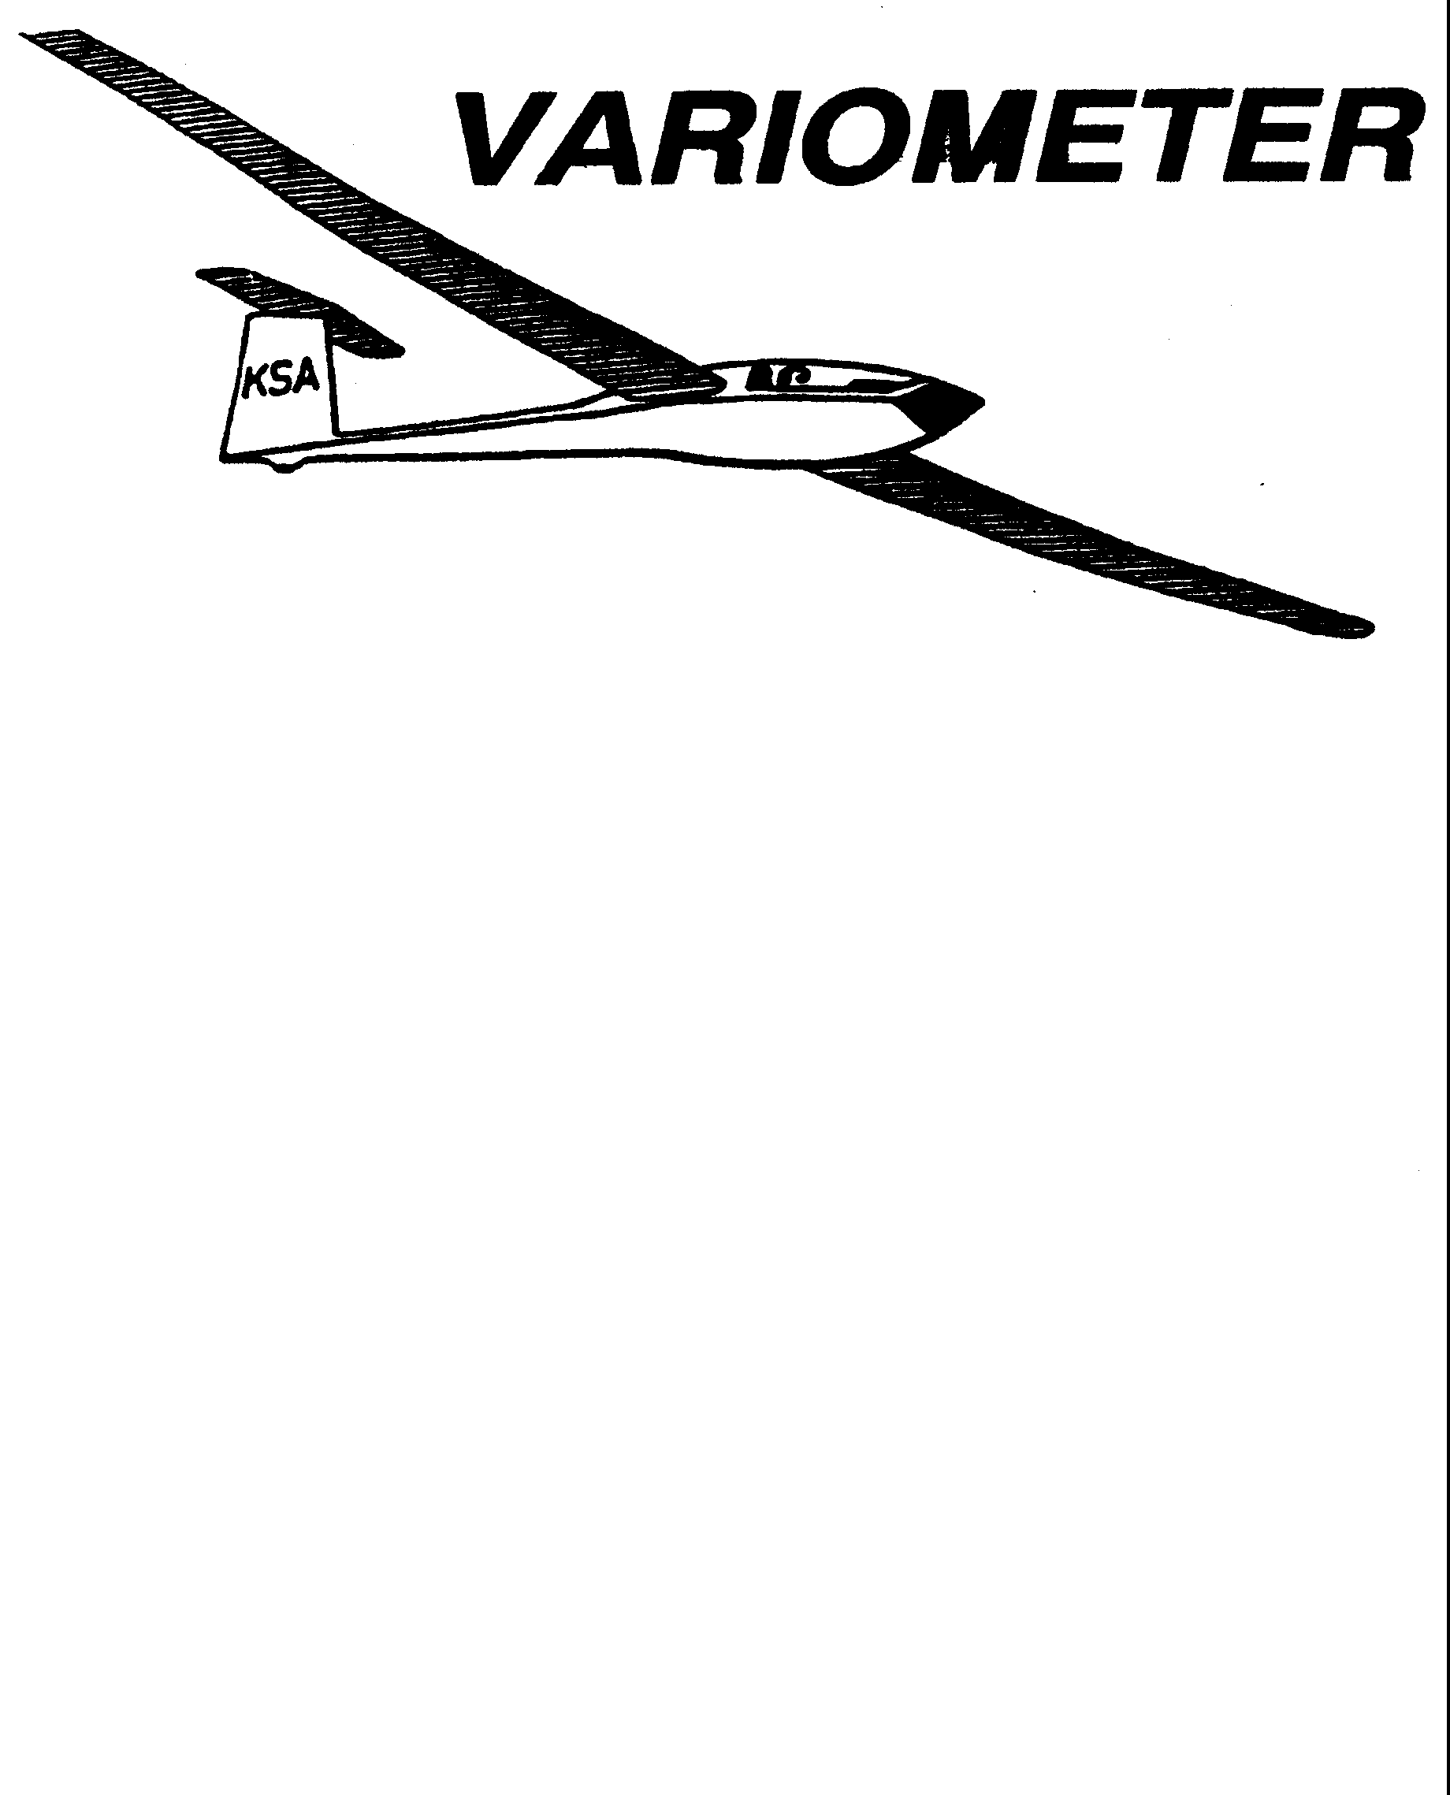

PRESIDENT – RAY GIRARDO (2009-2010
SECRETARY - TREASURER – NEALE EILER (2009-2010)
VICE PRESIDENT EAST – BOB BLANTON (2009-2010)
VICE PRESIDENT WEST – BOB HALL (2009-2010)
TOW PLANE MANAGER – STEVE LEONARD (2009-2010)
DIRECTORS: K. C. ALEXANDER (PAST PRESIDENT)

NEAL PFEIFFER(2009-2010)
DAVE WILKUS (2009-2010) PUBLISHED TO RECORD
ANDREW PETERS (2008-2009) THE UPS AND DOWNS
FRANK O’DONNELL (2008-2009) OF THE RAY SHARP -EDITOR
KANSAS SOARING ASSOCIATION

AUGUST, 2009

NOTES FROM THE PRESIDENT

Thus far, it has been a very interesting and productive flying season. More for those of you that are really flying than perhaps myself. My paltry few flights pale in comparison to the efforts of others, though my flight a week or so ago with Sue McNay in the 2-33 was quite memorable. As you read through the Variometers, you will quickly understand what I mean about the achievements of others this year. A lot of amazing accomplishments.

Have you ever really sat back and watched the operation at Sunflower when it is in full swing on a strong afternoon? The orchestration and choreography of the launch line can almost mesmerize you. What really needs to appreciated are the towpilots, instructors, and launch line managers who make it all come together. Without their efforts all of us would sit on the ground. Here is where I have to admit that I too am at fault, and what needs to be said applies as much to myself as well as the others who don’t make their assigned day. In my case, I simply forgot. In fact if it wasn’t for Dave Woody, I would have really forgotten and gone flying. Not good. We can’t make excuses, and must make our assigned days. If you can’t make it, please take the effort and call someone to substitute for you. Write it down, have someone phone to remind you, or call the upcoming weekend volunteers to remind them not to forget. It isn’t that hard. Dave Woody has almost volunteered to be my designated reminder for the rest of the year. Almost because he shouldn’t have to do it, and won’t. It’s my and your responsibility to work, after all KSA is a club. Let’s not be unfair to those who go to fly and end up working the line because we don’t show up. Please make your days.

Finally, special thanks to Bob Hall who even after tireless hours of towing, found the time to support independent Wichita film maker Rodney Pocowatchit shoot a scene for his latest film using the tower building as a backdrop. The film “The Dead Can’t Dance” is about a virus that turns everyone (alas even Italians) into zombies except for Native Americans. I can’t wait for the premier. I’m sure it will be even better than the 1980’s film shot in Wichita called “King Kung Fu”. You’ll have to see me at Sunflower to get the details on this one. Thanks.

!
Date | Tow Pilot | Line Manager | Instructor
Sat August 1 | Charles Pate  685-5695 | Bryan Pate  524-8829  Linda Pate  524-8829 | Mike Westemeir  316-729-2551
Sun August 2 | Mark Schlegel  680-3263 | Neale Eyler  729-0659  John Bird  620-728-1341
Sat August 8 | Bob Holliday  733-5403 | Jerry Boone  620-474-4177  Tony Hebert | Frank O’Donnell  316-788-3224
Sun August 9 | Frank O’Donnell  788-3224 | Steve Carlson  308-2839  Ray Girardo  942-0638
Sat August 15 | Brian Bird  620-664-7844 | Richard Duerksen  283-5430  Gary Trimpe  620-656-7381 | Aaron Martin  316-776-2287
Sun August 16 | Aaron Martin  776-2287 | Neal Pfeiffer  686-4306  Ron Blum  295-7812
Sat August 22 | Richard Kirkland  682-7814 | Ray Girardo  942-0638  Chris Black  648-4279 | Ben Sorensen  316-655-0257
Sun August 23 | Frank O’Donnell  788-3224 | Bob Blanton  683-9759  Everette Gould  620-662-0838
Sat August 29 | Mark Schlegel  680-3263 | John Bender  816-296-7453  Dakota Harms  282-6000 | Brian Bird  620-664-7844
Sun August 30 | Richard Kirkland  682-7814 | Harry Clayton  744-2389  Jerry Boone  620-474-4177
Sat September 5 | Ben Sorensen  655-0257 | Steve Carlson  308-2839  Darren Liby  620-662-0035 | Frank O’Donnell  316-788-3224

Date | Tow Pilot | Line Manager | Instructor
Sun September 6 | K.C. Alexander  943-7641 | John Wells  685-1043  Dakota Harms  282-6000
Mon September 7 | Bob Hall  620-663-9577 | David Woody  682-1895  Dan Camacho  733-0613
Sat September 12 | Aaron Martin  776-2287 | Ray Girardo  942-0638  Chris Black  648-4279 | Mike Westemeir  316-729-2551
Sun September 13 | Bernie Mohr  733-4524 | Steve Leonard  729-0356  Jacob Duerksen  283-5430
Sat September 19 | Dennis Brown  722-8351 | John Peters  620-637-3711  Bob Blanton  683-9759 | Andrew Peters  316-393-2261
Sun September 20 | Pat Ensign  816-835-6580 | Dave Wilkus  788-0932  John Bender  816-296-7453
Sat September 26 | Bob Holliday  733-5403 | John Bird  620-728-1341  John Wells  685-1043 | Aaron Martin  316-776-2287
Sun September 27 | Andrew Peters  393-2261 | Neale Eyler  729-0659  Everette Gould  620-662-0838

Thanks to all for the help so far this year. We have had a few no-shows, and would like to know what we can do to help in reminding you of a coming scheduled work day. If you would like a phone call, e-mail, or some other form of reminder, let Ray Girardo know, and we will see what we can do to accommodate your request for reminder. We are aware that many of the dates may not have been picked by you, and you may have traded with someone. But in order for the club to operate, we need people to show up on the days you are scheduled to work. The Duty Schedule can also be viewed online at:

http://my.calendars.net/ksa.
A few notes and observations on operations.

Tow tickets. In this issue of The Variometer, we are again including a blank tow ticket form. Please do not just cut this up and use the four provided. Please make copies and bring your own tow tickets with you. We will do our best to provide for you if you forget, but tow tickets are just like water, sunscreen, and food. They are an essential item for you to take to the gliderport, and you need to bring your own. Also, please stick with the standard size. It is very frustrating to be sorting through all the tow tickets and find that they are all different sizes and shapes. You will make the Towplane Manager’s life much easier if all your tickets are the standard 3 by 5 size.

Runway use. The runway is for taking off and landing. Please do not park the towplane or any glider out on the runway. If there is a glider out there and nobody ready to fly it, please move it off to the side of the runway. The runway we have is huge, but we all want to use the same bit of it. If we keep the runway clear, we can all roll up where we want, pull off to the side, and let the next person roll up where they want. There is a nice, clean area in the SE corner of the intersection that is a good place to park the towplane. Please park it there during the day when there are no gliders to be launched. If you land and stop away from the intersection, please move the glider off of the new blacktop and to the edge of the runway before you get your handling gear or help to pull to the intersection.

Takeoffs and Landings. I have noticed a large number of the towpilots landing to the side of the new blacktop. Please land on the new blacktop and not out in the grass, rocks, etc. I think the new surface is less abrasive on the tires, certainly has fewer rocks, and has less potential for hidden hazards. As you get closer to the gliders, you can move over as required to clear the gliders.

Tows. Towpilots, please be aware of where you are taking the glider you are towing. If it is one of the WSA two place gliders, try to keep upwind and not more than two miles of the center of the field at all times. There are paved roads that can be used as guides. The Haven-Arlington road to the south, Yoder Road to the east, K-17 to the West, and K-96 to the north.

A Fall Work Day is being planned. Next time you are at Sunflower, start looking around and make your list of things that could be done. We will try to define tasks and assign people to doing them. Some of the larger ones will have groups of people assigned to them. The goal is to allow people time to get the things they will need in order to do specific jobs at the field. There is lots that needs to be done, and if we all chip in, it is much easier to do.

ED NOTE: We will have official results of the Kowbell in next month’s issue, and a copy of a newspaper article relative to the Kowbell if we can process it.

Andrew is planning a Last Chance Ratings Camp October 2-5. This will be for anyone that needs that last little push to complete a Private, Commercial or CFIG rating. Please contact him if you need more information or continue to read the variometer.

John Bender is offering his (slick) Ka-6 for sale for $7500. His ad is in Wings-and wheels. (editor thinks the bird may be at Sunflower)

Ed Limper is selling a hand held radio for best bid over $25. Talk to Frank O’Donnell.

KSA VARIOMETER
1950 S WEBB ROAD #112
WICHITA, KS 67207
rayandginisharp@juno.com

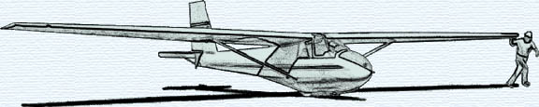

THE AUGUST 2009 KSA MEETING
SATURDAY AUGUST 8, 2009
AT SUNFLOWER
THIS IS A COOKOUT MEETING STARTING ANYTIME AFTER 5:00 p.m.
PLEASE BRING A GRILL AND CHARCOAL, etc.
(don’t forget the hot dogs)

