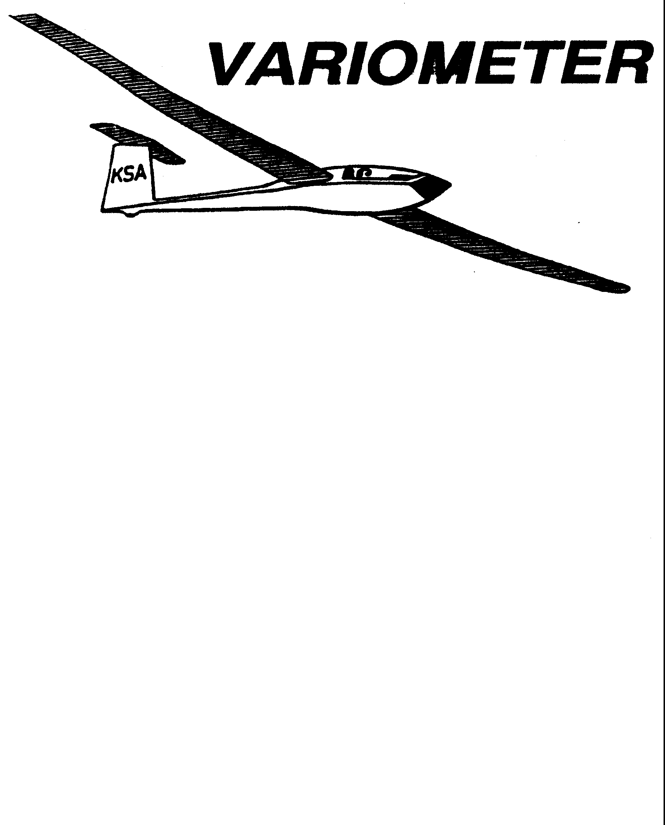

PRESIDENT – RAY GIRARDO (2009-2010
SECRETARY - TREASURER – NEALE EILER (2009-2010)
VICE PRESIDENT EAST – BOB BLANTON (2009-2010)
VICE PRESIDENT WEST – BOB HALL (2009-2010)
TOW PLANE MANAGER – STEVE LEONARD (2009-2010)
DIRECTORS: K. C. ALEXANDER (PAST PRESIDENT)

NEAL PFEIFFER(2009-2010)
DAVE WILKUS (2009-2010) PUBLISHED TO RECORD
ANDREW PETERS (2008-2009) THE UPS AND DOWNS
FRANK O’DONNELL (2008-2009) OF THE RAY SHARP -EDITOR
KANSAS SOARING ASSOCIATION

SEPTEMBER, 2009

NOTES FROM THE PRESIDENT

Even though it September, there is still a lot flying left in this season. I hope you are all out flying. It seems to be a cooler than average summer. I know because I compared this years and last years electric bill with an unchanged programmable thermostat (it must be something to do with engineering and data). I’m not sure what this meant to the soaring conditions this year, but judging from the comments I’ve heard it is has been cause for some interesting challenges.
One of things we are going to do this year is have an extensive fall clean up day. There is a lot that needs to be done. What the Board of Directors will do is define a list by priority of things that need to be accomplished. A KSA member will be assigned to that task with the responsibility of getting a group of other members together along with the material necessary to work that task until it is completed. Any material expenses will be reimbursed to the member.
It is essential that we all get together and work this, so please if you are called, make every effort to help out. The more members that are there, the faster it all gets done.
The specific workday will be finalized at the September 10 KSA Board of Directors Meeting, but the target date is Saturday October 10. Please mark this date on your calendars.

Ray

!

Date | Tow Pilot | Line Manager | Instructor
Sat September 12 | Aaron Martin  776-2287 | Ray Girardo  942-0638  Chris Black  648-4279 | Mike Westemeir  316-729-2551
Sun September 13 | Bernie Mohr  733-4524 | Steve Leonard  729-0356  Jacob Duerksen  283-5430
Sat September 19 | Dennis Brown  722-8351 | John Peters  620-637-3711  Bob Blanton  683-9759 | Andrew Peters  316-393-2261
Sun September 20 | Pat Ensign  816-835-6580 | Dave Wilkus  788-0932  John Bender  816-296-7453
Sat September 26 | Bob Holliday  733-5403 | John Bird  620-728-1341  John Wells  685-1043 | Aaron Martin  316-776-2287
Sun September 27 | Andrew Peters  393-2261 | Neale Eyler  729-0659  Everette Gould  620-662-0838

Andrew is planning a Last Chance Ratings Camp October 2-5. This will be for anyone that needs that last little push to complete a Private, Commercial or CFIG rating. Please contact him if you need more information or continue to read the variometer.

John Bender is offering his (slick) Ka-6 for sale for $7500. His ad is in Wings-and wheels. (editor thinks the bird may be at Sunflower)

Ed Limper is selling a hand held radio for best bid over $25. Talk to Frank O’Donnell.

Attached is a copy of the article in The Jetmore Republican about my Kowbell Adventure. It definitely has the earmarks of soaring lore (enhanced facts)!

HARD LANDING
By Michael Thornburg
The Jetmore Republican

I imagine tat it was a startled dispatcher that took the 911 call early Saturday evening reporting that a small plane had crash landed in a milo field northwest of Jetmore. In actuality, a glider being piloted by Steve Leonard, an engineer at Cessna in Wichita, had come down for a hard landing in the field with his glider spinning approximately one and a half time before coming to a complete stop. The pilot was unhurt.

Leonard was gliding in a contest called the Kowbell Classic which took off from the Sunflower Naval Station just east of Hutchinson. The Kowbell Classic began in 1962 with the pilots leaving the station and going any direction they chose and gliding as far as they possibly can. Steve was hoping to make it to another time zone, but lost his lift when he ran out of cumulus clouds and came down for a hard landing in a soft milo field. The winner of the competition receives a trophy which is passed on to the next year’s winner. Steve has won the trophy twice since he started gliding in 1988.

Shane MacNair and friend Haley Meyers as well as CJ Deines and Mick MacNair arrived at the scene to assist Leonard in moving the aircraft closer to the road so that Steve’s pickup crew (an hour away at the time) could load the glider into a specially designed trailer.

There was some damage to the landing gear from the hard landing on the soft soil and the glider had to be completely disassembled to fit into the trailer.

Leonard and crew did enjoy some time at the MacNair farm for eats and some cool air before returning to disassemble the aircraft. “All in all it was just another day on the farm.” Commented Sheryl MaNair.

The winner of this year’s Kowbell Classic landed south of Goodland. Steve finished 4th in the contest.

Getting the plane from the field to the dirt road was an interesting adventure. Involved lifting the Nimbus out of its ground track twice (once to get it ready to turn around and go the direction I landed, and once to get it up onto our 16 foot long 2 by 8 "runway"), chains and a strap, a four wheeler that got bogged down trying to pull the Nimbus-plow through the field, and pulling the plane straight from the field to the road. Thank goodness there wasn't a ditch, but just some crop, weeds, then the road.

Thought you might enjoy seeing this.

Steve

LAST CHANCE RATINGS CAMP

I am in the process of planning a camp for current students to finish a rating this season. This camp is not just for the members new to soaring, Commercial and CFIG applicants are also welcome to attend. Participants should have completed ALL requirements (written exam, flights/hours, etc.) for the rating prior to the camp. Instructors will provide the required three flights prior to the checkride, oral exam preparation, and sign offs. CFIG's will also be available to provide any additional instruction that may be required to complete the checkride.

The camp will run Saturday October 3rd through October 11th from 9 am to 5 pm, weather and applicants permitting. I am working with Designated Pilot Examiner Charles Pate, as well as a representative from the FSDO to provide checkride services. Examiner costs are yet to be determined, stay tuned to the Variometer next month.

If you are interested in taking advantage of this camp, please contact me via email apsoars@yahoo.com or cell phone 316-393-2261. Towpilots, Flight Instructors, and Line Managers that are interested in helping would also be appreciated.

There are scheduled flying days between now and the camp. So call your favorite CFIG, get serious about your flight training, and add a rating this season.

Andrew Peters, CFIG

· Our speaker will talk about “Stability and Control”.
· He is a rated glider pilot.
· He has worked 5 years at the following: Cessna, Boeing and Convair/San Diego – and 25 years at Beech Aircraft.
His career has been as an aerodynamicist, except for two years as a dynamics engineer. He is former Chief of Aerodynamics R & D at Beech.

Our OX5 Aviation Pioneers group has planned a bus trip to the Osa and Martin Johnson museum at Chanute, KS. Details are attached. We have 12 seats left for a first-come first-served basis. Join us for a good trip. Please call Bobbie Walter at 316-733-2377.

KSA VARIOMETER
1950 S WEBB ROAD #112
WICHITA, KS 67207
rayandginisharp@juno.com

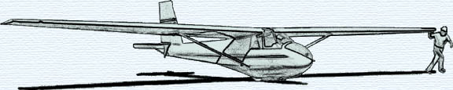

SEPTEMBER 2009 KSA MEETING
Saturday September 10, 2009, 7:30 p.m.
AT NIAR
Wichita State University
PROGRAM
Harold Walter
Stability & Control Expert
Licensed Glider Pilot

