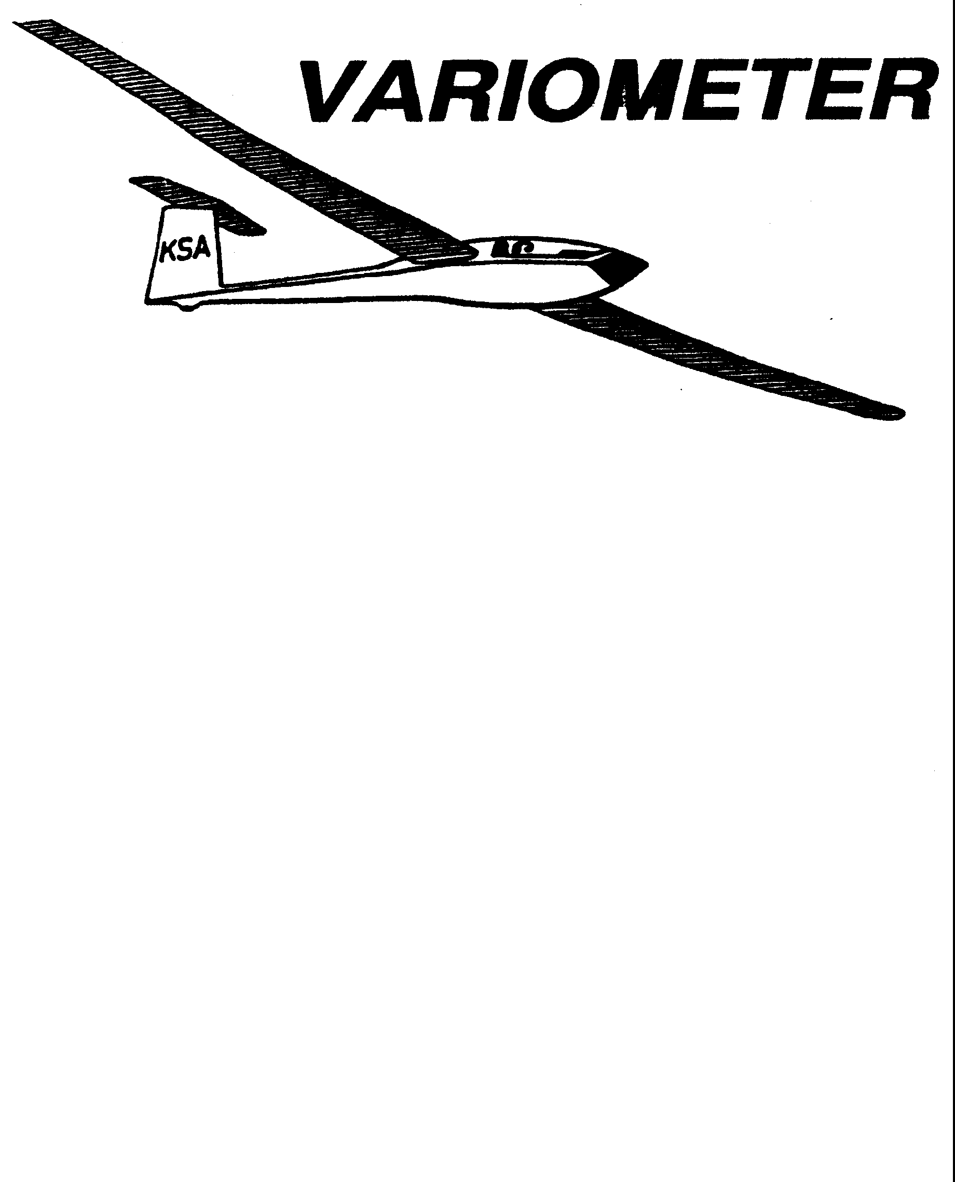

PRESIDENT – RAY GIRARDO (2009-2010
SECRETARY - TREASURER – NEALE EILER (2009-2010)
VICE PRESIDENT EAST – BOB BLANTON (2009-2010)
VICE PRESIDENT WEST – BOB HALL (2009-2010)
TOW PLANE MANAGER – STEVE LEONARD (2009-2010)
DIRECTORS: K. C. ALEXANDER (PAST PRESIDENT)

NEAL PFEIFFER(2009-2010)
DAVE WILKUS (2009-2010) PUBLISHED TO RECORD
ANDREW PETERS (2008-2009) THE UPS AND DOWNS
FRANK O’DONNELL (2008-2009) OF THE RAY SHARP -EDITOR
KANSAS SOARING ASSOCIATION

OCTOBER, 2009

NOTES FROM THE PRESIDENT

This is reminder. One of things we are going to do this year is have an EXTENSIVE FALL CLEAN UP DAY ON SATURDAY OCTOBER 17, 2009 starting as soon as people get there, but no later than 900 am. The rain dates are Sunday October 18 and then Saturday October 24. There is a lot that needs to be done. A KSA member will be asked to volunteer for a specific task and then have the responsibility of getting a group of other members together along with the material necessary to work that task until it is completed. Any material expenses will be reimbursed to the member.
It is essential that we all get together and work this, so please volunteer to lead a task, and if you are called, make every effort to help out. The more members that are there, the faster it all gets done. Some of the specific items that will be worked are:

- Fencing off the pool and barricading certain areas of the tower building
- Fixing the hangar door tracks. This may require cement replacement.
- Sealing the hangar roof screws.
- Breaking up the bad heaves on the ramp and refilling the aggregate back into the hole.
- Sweeping and general cleanup.

I know this sounds odd and is contrary to my earlier comments, but unfortunately I am traveling that weekend and out of town the following week and cannot make the cleanup day. I intend though to work on the subsequent weekend and will be picking the work that remains.
Finally this is a KSA election month. Two KSA Directors positions are open. Please take the time to fill in and bring the ballot to this weeks KSA meeting or mail in the ballot to the address noted or by October 10. Thanks,

Ray

KSA ELECTION BALLOT
October, 2009

Vote for two names only

□ Dennis Brown
□ Frank O’Donnell
□ Neal Pfeiffer
□ David Woody

Please bring this ballot to the October 10, 2009 KSA Meeting or
mail by October 10, 2009 to:

KSA Nominating Chairman
1424 North Byron Road
Wichita, Kansas 67

KSA VARIOMETER
1950 S WEBB ROAD #112
WICHITA, KS 67207
rayandginisharp@juno.com

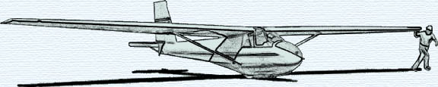

OCTOBER KSA MEETING
Saturday October 10, 2009
AT NIAR
Wichita State University
7:30 p.m.
PROGRAM
“Airplanes I Flew - Recollections of a Senior Pilot”
Don Fraiser, USAF Retired
Sponsored by Bob Hall

