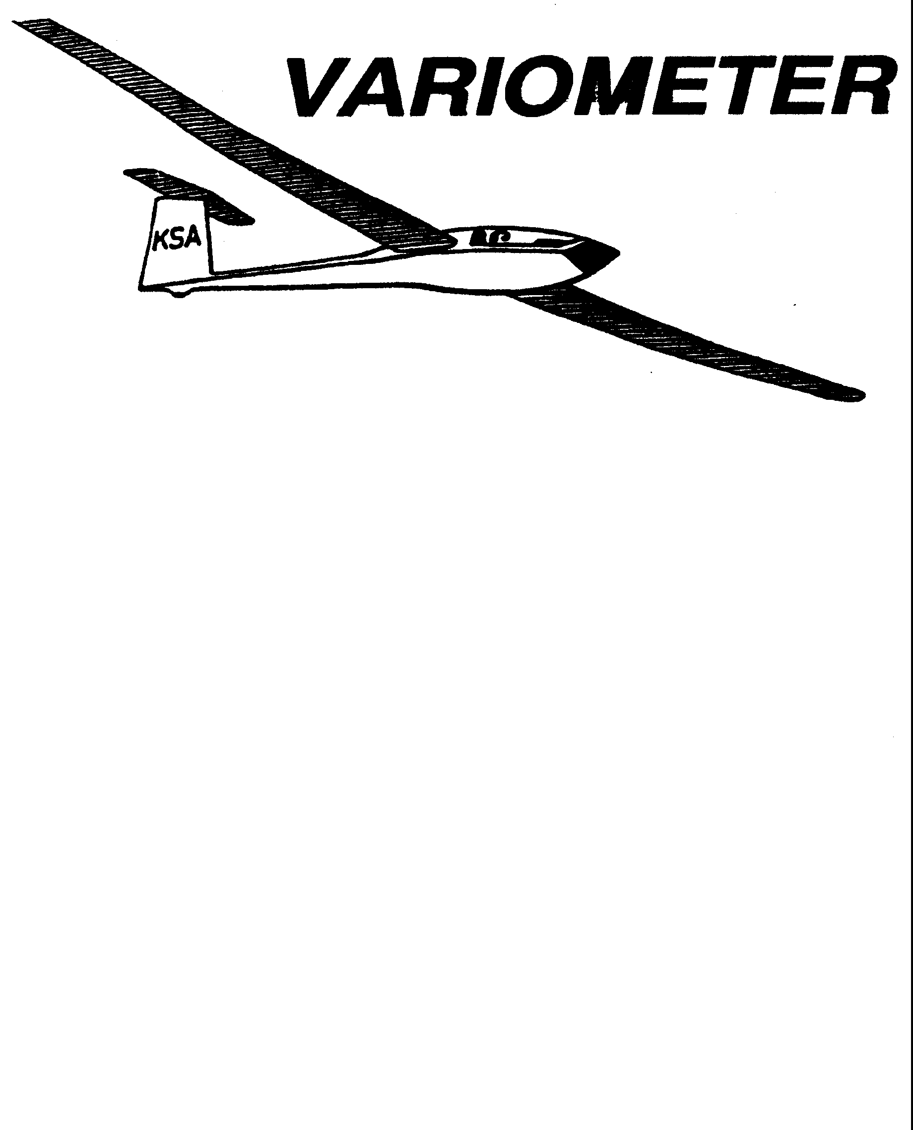

PRESIDENT – RAY GIRARDO (2009-2010
SECRETARY - TREASURER – NEALE EILER (2009-2010)
VICE PRESIDENT EAST – BOB BLANTON (2009-2010)
VICE PRESIDENT WEST – BOB HALL (2009-2010)
TOW PLANE MANAGER – STEVE LEONARD (2009-2010)
DIRECTORS: K. C. ALEXANDER (PAST PRESIDENT)

NEAL PFEIFFER(2009-2010)
DAVE WILKUS (2009-2010) PUBLISHED TO RECORD
ANDREW PETERS (2008-2009) THE UPS AND DOWNS
FRANK O’DONNELL (2008-2009) OF THE RAY SHARP -EDITOR
KANSAS SOARING ASSOCIATION

NOVEMBER, 2009

NOTES FROM THE PRESIDENT

We know it can happen. A little bit of age, a little bit of a lot going on, being a bit tired, or getting in a bit of a hurry and an easily lead to an avoidable mistake occurs. The results of this mistake can have consequences from no bit deal to just a nuisance to very serious. Being methodical and careful is very important. Checklists and routines compliment each other when used. Consider this whether transporting a glider, assembling a glider, or more importantly preparing for and flying the glider.

Yes, simple and avoidable mistakes can and do occur. Those of you who attended the last KSA Meeting know this. In placing the names for the fall KSA election from the Nominating Chairman to the Variometer I mis-read the list and typed a wrong name on the ballot. Duh. As result the election last month was voided and a new corrected ballot is included in this months Variometer. Please bring to the November KSA Meeting or mail to the address noted.

Nice fall weather seems to have arrived at least temporarily and hopefully this is being taken advantage of. Things have not slowed much for me but I am going to make it a point to go fly. You should do the same…before it rains again.

Ray

PLAN AHEAD

GET YOUR REPORT OF MEMORABLE FLIGHTS IN TO STEVE LEONARD

KANSAS SOARING ASSOCIATION

ANNUAL AWARDS BANQUET

SATURDAY, JANUARY 9, 2010
5:30 P.M. CONVERSATION
6:30 FOOD
WOODLAWN BAPTIST CHURCH FELLOWSHIP HALL

960 S Woodlawn
COST IS $12.50, MENU IS BEING TWEAKED TO BE BETTER THAN
LAST YEAR, IF YOU KNOW WHERE YOUCAN
MATCH THE MEAL FOR THE PRICE,YOUR EDITOR NEEDS TO KNOW

Reservations Required by January 4 , 2010, TO THE VARIOMETER

eMAIL preferred, Phone accepted

KSA ELECTION BALLOT
November, 2009

Vote for two names only

□ Dennis Brown
□ Frank O’Donnell
□ Andrew Peters
□ David Woody

Please bring this ballot to the November 14, 2009 KSA Meeting or
mail by November 14, 2009 to:

KSA Nominating Chairman
1424 North Byron Road
Wichita, Kansas 67212

KSA VARIOMETER
1950 S WEBB ROAD #112
WICHITA, KS 67207
rayandginisharp@juno.com

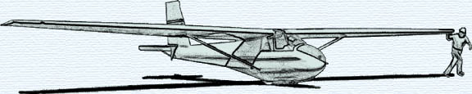

NOVEMBER KSA MEETING
Saturday November 14, 2009 7:30 p.m.

AT NIAR
Wichita State University
PROGRAM

“ARGENTINA”
Gliding in the 5th Dimension
3000 km in a glider

Sponsored by David Wilkus

