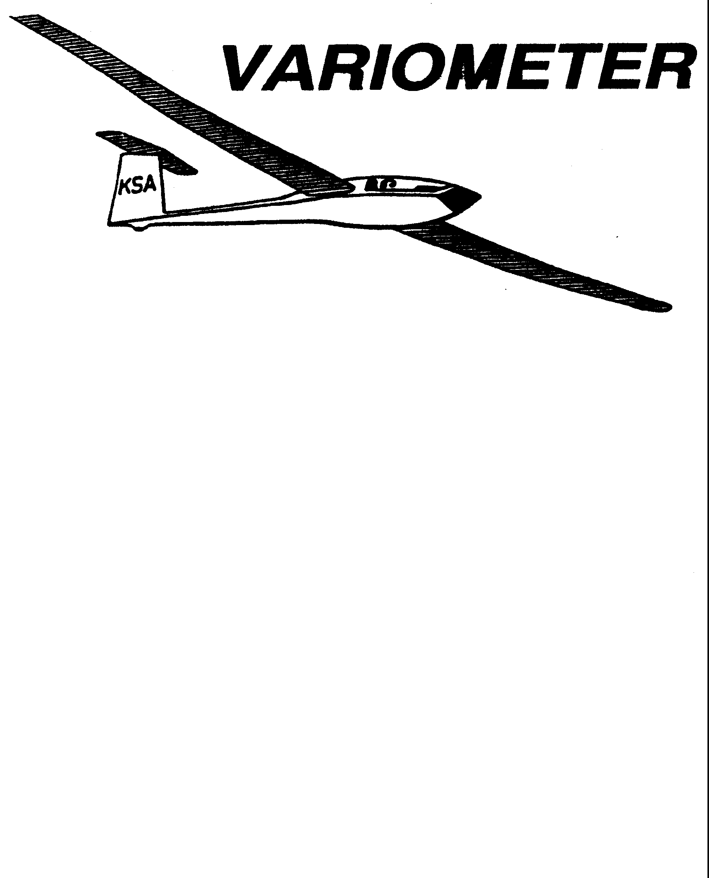

PUBLISHED TO RECORD
THE UPS AND DOWNS
OF THE
KANSAS SOARING ASSOCIATION
December 2009 Editor: Andrew Peters
PRESIDENT – RAY GIRARDO (2009-2010)
SECRETARY/TREASURER – NEALE EYLER (2009-2010)
VICE PRESIDENT EAST – BOB BLANTON (2009-2010)
VICE PRESIDENT WEST – BOB HALL (2009-2010)
TOW PLANE MANAGER – STEVE LEONARD (2009-2010)
DIRECTORS:
K. C. ALEXANDER (PAST PRESIDENT)
NEAL PFEIFFER(2009-2010) DAVE WILKUS (2009-2010)
FRANK O’DONNELL (2010-2011) DAVE WOODY (2010-2011)

NOTES FROM THE PRESIDENT

Well, the results of the election have finally been tallied. It took a bit longer due to my ballot snafu, and some late arriving ballots. This year’s Board of Directors race was the closet I can recall with two votes separating the winners and the other candidates. A recall challenge may be in the works! Those Directors elected by the membership are:
- Frank O’Donnell
- Dave Woody
Congratulations Frank and Dave, and thanks to Dennis and Andrew for their service and offers to be candidates.

A couple of other points this month.
First, please see the flyer for the January Awards Banquet and do not forget to call and confirm your reservation. This is always a great social event and the opportunity to recognize the flying achievements of this past season. And yes, the food is typically exceptional!
Second, do not forget January 1, 2010 where weather permitting the soaring season gets its unofficial start. Even though the flying is more gliding than soaring it’s a lot of fun and those who haven’t done this should do so. It starts as soon as the first brave soul gets up to Sunflower and brings the equipment out.
Finally we have a great program this month. Neal Eyler has arrangement a talk by an ex-military pilot with real experiences flying the U-2. It should be fascinating.

Have a safe and enjoyable holiday season. - R

KSA Calendar
2009
December 26th – Deadline for Submitting Awards Applications

2010
January 1st – 12:00 pm New Year’s Day First Flights at Sunflower
January 4th – RSVP to Ray Sharp for Awards Banquet
January 9th – 5:30 pm Annual Awards Banquet at Woodlawn Baptist Church

February 13th – 7:30 pm KSA Meeting at NIAR.

March 13th – 7:30 pm KSA Meeting at NIAR

April 10th – 7:30 pm KSA Meeting at NIAR

May – Resume flight operations at Sunflower
May 15th – KSA Meeting
May 31st – Pay your KSA 2010 dues!

June 12th – KSA Meeting

July 3rd – 2010 Kansas Kowbell Klassic
July 10th – KSA Meeting

Comments from the Editor
Sorry for the late distribution of this issue. The blame rests on my shoulders. This was my first effort, and there was a lot of work to be done getting everything squared away.

For some of you, this may be the first electronic version of the Variometer you have seen. I have tried to update the email distribution list accordingly. If you would like me to use a different email, please let me know.

KSA is trying to go to an all electronic distribution for the Variometer. It will save with postage and with time (an avoid paper cuts!) If you are receiving this via snail mail and have a valid email address, please let me know.

If you have any suggestions for content, format, or distribution, I am all ears. The role of the editor is to solicit input from the organization and assemble it into the newsletter. I hope that you will help me make this newsletter informative and entertaining each month.

One change you will notice is the KSA Calendar. I hope to capture up coming events so that you can plan ahead (and see what is going on in the club.)

KANSAS SOARING ASSOCIATION

ANNUAL AWARDS BANQUET

SATURDAY, JANUARY 9, 2010
5:30 P.M. CONVERSATION
6:30 FOOD
WOODLAWN BAPTIST CHURCH FELLOWSHIP HALL

960 S Woodlawn
COST IS $12.50, MENU IS BEING TWEAKED TO BE BETTER THAN
LAST YEAR,

RESERVATIONS REQUIRED BY JANUARY 4 , 2010, TO RAY SHARP

rayandginisharp@juno.com (preferred), or 316-684-1986

October “Last Chance” Checkride Camp Huge Success!
Congratulations to Nick Neidert, Sonja Flesberg, Shea Zucherman, and Christian Maude - the newest Private Glider Pilots to Kansas. The four completed their checkrides at the October Ratings camp. Special thanks to Charles Pate, the DPE who worked as hard as the applicants to make the checkrides a success.
We all know that soaring is unique in that it takes many others to help us get into the air. To those that helped with the camp, Mike Wastemeir, Tony Condon, KC Alexander, Jerry Boone, Steve Leonard, Frank O'Donnell, Brian Bird, and Summer Gajewski, on behalf of Nick, Sonja, Shea, and Christian, THANK YOU!

KSA FLYING AWARDS
(The following list is the basic description of the awards presented at the annual KSA Awards Banquet. The specific rules for each award have been published in previous issues of the Variometer. They were removed to save space in this issue. If you would like to see the specific rules, send me an email at apsoars@yahoo.com – Editor)
Wooden Wings Award
Awarded for the longest flight in a wooden winged sailplane. The task may be free distance, or if turnpoint are to be used, they must be declared in advance of the flight and in the sequence to be used. The task declaration may be written or verbal. The turnpoints need not form a closed course. A remote finish point can be used.
Mamie Cup
Awarded for the greatest distance flown from a Kansas departure. The task may be free distance, or if turnpoint are to be used, they must be declared in advance of the flight and in the sequence to be used. The task declaration may be written or verbal. The turnpoints need not form a closed course. A remote finish point can be used.
KSA Flying Horse (Silver)
Awarded for the best speed achieved around a 100 KM pre-declared closed course with a maximum of two turnpoints.
KSA 200 KM
Awarded for the best speed achieved around a 200 KM pre-declared closed course with a maximum of two turnpoints.
KSA Flying Horse (Gold)
Awarded for the best speed achieved around a 300 KM pre-declared closed course with a maximum of two turnpoints.
KSA Handicap Score Trophy
Awarded for the best combined score in four tasks - Duration (not handicapped, but 6 hours max scored), Altitude Gain (not handicapped), Distance, and Speed. Distance and speed are handicapped per SSA Handicaps or the KSA amended/added handicap. Departure point for all flights must be in Kansas. Data must be taken from four flights (i.e., one flight per task).
Charles Henning Award (Cumulative Speed Trophy)
Awarded to the pilot who has the highest average handicap speed over two flights for the year.
KANSAS KOWBELL KLASSIC
Awarded to the pilot who makes the longest flight, as measured on US Koast and Geodetic sectional charts, from the release point to his first point of landing, as verified on a standard SSA Landing Form. In kase of any dispute on measurement of the distance, said dispute will be steeled by Indian “rasslin,” (Texas Rules).
KANSAS KOWBELL KLASSIC KONSOLATION
Awarded to the pilot who completes the longest pre-declared task, as measured on US Koast and Geodetic sectional charts, from the release point, through any pre-declared turnpoints, to his point of landing, as verified on a Standard SSA Landing Form.
Lead C
Awarded to the pilot or soaring supporter who makes the most noteworthy non-achievement during the calendar year.
Preying Mantis
Awarded to the pilot who makes the most significant advance in his or her soaring ability during the calendar year. To be eligible for this award, the pilot must not yet have his or her Silver Badge at the beginning of the calendar year.
Towing Operations
Awarded to the person who made the most significant contribution to the towing operation during the calendar year.
Club Maintenance
Awarded to the person who contributed the most to the maintenance of the club owned equipment.
Rex Hamilton Memorial Award
Awarded by the SSA Governor for the state of Kansas by criteria defined by the Governor. Past criteria have included, but are not limited to: 1) Most impressive flight based on the sailplane, conditions, and pilot experience, 2) Significant accomplishment in soaring for that year or for a significant number of years.

GET YOUR REPORT OF MEMORABLE FLIGHTS IN TO DENNIS BROWN OR NEALE EYLER BY DECEMBER 26th.

2009 KSA AWARDS APPLICATION

Pilot’s Name____________________________________ Date______________

AWARD | DATE  OF FLIGHT | SAILPLANE | SPECIFICS
Preying Mantis |  |  | (Nominate Someone)
Towing Operations |  |  | (Nominate Someone)
Club Maintenance |  |  | (Nominate Someone)
Wooden Wings |  |  | Distance Flown
Flying Horse Silver  (100 KM Speed Task) |  |  | Speed in MPH
Flying Horse Crystal  (200 KM Speed Task) |  |  | Speed in MPH
Flying Horse Gold  (300 KM Speed Task) |  |  | Speed in MPH
Charles Henning Memorial Award (two flights required) | Flight 1 Date  Flight 2 Date | Flight 1 Sailplane  Flight 2 Sailplane | Flight 1 Speed (and time)  Flight 2 Speed (and time)
Kansas Kowbell Klassic | Landing Location |  | Distance
Kansas Kowbell Klassic Konsolation | Pre-declared Task (must have been completed to count!) |  | Distance
Mamie Cup |  |  | Distance
Pilot of the Year by Handicap Score | Altitude  Duration  Speed*  Distance* |  | (feet)  (hours:minutes)  (MPH)  (Statute miles)
Rex Hamilton Memorial Award |  |  | (Nominate Someone)
Other Significant Accomplishments (First Solo, First soaring flight, FAI Badge Leg, completion of an FAI Badge, 100th flight, 1000th tow, etc.

Documentation required for all flights, per rules published in The Variometer.
*If you had disposable ballast on board at takeoff of the Speed or Distance flight for consideration, you must put a “B” next to your claimed speed or distance. This affects the handicap number used for evaluating you performance.

“I certify that all flight claims made above were launched in Kansas and are properly documented (does not apply to “Other Significant Accomplishments” category).

Signed__________________________________________

Submit Applications to Dennis Brown (glide303@toast.net) or Neale Eyler (ndjseyler@hotmail.com) by December 26th 2009.

KSA VARIOMETER
5101 E27TH STREET N
WICHITA, KS 67220
apsoars@yahoo.com

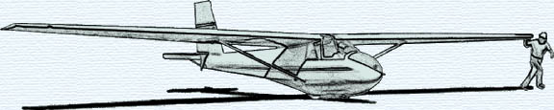

DECEMBER KSA MEETING
Saturday December 12, 2009

AT NIAR

Wichita State University
7:30 p.m.
GUEST SPEAKER

Donald H. Feld, Colonel, U.S. Air Force (Ret.)

Colonel Feld served twenty-six years in the U. S. Air Force. As a command
pilot, Col. Feld has over 3,000 hours of military flying time including 300 hours of fighter combat missions and 1,200 hours of tactical and strategic reconnaissance missions in the U-2 aircraft.

Sponsored by Neal Eyler

