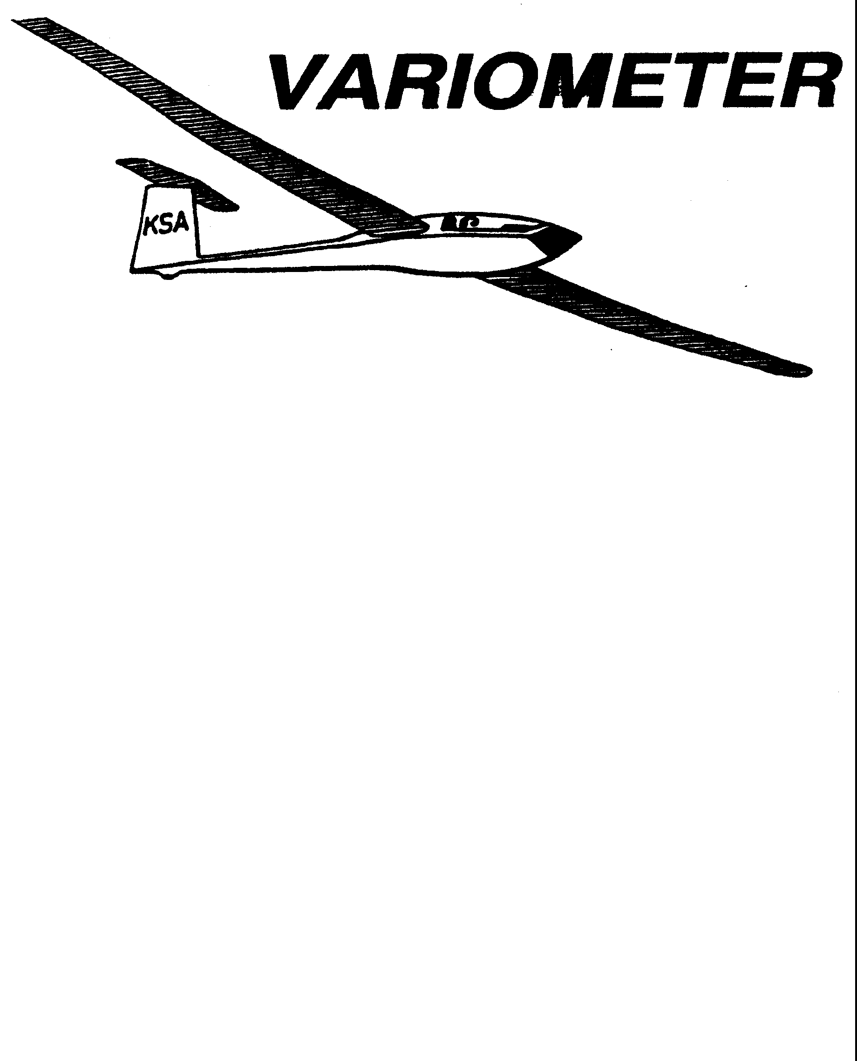

PUBLISHED TO RECORD
THE UPS AND DOWNS
OF THE
KANSAS SOARING ASSOCIATION
January 2010 Editor: Andrew Peters
PRESIDENT – RAY GIRARDO (2009-2010)
SECRETARY/TREASURER – NEALE EYLER (2009-2010)
VICE PRESIDENT EAST – BOB BLANTON (2009-2010)
VICE PRESIDENT WEST – BOB HALL (2009-2010)
TOW PLANE MANAGER – STEVE LEONARD (2009-2010)
DIRECTORS:
K. C. ALEXANDER (PAST PRESIDENT)
NEAL PFEIFFER(2009-2010) DAVE WILKUS (2009-2010)
FRANK O’DONNELL (2010-2011) DAVE WOODY (2010-2011)

NOTES FROM THE PRESIDENT

Please see the flyer for the January Awards Banquet scheduled for January 9. This is always a great social event and the opportunity to recognize the flying achievements of this past season. And yes, the food is typically exceptional!
Believe it or not, spring is just around the corner. At least the way my clock has been running. Every day is almost like being in ground rush. Your KSA Board of Directors has a great list of upcoming programs coming up to prepare and motivate all of us for the warmer weather ahead. Stay tuned! - R
Comments from the Editor
Once again I am going to apologize for the tardiness of this issue. I hope everyone had an enjoyable holiday break.

To those of you reading this on hard copy, I am sorry you didn’t receive the December 2009 issue. I have been working hard identifying member with email addresses, the preferred means of distributing the Variometer. If you have an email that can serve in place of a stamp, please let me know (apsoars@yahoo.com).

I did receive one item for this month’s issue. Plus, there are the results of the awards banquet. But, the cupboards are bare. Just like a 10+ knot thermal lifts our sailplanes to cloud base, so will you, sharing your stories, raise our spirits through the winter. As Ray Sharp said at the banquet, we all have a lesson to teach, a story to tell, an experience worth sharing. 3 Tango is standing by.

KSA Calendar
2010
January 20th – KSA Board of Directors Meeting, 6:00 at Gander Mountain
January 28th-30th – SSA Convention, in Little Rock, AR

February 13th – 7:30 pm KSA Meeting at NIAR.

March 13th – 7:30 pm KSA Meeting at NIAR

April 10th – 7:30 pm KSA Meeting at NIAR

May – Resume flight operations at Sunflower
May 15th – KSA Meeting
May 24th-29th – Region 10 Contest, Cherry Valley, AR
May 31st – Pay your KSA 2010 dues!

June 12th – KSA Meeting
June 15th-24th – Sports Class Nationals, Parowan, UT
June 29th- July 8th – Open/Standard Class Nationals, Hobbs, NM

July 3rd – 2010 Kansas Kowbell Klassic
July 10th – KSA Meeting

August 3rd-12th – 15-meter Nationals, Uvalde, TX

(The contests are included because several of your fellow members plan on competing in them this year. You can see the results on SSA.org and our flights are often posted on the OLC. This year, two members have SPOT GPS tracking devices. Most contests have a web page to view near real time the day’s task. Stay tuned for the specific websites in future issues. – 3T)

Awards Banquet Results!
Thirty club members braved the cold January air and attended this year’s awards banquet. The excellent food was provided by our friends at Woodlawn Baptist Church and arranged by our dedicated member Ray Sharp. Dennis Brown and Neale Eyler served as the Awards Committee, and Ray Girardo served as our master of ceremonies. Steve Leonard was again responsible for returning all the trophies he took home last year, as well as getting name plates made for the traveling trophies.
Wooden Wings Award – Neal Pfeiffer
Awarded for the longest flight in a wooden winged sailplane. The task may be free distance, or if turnpoint are to be used, they must be declared in advance of the flight and in the sequence to be used. The task declaration may be written or verbal. The turnpoints need not form a closed course. A remote finish point can be used.
Mamie Cup – Steve Leonard (241.9 sm)
Awarded for the greatest distance flown from a Kansas departure. The task may be free distance, or if turnpoint are to be used, they must be declared in advance of the flight and in the sequence to be used. The task declaration may be written or verbal. The turnpoints need not form a closed course. A remote finish point can be used.
KSA Flying Horse (Silver) - Dennis Brown (61.5 mph)
Awarded for the best speed achieved around a 100 KM pre-declared closed course with a maximum of two turnpoints.
KSA 200 KM – Dennis Brown (46.1 mph)
Awarded for the best speed achieved around a 200 KM pre-declared closed course with a maximum of two turnpoints.
KSA Flying Horse (Gold) – Andrew Peters (44.9 mph)
Awarded for the best speed achieved around a 300 KM pre-declared closed course with a maximum of two turnpoints.
KSA Handicap Score Trophy – Steve Leonard
Awarded for the best combined score in four tasks - Duration (not handicapped, but 6 hours max scored), Altitude Gain (not handicapped), Distance, and Speed. Distance and speed are handicapped per SSA Handicaps or the KSA amended/added handicap. Departure point for all flights must be in Kansas. Data must be taken from four flights (i.e., one flight per task).
Charles Henning Award (Cumulative Speed Trophy) Dennis Brown (avg 45.4 mph)
Awarded to the pilot who has the highest average handicap speed over two flights for the year.
KANSAS KOWBELL KLASSIC – Bob Holiday
Awarded to the pilot who makes the longest flight, as measured on US Koast and Geodetic sectional charts, from the release point to his first point of landing, as verified on a standard SSA Landing Form. In kase of any dispute on measurement of the distance, said dispute will be steeled by Indian “rasslin,” (Texas Rules).
KANSAS KOWBELL KLASSIC KONSOLATION – Not Awarded
Awarded to the pilot who completes the longest pre-declared task, as measured on US Koast and Geodetic sectional charts, from the release point, through any pre-declared turnpoints, to his point of landing, as verified on a Standard SSA Landing Form.
Lead C – Not Awarded
Awarded to the pilot or soaring supporter who makes the most noteworthy non-achievement during the calendar year.
Preying Mantis - Pat Ensign
Awarded to the pilot who makes the most significant advance in his or her soaring ability during the calendar year. To be eligible for this award, the pilot must not yet have his or her Silver Badge at the beginning of the calendar year.
Towing Operations – Bob Hall
Awarded to the person who made the most significant contribution to the towing operation during the calendar year.
Club Maintenance – K.C. Alexander
Awarded to the person who contributed the most to the maintenance of the club owned equipment.
Rex Hamilton Memorial Award – Tony Condon
Awarded by the SSA Governor for the state of Kansas by criteria defined by the Governor. Past criteria have included, but are not limited to: 1) Most impressive flight based on the sailplane, conditions, and pilot experience, 2) Significant accomplishment in soaring for that year or for a significant number of years.

The WSA 50km speed trophy again went to Rich Stone. Certificates were presented to club members for first solo (Summer Gajewski), completing a pilot certificate (Keith Smith, Nick Neidert, Sonja Flesberg, Shea Zuckerman, and Christian Maude), and participating in soaring contests (Bob Holiday, Steve Leonard, and Andrew Peters.)

Ray Sharp was recognized with a special award for his many years of service to the club. He served as the Editor of the Variometer for over 20 years! He has also made and repaired tow ropes for the club, organized the awards banquet for the past several years, and made countless other contributions to the club. During his remarks after receiving the trophy, an eagle with outstretched wings on a round oak base, he said “I have received more from KSA than I could ever give back. Thank you for your service.”

Rules for the various traveling trophies will be published in a future issue of the Variometer. With lots of new faces, new gliders, and new pilots – we should finally get to be seeing some new names on the trophies. Pick a task, and go for it! If you have questions, talk to someone. Let’s all go out there and get after it!

Tow Tickets
The last of the Variometer contains Tow Tickets. There’s no reason for anyone to show up to Sunflower without some. Please use the tickets as printed in the Variometer. And please cut them out so that they are all the same size. The Tow Pilots’ and Tow Plane Manager’s job is easier if they can be neatly stacked. Now’s the time to cut them out and get a stack ready for the summer flying.
Aviation Dinner/Speaker
One of our members who is also active in the CAF wanted to share this opportunity coming to Wichita in March.

KSA VARIOMETER
5101 E27TH STREET N
WICHITA, KS 67220
apsoars@yahoo.com

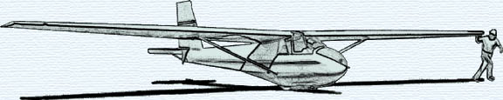

February KSA MEETING
Saturday February 13, 2010

AT NIAR

Wichita State University
7:30 p.m.

