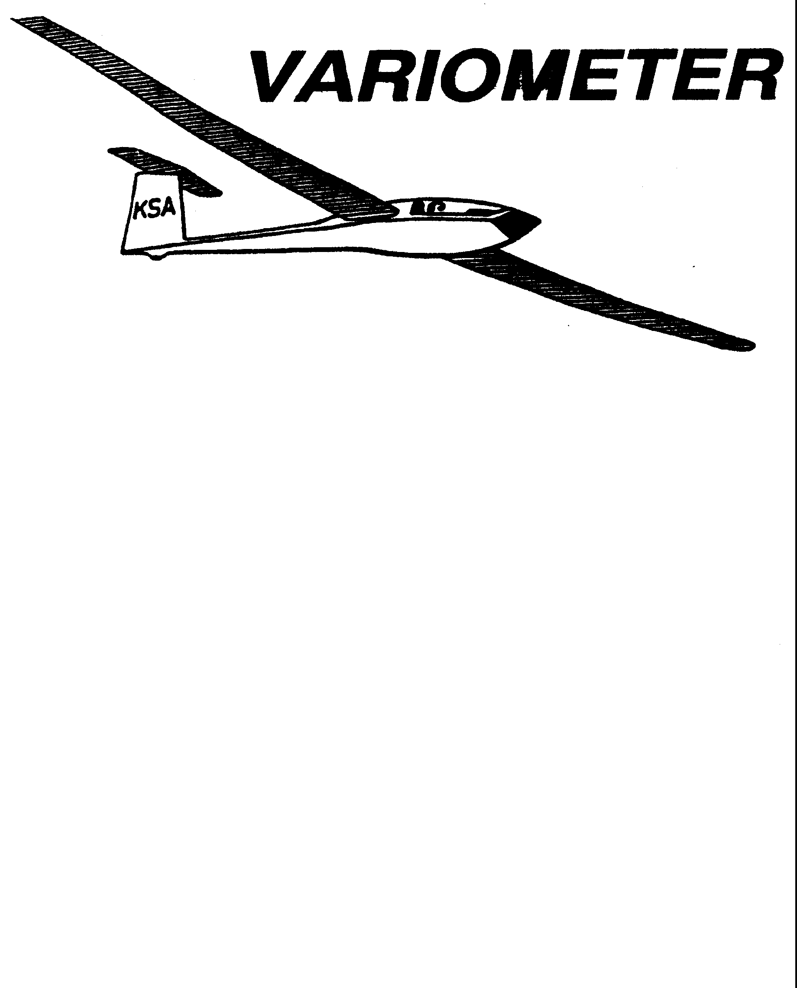

PUBLISHED TO RECORD
THE UPS AND DOWNS
OF THE
KANSAS SOARING ASSOCIATION
June 2010 Editor: Andrew Peters
PRESIDENT – RAY GIRARDO (2009-2010)
SECRETARY/TREASURER – NEALE EYLER (2009-2010)
VICE PRESIDENT EAST – BOB BLANTON (2009-2010)
VICE PRESIDENT WEST – BOB HALL (2009-2010)
TOW PLANE MANAGER – STEVE LEONARD (2009-2010)
DIRECTORS:
K. C. ALEXANDER (PAST PRESIDENT)
NEAL PFEIFFER (2009-2010) DAVE WILKUS (2009-2010)
FRANK O’DONNELL (2010-2011) DAVE WOODY (2010-2011)

NOTES FROM THE PRESIDENT

The flying season is really in full swing! There has been lot’s of activity at Sunflower and at other soaring locations around Kansas. It is very important to support all aspects of operations by making your assigned Duty Day, whether that is as an instructor, tow pilot, or launch line manager. Glider operations are not possible without the dedication, help and support of others. The duty roster for the rest of the year is now complete and will be published in the Variometer. It is impossible to accommodate everyone’s request for a particular day, but we (Steve, Andrew and I) try to do the best we can. Remember, if you cannot make your assigned duty day, it is your responsibility to find a substitute.
Tiedown: Do not tie down glider trailers between the new hangar and the fuel tank. This area needs to remain clear for parking of visiting aircraft. Overnight parking of gliders in this area is permissible.
2010 Hangar Rent and Use: Effective November 2, 2010 hangar space can be rented for $20 per month in the T-Hangar for storing glider trailers, boats or other vehicles during the off season. Aircraft storage will have priority at $40 per month. Trailers must be stored such that access to aircraft is not restricted. If all available space in the T-Hangar is taken, storage may be obtained in the new hangar for $30 per month. Glider trailers boats, etc., stored in the hangar over the winter months must be removed no later than March 31.
2011 New Hangar Fee: Effective January 1, 2011 hangar rent for non-club owned aircraft stored in the new hangar will be $60 per month. There will not be a yearly rate established for the new hangar. Space in the new hangar will only be available if there is no space in the T-Hangar. Club owned equipment (KSA and WSA) will have priority for this space (closest to the door). T-hangar rate remains at $40 per month or $400 if paid in advance for a complete year.
Please call myself, Steve Leonard, or Neale Eyler if you have any questions.
Safe Soaring!
-R

KSA Calendar
2010
June 12th – Evening KSA Cookout Meeting at Sunflower (5:30 pm)
June 12th - 13th – WWC: Modified Assigned Task
June 15th - 24th – Sports Class Nationals, Parowan, UT
June 28th - July 3rd – Region 9 Sports Class, Hobbs, NM
June 29th - July 8th – Open/Standard Class Nationals, Hobbs, NM

July 3rd – 2010 Kansas Kowbell Klassic
July 3rd - 4th – WWC: Free Distance
July 10th – Evening KSA Cookout Meeting at Sunflower (5:30 pm)
July 26th - 31st – Region 10 Central Texas Contest, Llano TX

August 3rd-12th – 15-meter Nationals, Uvalde, TX
August 7th - 8th – WWC: Prescribed Area Distance
August 14th – Evening KSA Cookout Meeting at Sunflower (5:30 pm)

September 11th – KSA Cookout Meeting at Sunflower (5:30 pm)
September 18th - 19th – WWC: WSA Triangle Lap Race
September 23-26th – Vintage/Classic Sailplane Regatta at Wichita Glider Port

October 9th – 7:30 pm KSA Meeting at NIAR – ELECTIONS!
October 16th - 17th – WWC: Last man down
October 17th – Last Scheduled Duty Day for Flight Operations at Sunflower
October 23rd – Fall Clean Up Day

November 13th – 7:30 pm KSA Meeting at NIAR
December 11th – 7:30 pm KSA Meeting at NIAR

Sunflower Seeds
May 1 – No Report
May 2 – Great Soaring Day! Doug Wilson and Richard Boone were the line managers (I think) and Andrew Peters towed. Jerry Boone completed his Silver Distance flight, he flew about 140 miles. Tony Condon flew his Cherokee 193 miles to Falls City, Nebraska for Gold Distance and good enough to win the OLC in the USA (A guy from Europe beat him by just a few km.) Keith Smith, Dennis Brown, Pat Ensign, Bob Hall, and Steve Leonard were present. Andrew flew with Steve for his BFR. Bob Holliday called in on the radio, he flew from the WGP to Ulysses. Flew back to Wichita the next day. Sunday and Monday were the two best soaring days I have seen thus far this year. 8-9000' cloud bases with strong lift.
May 8 – It was a good day for soaring at Sunflower. Summer Gajewski worked the launch line and Bob Hall provided tows. At the field were Jerry Boone (gave 3 or 4 friends rides) Dennis Brown, Scott Demmick, Steve Leonard, Dave Wilkus. Lift was present under the overcast skies, top of lift was around 5000'. KSA BBQ meeting was held, but no news from the event.
May 9 – No Report
May 15 – No Report
May 16 - No Report
May 20 – Overcast skies around 2000'. Bob Hall towed, Summer Gajewski and Leah Condon flew with Tony Condon instructing. 14 flights, including 3 solos for Summer. Hey look, you can fly during the week! - 3T
May 22 – Winds 30 gusting 40. No flying.
May 23 – No report, winds were above WSA minimums.
May 29 – Neal Pfieffer (LLM), Frank O'Donnel (Tow), Andrew Peters (CFIG). 14 tows taken by John Bender, Pat Ensign, Dennis Brown, Dave Wilkus, Rich Stone, Summer Gajewski, Gavin Smith, and Steve Wenke. Harry Clayton, Sue Erlenwein, Ray Sharp, Steve Leonard, and Neal Eyler were present. Harry lead the charge in getting the WSA airplanes annualed.
May 30 – Harry Clayton and Sue Erlenwein (LLM), Bob Hall (Tow). Dave Woody, Ben Sorenson, Dennis Brown, Bob Blanton, and Andrew Peters all took tows. Cold front moved through, with a wind shift and noticeable temperature drop. No significant lift, the day was cut short and everyone went home early.
May 31 – No report.

Comments from the Editor

First, I must appologize to our paper readers. I failed to mail the May Variometer, things got busy and I just forgot. If you want to get a back issue of it, please call me 316-393-2261 and I will send it out.

Reminder to the launch line managers – please remember to record who was present, what the flying was like, and how many flights occurred during your duty day. Email me your notes and I will include them in the Sunflower Seeds section. Thanks to Summer, Tony, Steve, and Frank for recording May's activity.

The VARIOMETER is able to accept photos. Please email them to me at apsoars@yahoo.com. Include a description and I'll turn it into an article.

3T is standing by….

A note from the WSA Treasurer
A reminder to all,

When filling out the billing slips in WSA aircraft, you need to put the instructors name or initials in the Ins. column of the billing slip when you fly with an instructor. Do not put any other mark in this column. In the future, if there is ANY mark in this column you will be billed for instruction. We have people using a slash for no instruction and others using a slash for instruction, also some checkmarks and some slashes look alike. This becomes an issue when trying to enter billing data.

Sue

Chasing the Cherokee (version 1)
by Summer Gajewski
Ok, You wanted a story? Here ya go, the story of a overly extended day of chasing Tony's GOLD distance. Feel free to forward to who ever you like.
Well Sunday started out like any other FANTASTIC looking glider day, with students on the ground and instructors (and licensed glider pilots) in the sky. (no hard feelings of course, just a bit of green eyed envy) That is, until Tony asked Shea and me if we would like to experience some good old fashioned glider chasing, so him and I figured "what the hay?" we are always wanting to see ALL of the ins and outs of gliding. So equipped with fabulous KANSAS (and for some reason TX) road maps, a radio to Tony, and a half dead pick-up truck hauling and overly long trailer we set out. Now, let me say neither of us expected it to be a short day, what with the magnificent fluffy cumulus leering over head, and the experience of Tony, but NEVER did we predict that we would be arriving in NEBRASKA at 12AM. However, I must say it was a lovely day, and I personally have no regrets, about agreeing to be on the chasing crew.
I also must say that thanks to my mad navigating skills, we only got turned around about once or twice. We did, however, have a TON of fun stopping at an old ghetto, small town gas station where Shea proceeded to break the prepay gas device on the pump which put us about 20 mins behind Tony about half way through the day. (Don't let Shea tell you any different, he broke it)
Another fun point was when we were getting closer to the north eastern end of Kansas. We were making good time and were picking up Tony on his transponder (radio thing) again...until we hit Limestone road...which both Shea and myself now believe to be the cursed road among chasers. To start out with, when we started to drive down it I began looking for my usual identifying roads to make sure that we were going to right direction, but then the
Chasing the Cherokee (version 2)
by Shea Zuckerman
As a result of Steve L's brilliant idea to go down in the history books, everyone sit down, get comfy, because it's storytime kiddies!
In the far too recent past Summer and I had an adventure neither of us bargained for. Let me set the scene: Picture me driving a pickup with more miles on it than the wheel, hauling Tony Condon's trailer which is as long as a bus and shiny as a mirror, with Summer riding shotgun holding the map. Tony whipped off tow above, and Summer and I were off below. Reminded me of the movie 'Twister' where they get the weather info that sets the team off chasing a rogue tornado. Yes, Tony was a rogue tornado. What else could he be when he goes wherever our beloved invisible tornadoes rise.
We headed North towards nothing in particular. Summer guiding our one vehicle circus; hunting and pecking for roads that are solidly paved. Funny how towards the end we found out the map tells you which ones are paved and which aren't. Newbies. Tony and his vintage Cherokee effortlessly lifted to over 7K, and we effortlessly got lost. As he crept more east we attempted to follow on a road that was going directly on an intercept course. Summer was navigating with flair, I was one with the bus. All was well...until. Our path, without any warning, no signs, nothing, whipped right. (Tony, the brakes on your truck work fine, or at least they did then) . Our brilliant road wasn't getting us any closer to the eastbound sailplane suddenly. Turning around to remedy this error is an excersize in traffic management. You all know what I'm talking about.
I might also add that this truck (and, incidentally, the invention of the wheel) both come equipped with no cruise control. I looked very much forward to getting off-track briefly so I could pull over and work out the kink in my gas foot. I am sure Summer looked forward to those brief breaks also so she could tell me to shut up about the dinosaur on wheels.
fact that there were pretty much NO intersecting roads for the next 5 miles really helped out.
Then when there WERE intersecting roads they were no where to be found on the map. So eventually we drove through a town that I personally had no idea what the name of it was, because I don't think it was even listed on the map. It was so tiny (and creepy) that we thought it must be deserted, because most of the houses looked run down and there were no people or cars anywhere.
Well as it turned out the Town we passed through wasn't deserted, because we eventually saw some people working on a boat, where when we drove passed them the promptly started to wave happily at us (we actually got waved at a lot when passing though smaller towns, kinda nice, but kinda weird too).
So, we eventually pulled ourselves away from the evil powers of that cursed Limestone road, and found our way up to Falls City, Nebraska. And believe me, I was really happy that Tony had decided to stop there not only because we were just a LITTLE bit tired, but also because thats where the maps that we had stopped as well.
In the end our times were roughly: we left Falls City around 12AM, got back to Wichita around 3AM where Tony lent me his car to drive back to the glider port where my car was parked, and then after I had exchanged Tony's car for my own, I drove back to Hutch and went to sleep around 4:30ish AM. Then I got back up at 6:30AM (and literally drank five cups of extra dark coffee(or as my mother likes to call it "motor oil")) and went to my 7AM ZERO HOUR at the high school. YAY!
I will say though that the entire trip was a BLAST. Good people+GREAT Soaring+A funny clunky old truck= Good Times.

Fast forward to later when we were back to chasing Tony-Tornado. Both Summer and I thought at best we would be chasing for say, maybe 4 hours. Conditions were just too perfect, and we, after much in-cab banter, 2 fuel stops, unfortunately shaped Nutter-Butters, and nightfall, caught Tony chilling somewhere in Nebraska! That man and his wooden stick ship flew for over 180 miles out of Sunflower and for well over 6 hours! Unbelievable! We drove more than 300 miles through Kansas to reach him. All of us were astonished at the duration and distance of the flight. He was soaring for whatever distance, and ended up with a Gold Badge by accident. That's some skills!
Green with envy, we met him at the airport to trailer the ship in the dark. The weather was threatening rain, but we caught some luck and never saw any. Weary from travel, but excited about the journey, we drove the circus back to Wichita and arrived here at 3 in the morning, polishing off an adventure that began at 1 the previous afternoon.
Were Summer and I mad that WE weren't the ones flying? Absolutely. Would we have given up the opportunity to putz around, hone our tracking skills, and create a story? Absolutely not. It was a memorable day, both on the ground and in the sky.

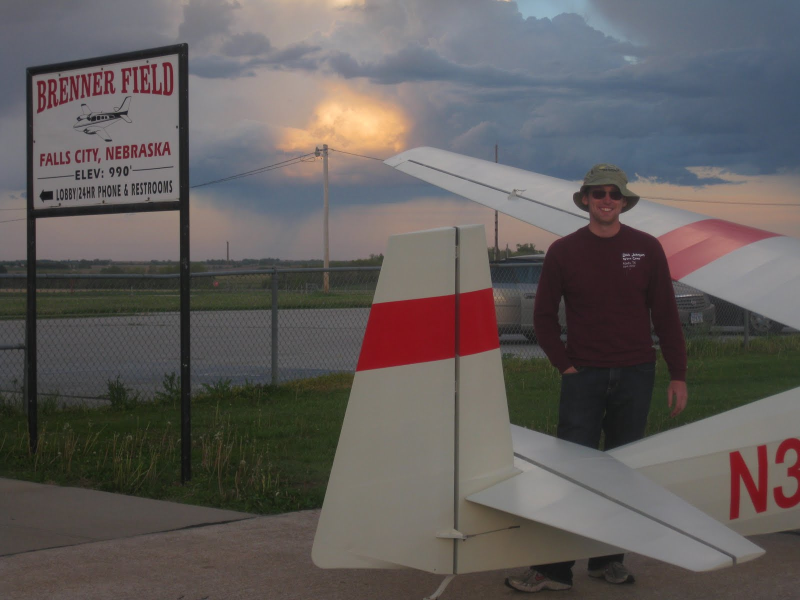
The lucky pilot, on the ground after his Gold Distance Flight!

RULES FOR KANSAS KOWBELL KLASSIC
(As re-printed from the May 1963 issue of SOARING)
1) Any soaring pilot and sailplane may enter.
2) Only one flight per pilot will be eligible for konsideration, and the flight must be made on the date selected for the Kowbell Klassic.
3) The winner each year will be the pilot who makes the longest flight, as measured on US Koast and Geodetic sectional charts, from the release point to his first point of landing, as verified on a standard SSA Landing Form. In kase of any dispute on measurement of the distance, said dispute will be steeled by Indian “rasslin,” (Texas Rules).
4) The release altitude will be no higher than 2000 feet above the contest site.
5) The release point will be vertically above the contest site.
6) The Annual Klassic will be held each year on the first Saturday after the first full moon that falls on or after the summer solstice (i.e., the first point of the sign of Kancer)
7) Normal adverse soaring weather, i.e., rain, overcast sky, lack of thermal, etc shall not constitue a valid reason for postponement of the Kowbell Klassic. If the weather is unsafe for glider flight, then the next Saturday during which unsafe weather is not present shall be the date of the Kowbell Klassic.
8) A suitable trophy has been fabricated by Mickey Jensen and Marshall Claybourn, and the aforementioned trophy shall be placed in the possession of the Officers of the Kansas Soaring Association who will be charged with its annual presentation, in accordance with these rules.
9) Any person who wins the Kowbell Klassic thrice in succession shall become the permanent owner of the trophy and a replacement will be provided by the original source.

RULES FOR THE KANSAS KOWBELL KLASSIC KONSOLATION

The rules for the Kansas Kowbell Klassic Konsolation are the same as for the Kansas Kowbell Klassic, except as amended below.

1) Any soaring pilot and sailplane may enter, except for the winner of the previous days Kowbell Klassic.
2) The winner each year will be the pilot who completes the longest pre-declared task, as measured on US Koast and Geodetic sectional charts, from the release point, through any pre-declared turnpoints, to his point of landing, as verified on a Standard SSA Landing Form.
6) The Annual Kowbell Klassic Konsolation will be held each year on the Sunday following the AnnualKowbell Klassic, unless the second place competitor in the Kowbell Klassic flew farther than 200 miles. In this kase, the Kowbell Klassic Konsolation will be held on the Saturday following the Kowbell Klassic.

KSA Calendar Online
Did you know that there is a calendar online for KSA? http://www.my.calendars.net/KSA
You can see up to date duty schedules and other activities throughout the year. Speaking of the duty schedule, if you arrange a swap with someone, please update the calendar.
Click on Add Events: Daily on the left side of the calendar menu. Select the day of the month you wish to edit, the select EDIT for Sunflower Duty Roster.
If you can send me an email, I will update the roster that is included in the Variometer.
Weekend Warrior Contest
by Andrew Peters

Results for WWC #1 – Climb is King
No task claims were made. Saturday the winds were 30 gusting to 40, with Sunday only marginally less. To my knowledge, no one flew. So everyone is still in the running!
General Rules:
- Any member has two days to complete the task.
- Tasks can be performed more than once – only the fastest – longest – highest will count.
- Your contest record must be submitted to the Scorer (Andrew Peters, 3T) by midnight on the Monday following the contest weekend. The contestant with the best task will receive 1000 points. Other contestants will receive points as a percentage of their task compared to the winners.
- All speed and distance tasks will be handicapped (SSA handicaps will be used – if one doesn't exist for your glider, one will be assigned based on the experience of the glider owner and other experienced competition pilots.)
- If you don't yet have your Silver badge and you want to compete, you will get a 100 point bonus added to your score.
- If a multi-place glider is used, and you take another pilot with you who has not completed their Silver badge, a 100 point bonus will be earned. Landing at a charted airport will earn a 25 point airfield bonus.
- At least two people need to compete for the weekend to be a valid contest weekend.
- The Weekend Warrior Champion will be the member with the highest cumulative score for any four of the six contest weekends at the end of the season.
- Expensive GPS recorders are not required, although might make it easier on the scorer. A paper record and digital photo's can be used. Just make sure the photo contains sufficient detail that Google Maps can verify your location and orientation to Sunflower. Any GPS that will record your coordinates can also be used – SPOT, running watches, even some smart phones have tracking capability.
June 12-13th – Modified Assigned Task (MAT)
The Modified Assigned Task (MAT) is a type of speed task used in glider US glider competitions. Some parts of the task are assigned by the Contest Director. Other parts of the task are up to the individual competitors.
For the WWC, here is the MAT task:
- Minimum Time: 2 hour
- Start Point: Overhead Sunflower
- Maximum Start Height: 3500' AGL x your Handicap
(e.g. 1582' + 3500' x 0.915 = 4785' MSL)
- Maximum number of turn points: 11 (does not include start or finish points)
- Repeating turn points is acceptable.
- Photos: Must be taken looking back towards Sunflower.
- GPS: Must go to the far side of the turn point from Sunflower.
- Finish Height: 500' AGL minimum (2082' MSL with current Hutchinson altimeter setting.)
Turn point files can be found at http://soaringweb.org/TP/NA.html#US for Hutchinson, KS. The list of turn points is also going to be distributed with this copy of the VARIOMETER via email.
Task Explanation
The start will be over Sunflower (plan to cross the runway or imagine a line from the tower to the wind sock to cross on your way to the first turn point.) Note your time crossing the start line. Also, remember that the maximum start height is 1582 + 3500 x your handicap. You need to cross the line below this altitude. Call in your start time on 123.5.
Fly to the far side of the turn point (reference Sunflower), take a photo or use GPS. Proceed to the next turn point of your choosing. Make sure you record the turn point name/number and the order that you arrive at them. Repeating turn points is acceptable. Continue to fly to turn points until the minimum time has passed since your start. You must return to Sunflower to receive speed points.
You can only list 11 turn points, not including the start and finish points. Remember, if photos are being used to verify your task, you need to be oriented looking back at Sunflower and the landmarks must be distinguishable on Google Earth or Google Maps. Your distance will be the total of the distances between all the turn points you declare after the flight.
Your distance will be divided by time to compute your speed. If you return before the minimum time, your distance is divided by the minimum time. If you fly longer than the minimum time, your your actual time flown is used.
Low finishes are not going to be encouraged. Therefore, you should plan on arriving back overhead Sunflower no lower than 500' AGL (2082' MSL). If anyone observes unsafe or low finishes, disqualification or penalties may result.
Questions can be submitted to me, at apsoars@yahoo.com.
July 3rd- 4th – Free Distance
The Free Distance task goes back to the old glory days of soaring, where the goal was to fly as far as possible, in any direction you chose, and not come back to the original point of departure. This task coincides with the Kowbell, whose rules appear earlier in this issue. For the WWC, there are some additional scoring opportunities. If Sunday qualifies for the Konsolation, your Konsolation task distance will be added to your free distance flight.
Scoring:
The person flying the longest handicapped distance will receive 1000 pts. Scores for the other competitors will be a percentage of the winners, based on the ration of the handicapped distances. Landing at an airport will result in a 25 point bonus. The other bonus point opportunites also apply (see general rules.) Konsolation distance will be added to any additional free distance miles.
Landing location needs to be submitted to the Scorer by midnight Monday, July 5th. Latitude and Longitude, airport identifier, etc. A logger is not required, but there must be some means to verify your landing location.
Fly safe, fly far, fly fast! - 3T
Scheduled Work Day is 12:00 to 5:00 pm
Date | Tow Pilot | Line Managers | Instructor
Sat June 12 | K.C. Alexander  316-943-7641 | Leah Condon 249-3535  Ray Girardo 942-0638 | Tony Condon  515-291-0089
Sun June 13 | Mark Schlegel  316-641-5093 | Scott Dimmick 733-5678  David Woody 682-1895
Sat June 19 | Dennis Brown  316-722-8351 | Gary Hurst 620-257-5016  Rich Stone 612-2008 | Andrew Peters  316-393-2261
Sun June 20 | Frank O’Donnell  316-788-3224 | Ron Blum  Doug Wilson 733-5537
Sat June 26 | Bernie Mohr  316-733-4524 | Harry Clayton 744-2389  Summer Gajewski (620)899-1151 | Tony Condon  515-291-0089
Sun June 27 | Pat Ensign  816-835-6580 | Jerry Boone 620-662-5330  Neal Pfeiffer 686-4306
Sat July 3 (Kowbell) | K.C. Alexander  316-943-7461 | Ray Girardo 942-0638  Dakota Harms 282-6000 | Frank O’Donnell  316-788-3224
Sun July 4 | Jack Seltman  316-636-4218 | Neale Eyler 729-0659  Ashok Chathbai 516-9581
Mon July 5 | Bob Hall  620-663-9577 | Scott Dimmick 733-5678  David Woody 682-1895
Sat July 10 | Bernie Mohr  316-733-4524 | Neal Pfeiffer 686-4306  Bob Blanton 683-9759 | Tony Condon  515-291-0089
Sun July 11 | Bob Holliday  316-733-5403 | David Wilkus 788-0932  Christian Maude 620-532-3608
Sat July 17 | Charles Pate  316-685-5695 | Bryan Pate 524-8829  Linda Pate 524-8829 | Andrew Peters  316-393-2261
Sun July 18 | Ben Sorensen  316-655-0257 | Ron Blum  Shea Zuckerman 801-554-7337
Sat July 24 | Andrew Peters  316-393-2261 | Jerry Boone 620-662-5330  Gary Hurst 620-257-5016 | Tony Condon  515-291-0089
Sun July 25 | Pat Ensign  816-835-6580 | Harry Clayton 744-2389  Summer Gajewski (620)899-1151
Sat July 31 | Mark Schlegel  316-641-5093 | Leah Condon 249-3535  Ray Girardo 942-0638 | Frank O’Donnell  316-788-3224
Sun Aug 1 | K.C. Alexander  316-943-7461 | Scott Dimmick 733-5678  Neale Eyler 729-0659
Sat Aug 7 | Bob Holliday  316-733-5403 | David Woody 682-1895  Endri Lika 620-474-6445 | Dave Stanko  316-393-6249
Sun Aug 8 | Jack Seltman  316-636-4218 | Leah Condon 249-3535  John Peters 682-4287
Sat Aug 14 | Tony Condon  515-291-0089 | Shea Zucherman 801-554-7337  Ray Girardo 942-0638 | Mike Westemeir  316-729-2551
Sun Aug 15 | Bob Hall  620-662-9577 | Doug Wilson 733-5537  Ron Blum fly-in-home@att.net
Sat Aug 21 | Bernie Mohr  316-733-4524 | Asok Chathbai 516-9581  David Wilkus 788-0932 | Andrew Peters  316-393-2261
Sun Aug 22 | Tony Condon  515-291-0089 | Christian Maude 620-532-3608  Neal Pfeiffer 686-4306
Sat Aug 28 | Ben Sorensen  316-655-0257 | Bob Blanton 683-9759  Gary Hurst 620-257-5016 | Brian Bird  620-664-7844
Sun Aug 29 | K.C. Alexander  316-943-7461 | Harry Clayton 744-2389  Steve Leonard 729-0356
Sat Sep 4 | Mark Schlegel  316-641-5093 | John Bird 620-728-1341  John Peters 682-4287 | Dave Stanko  316-393-6249
Sun Sep 5 | Frank O’Donnell  316-788-3224 | Jerry Boone 620-662-5330  Rich Stone 612-2008
09/06/10 | Dennis Brown  316-722-8351 | Ashok Chathbai 516-9581  Christian Maude 620-532-3608
Sat Sep 11 | Charles Pate  316-685-5695 | Bryan & Linda Pate 524-8829 | Mike Westemeir  316-729-2551
Sun Sep 12 | Andrew Peters  316-393-2261 | Scott Dimmick 733-5678  Endri Lika 620-474-6445
Sat Sep 18 | Bob Hall  620-662-9577 | David Wilkus 788-0932  Doug Wilson 733-5537 | Brian Bird  620-664-7844
Sun Sep 19 | Mark Schlegel  316-641-5093 | Ray Girardo 942-0638  Ron Blum fly-in-home@att.net
Sat Sep 25 | Tony Condon  515-291-0089 | David Woody 682-1895  Summer Gajewski (620)899-1151 | Andrew Peters  316-393-2261
Sun Sep 26 | Bernie Mohr  316-733-4524 | Dakota Harms 282-6000  Neale Eyler 729-0659
Sat Oct 2 | Pat Ensign  816-835-6580 | Ashok Chathbai 516-9581  Christian Maude 620-532-3608 | Dave Stanko  316-393-6249
Sun Oct 3 | Brian Bird  620-664-7844 | Steve Leonard 729-0356  Rich Stone 612-2008
Sat Oct 9 | Bob Holliday  316-733-5403 | Ray Girardo 942-0638  Ron Blum fly-in-home@att.net | Mike Westemeir  316-729-2551
Sun Oct 10 | Frank O’Donnell  316-788-3224 | John Bird 620-728-1341  Endri Lika 620-474-6445
Sat Oct 16 | Jack Seltman  316-636-4218 | Scott Dimmick 733-5678  John Peters 682-4287 | Brian Bird  620-664-7844
Sun Oct 17 | K.C. Alexander  316-943-7461 | Gary Hurst 620-257-5016  Harry Clayton 744-2389

Tow Tickets
The last page of the Variometer contains Tow Tickets. Now there’s no reason for anyone to show up to Sunflower without some.
Please use the tickets as printed in the Variometer.
Please cut them out so that they are all the same size.
The Tow Pilot’s and Tow Plane Manager’s jobs are easier if they can be neatly stacked. Now is a great time to cut them out and get a stack ready for the summer’s flying.

KSA VARIOMETER
5101 E27TH STREET N
WICHITA, KS 67220
apsoars@yahoo.com

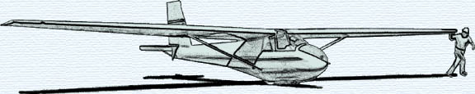

MONTHLY KSA MEETING
Saturday June 12, 2010

COOKOUT MEETING
AT SUNFLOWER
Grills will be lit about 6:00 PM or so….
Please bring some charcoal, lighter fluid and especially matches along with whatever burgers, dogs, etc. you like

