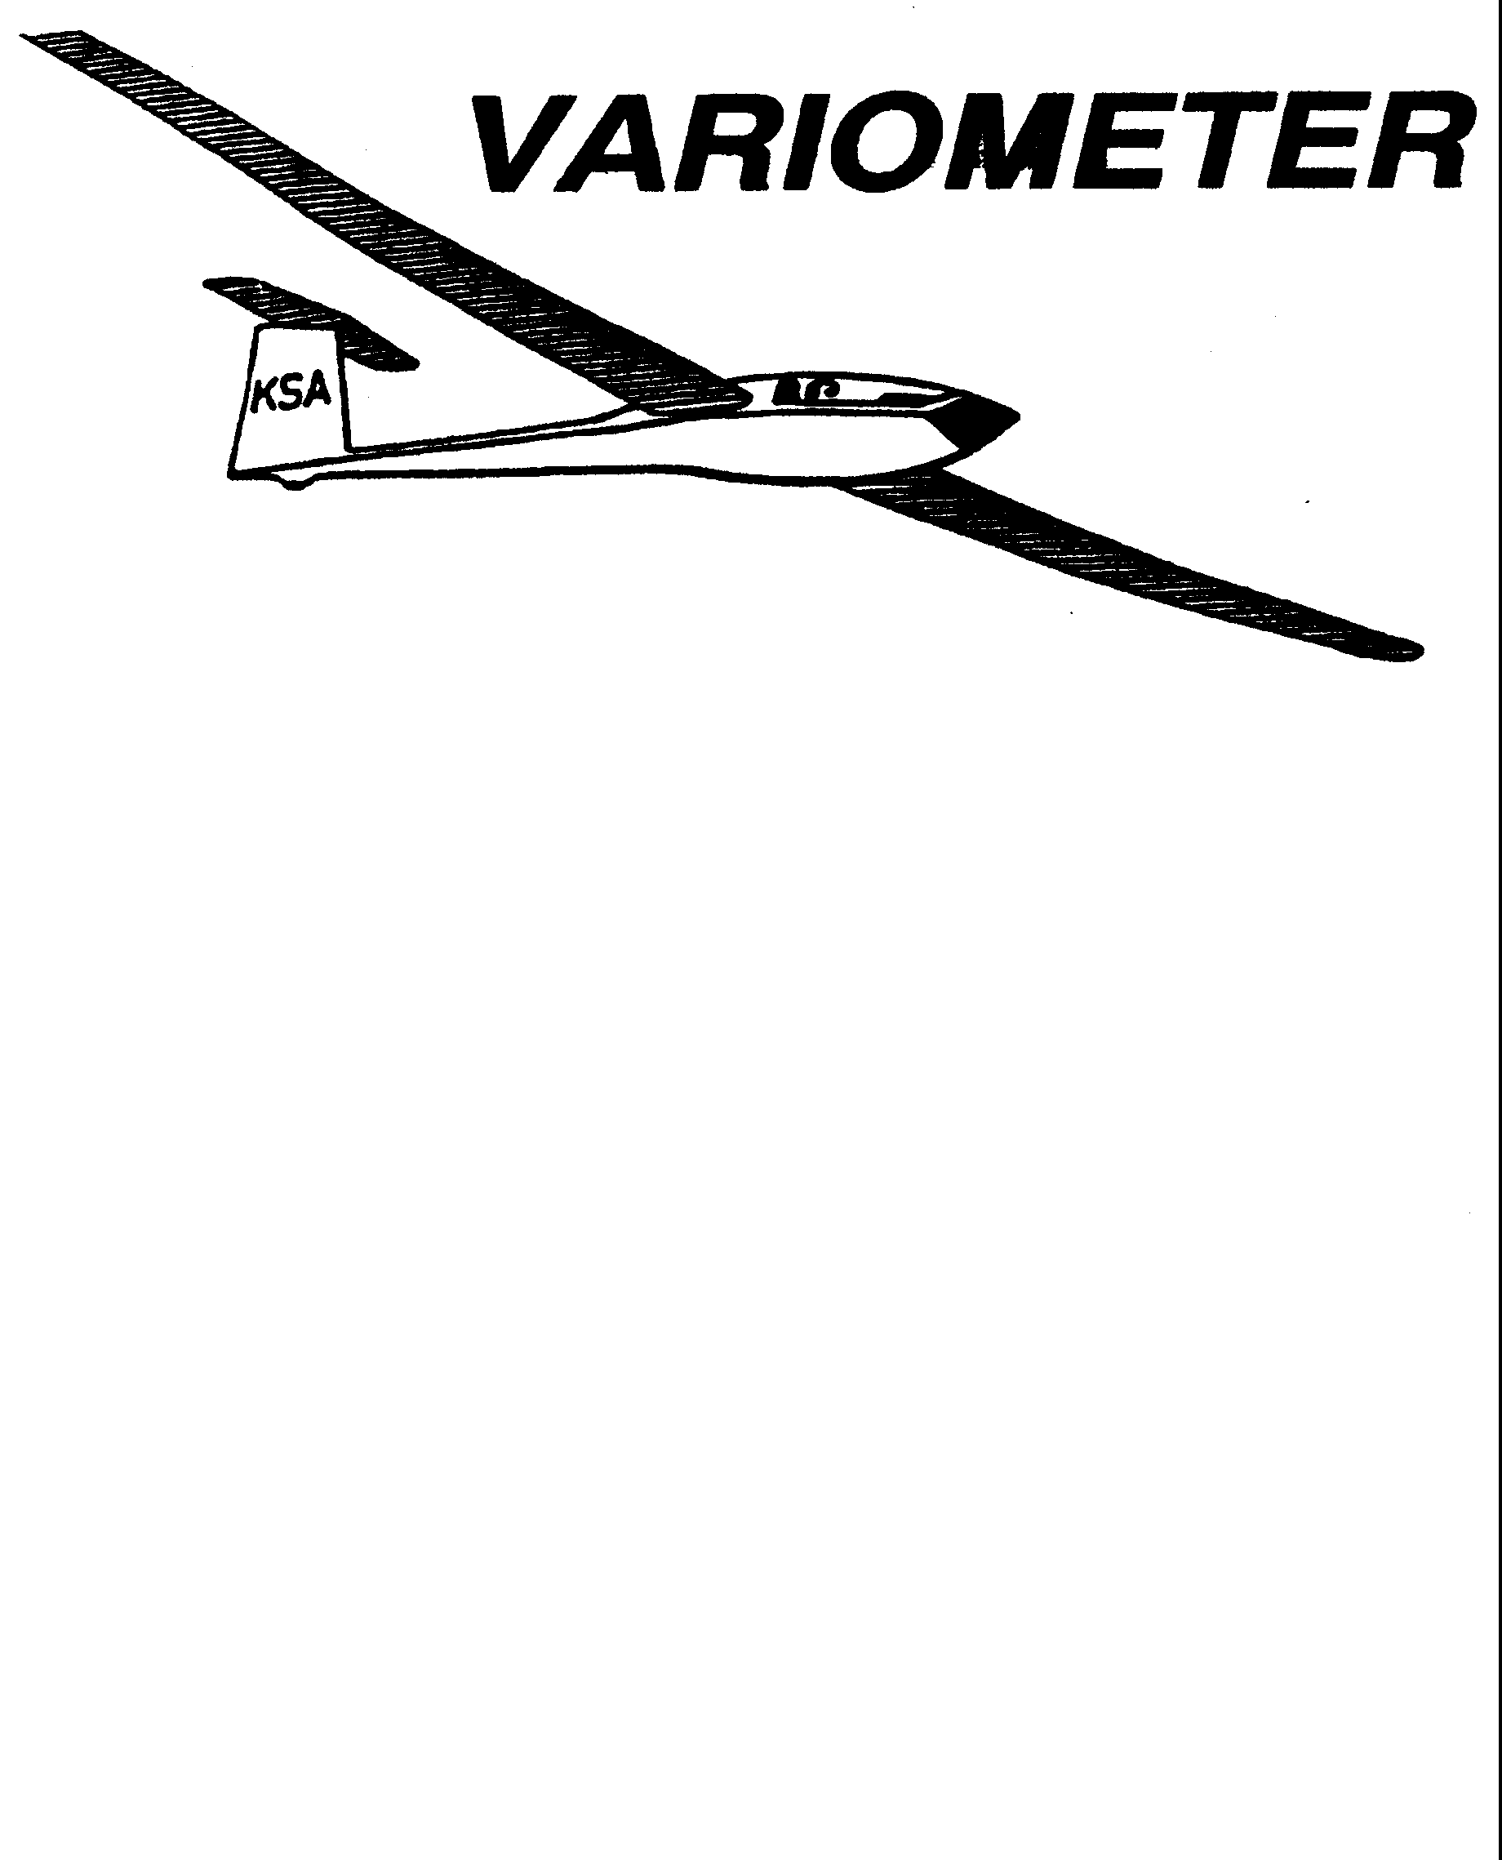

PUBLISHED TO RECORD
THE UPS AND DOWNS
OF THE
KANSAS SOARING ASSOCIATION
July/August 2010 Editor: Andrew Peters
PRESIDENT – RAY GIRARDO (2009-2010)

SECRETARY/TREASURER – NEALE EYLER (2009-2010)

VICE PRESIDENT EAST – BOB BLANTON (2009-2010)

VICE PRESIDENT WEST – BOB HALL (2009-2010)

TOW PLANE MANAGER – STEVE LEONARD (2009-2010)

DIRECTORS:

K. C. ALEXANDER (PAST PRESIDENT)
NEAL PFEIFFER (2009-2010) DAVE WILKUS (2009-2010)
FRANK O’DONNELL (2010-2011) DAVE WOODY (2010-2011)

KSA Calendar
2010
July 26th - 31st – Region 10 Central Texas Contest, Llano TX

August 3rd-12th – 15-meter Nationals, Uvalde, TX
August 7th - 8th – WWC: Prescribed Area Distance
August 14th – Evening KSA Cookout Meeting at Sunflower (5:30 pm)

September 11th – KSA Cookout Meeting at Sunflower (5:30 pm)

September 18th - 19th – WWC: WSA Triangle Lap Race
September 23-26th – Vintage/Classic Sailplane Regatta at Wichita Glider Port

October 9th – 7:30 pm KSA Meeting at NIAR – ELECTIONS!
October 16th - 17th – WWC: Last man down
October 17th – Last Scheduled Duty Day for Flight Operations at Sunflower
October 23rd – Fall Clean Up Day

November 13th – 7:30 pm KSA Meeting at NIAR
December 11th – 7:30 pm KSA Meeting at NIAR

Sunflower Seeds

June 5 – Tony C instructed, Pat Ensign towed. Neale and Shea ran the line. It was HOT, in the high 90's. I flew the 2-33 with Summer and Leah. Lift was spotty and there was plenty of sink. John Bender flew the Lark and Dennis flew his Mosquito. John reported there were 3 thermals working. Summer did a few solo flights. Keith Smith and Jerry Boone flew. Jerry was last to land, flying over 3 hours. Estimate18 tows for the day. Keith, Jerry, Summer, Shea, Leah and Tony along with Jerry's wife Lyn and son Matt all gathered at Bullseye Grill in Yoder after flying for supper and stories. The Strawberry Milkshakes are great!
June 6 - Busy day, even though it started a bit slow, and had a minor disruption. 17 flights were made today. Those present and flying included Pat Ensign and John Bender (headed back to Kansas City early to go do some sky-diving), Shea Zuckerman and friend, Bob Blanton, Keith Smith, Summer Gajewski, Dennis Brown, Dave Woody, Sue McNay, Bob Park, Mark Schlegel, and Scott Dimick. Also stopping in for a visit were Becky Cole, Don Beaton, and new member Matthew Colclasure. Towing was Tony Condon and line crew was Steve Leonard and Leah Condon. Keith Smith was also cheered on by wife Amy and daughter Tori. Shea is now taking people for rides (maybe soon we will have some real thermals for you to show them, Shea!), Keith is getting the hang of his PW-5 (longest flight honors for the day), and Summer had a 45 minute solo flight with several different thermal climbs along the way. You could sense her excitement when she got out of the plane! There were flight reviews, currency flying, and just plain soaring. A good time was had by all. Bob Blanton had the misfortune of a rope break while at 300-400 feet. He was far enough out that getting back was iffy, so he opted for the field he was pointed towards. It was a hot walk back on the wing tip, but the field was level and firm, so we drove out, hooked up a rope, and pulled the 2-22 out of the field, down the road, and back to the airport. The real lesson for us all to take away from today is that if getting back to the field is "iffy", pick a nice field and land safely. It is not that big a deal to come and get a plane and get it back to the field. Good level headed thinking, Bob! Afterwards Bob got right back in the saddle and completed at least 3 more flights for the day with the newly made tow rope.
June 19 - Not the greatest of days for Soaring, though you wouldn’t believe it based on the temperature. The day started out with winds claimed at 160 deg and 3 knots and continued to strengthen to 180 deg 18 G 26. This brings up a point for line managers to check the winds from Hutchinson ATIS every so often. If you hear that they are getting close to the WSA club limits (WSA rules 1. P. The club ships are to remain in, or be returned to the hanger anytime the wind is blowing steady at 20 mph or greater, or if gusting over 25 mph, unless the pilot has specific approval from an on-field instructor to fly.) Good to keep the instructor aware if he is flying instruction rides. Also, make sure the people who are flying said sailplanes don’t leave them unattended without securing them to tie downs, in such conditions. Flights started at 1245 with Mr Doug Wilson working on honing his skills in the Grob with instructor of the Day Andrew Peters. Bob Blanton gave his Grand Son Robbie a ride in the 2-33 while waiting for Andrew to give him a ground check in his newly acquired Schweizer 1-34. With the help of Harry and Sue Clayton he finally did managed to get it into the air and safely down 3 times. Steve Leonard was out to fly his 604 and surprised everyone with his high speed crosswind pass at the end of the day, even though he did announce it. Dave Wilkas flew his Diamont. Other students in attendance were Summer flying 3 in the 2-33, Steve Wenke getting 2 in the 2-33 and Robbie getting his first 3 instructional rides in the 2-33. The 2-22 even made it up for a spin around the pattern with Harry Clayton at the controls. Thanks to Gary Hurst and Rich Stone for keeping the action on the line safe and smooth and Dennis Brown for 18 picture perfect tows. Others in attendance: Sue and David, Bob Blayton’s extended family, Larry Walton, Becky, and Shea. Thanks to everyone for coming out.
June 20 - The assigned crew (Frank, Ron, & Richard Boone) arrived as scheduled, as did Dave Stanko and student Steve Wenke, but the weather, as forecast, didn't cooperate: Winds above WSA limits, turbulent, and hot. However, it takes more than 25 + 30 to stop Steve, Andrew, & Dennis, who launched about 2:30 and struggled. Steve landed last, after 4:30. A long-time WSA member, Amir Rashkan, whizzed in about 4:15 in his neat Grumman. He is back in Wichita, will restore his KSA membership, and resume glider flying as soon as possible. The towplane flew well, but the safety-wire job on the right window worried Frank, so Richard quickly improved it - thanks again. Visiting were Bob Hall, Bob Park, and Becky
July 3,4,5 – No flights reported. Wet, windy, and rainy holiday weekend. July 3 The assigned crew (KC Alexander, Ray Girardo, Dakota Harms, Frank O'Donnell) was there plus others: John Bender and his glider from K.C., Bernie Mohr, Harry and Sue, Jerry Boone, Dave Woody and Sue McNay, Summer Gajewski, D.J. Harms, Dennis Brown, Bob Park, Al Alexander and others. Ceiling was 1500 broken and wind 15+ 25, as forecast. Everyone bailed by 2:00 pm.
July 10 – Kansas Kowbell Klassic – Bob Holiday, Neal Pfeiffer, Tony Condon, John Bender, Jerry Boone, Andrew Peters, Steve Leonard, and Keith Smith all launched on Kowbell. Dennis Brown, Gary Hurst, Matt Colclasure flew locally. KC Alexander, Al Alexander, Doug Wilson, Bob Blanton, Robbie (Bob’s grandson), Bob Park, Bernie Mohr, Frank O’Donnell and possibly others were present. Thanks to Bernie, Doug, Al, and Bob for towing and running the launch line and Frank for instructing.
July 11 - Summer Gajewski, Steve Wenke, Leah Condon, and Gavin Smith all took flights in the 2-22 and/or 2-33. Matt Coclasure flew the Ka-6. Andrew Peters, Jerry Boone, Dave Woody, Harry Clayton, and Dennis Brown all flew their personal gliders. A BIG thanks to Bob Holliday for towing and Neal Pfieffer and Steve Leonard for running the line.

Comments from the Editor

I hope you enjoy this double issue of the Variometer. I am learning that putting out a monthly newsletter is not always easy. Seems the first of the month arrives sooner and sooner and I am always playing catch up. Hence the double issue this time. July/August.

Thanks everyone for sending in photos and stories. Will try to fit it all in, but if you don't see it here, I probably haven't lost it, just wait until next month – September in this case! And for those of you that have some great flights in the coming weeks – please send me a blurb about them.

3T is standing by….

Recent Achievements

UJ Pesonen – K-6 Checkout
Keith Smith – 181 mile XC flight
Steve Wenke – First Solo, 2-33
Leah Condon – First Solo, 2-33
Matt Colclasure –A and B badges, K-6 Checkout
Summer Gajewski – solo 2-22
Bob Holiday – 2010 Kowbell Winner – 177 miles to Oakley, KS.

Parachute for a Pillow

By Keith Smith, PW-5 N202LW

The moon was an orange ball rising through a gap in the trees. Not full, more like two- thirds, maybe like a dog’s tennis ball that has been run over by the mower. It was 12:12 and I watched it over my right shoulder with my head hanging out of a pickup window and my legs stretched across the seat. Gavin was at least an hour away, on the road with the trailer. It would be 02:30 before the PW was loaded in the trailer and a dust cloud rose as we pulled out of the corn stubble.
The landowner had said it would be no problem having landed there because the soybeans had been hailed out only two weeks before. I was relieved at that. The landing was straight down the furrow, 26 paces because in my efforts to stay on the main and wings level, I’d been late dropping the nose and applying any brakes. The sounds of old corn stubble scratching the right wing tip was the only reminder of improper technique. But hey, we’d come in over the wires in about 100 yards with full spoilers and slipped some extra because on the mid-field I’d seen a ditch on the quarter section far end that I didn’t notice when I committed.
Jerry had called me the night prior with a weather prep and the opportunity to do a weekday flight, something I had been itching for. Dennis had already agreed to do a mid-week tow twice but I had been unable to find a wing runner. So I was there early on my birthday and achieved a goal I had been working towards – I rigged the PW-5 all by myself for the first time! Since wing alignment had been a problem I was really happy that the efforts of many club members to help with the process had finally worked out.
Jerry showed and put together the Duster in 1/3 the time it had taken me on the PW. He helped me to wire up the new logger in the PW and we were ready to go. The cumulus were all over the sky, maybe fifty percent, by the time we were rigged.
The plan was for me to go NW with the tailwind. I did some badge paperwork figuring it was futile and got the PW on the line. I told them that I wouldn’t try unless I could get good lift up close to cloudbase. Jerry launched again and was out of sight by the time I was ready to go, as usual I was pokey getting out on the line. The tow was smooth and as Dennis turned west over the runway we hit a good thermal. I was slow to release and missed it by the time I came around. I found a light 0-2 up over the NW corner and quickly started drifting NW as I scratched around. I don’t think we got over 3,800 and were about 2 miles west of the SW corner of Hutchinson when I turned tail and headed back to Sunflower. I laughed to myself that I was going to tell the guys I was just chicken. With all those clouds nothing was happening under the good looking ones. The lift was in the small ones that were just forming up and they were narrow.
When I got back to Sunflower Jerry was thermaling on the NW corner and must have been 500 feet above me. I turned right to stay with him but it was slow going up. Just when he broke out for the SW I had hit 4.0 up and had climbed above where he had left the thermal. So, I decided to go back NW and run with the wind again as the clouds still looked promising. Before I knew it we were west of Nickerson because the wind was moving us quickly in the thermals. Never over 4.0, the lift was enough to stay encouraged and at that point I decided I would make it to Lyons or land out. In the early afternoon as I was pulling away from Sunflower with a tailwind to the NW, I could just see a wall of clouds towards the SE, not overdeveloped, but just no sun underneath. I got lucky and had the lift, tailwind and a great little easy to fly sailplane to help.
As I kept hop-scotching I would just pick out the next N-S wheat stubble or worked field. The clouds had just enough separation that I was running to them and working hard to climb back up with the cloudbases lifting while the tailwind seemed to increase. Still the best lift was running 2.0-4.0 all the way to Wilson Lake. How strange to focus so completely. It may be one of the best parts of a soaring flight.
Some of the guys will laugh but I was still using my sectional and basic instruments 90% of the time. Thanks Neal Pfeiffer because I had done a quick fix on my mechanical vario tubing with some smaller o-rings as clamps over a fitting and it was now working properly. He was working the line last Sunday and helped trace down the tubing problem.
On the north side of Wilson Lake I was losing the magic. I got down to 3,000 and picked two nice long N-S wheat stubble fields. Just when I was ready to start getting serious about my first landout, I hit a 6 kts up that put me close to 8,000ft. From there past Smith Center it just kept getting better.
As I approached Red Cloud, NE I had a few that were 6-8 up. Then I had the most amazing thing happen. I chose to leave the last three clouds in my cloud street and shift right a couple of miles for a series of 6-7 clouds that looked better. When I nosed under them I experimented and could maintain altitude at 55-60kts in a nice dolphin that lasted for what seemed like fifteen miles.
By then I had left Red Could to my right rear and remembered Jerry saying just keep going straight. There were no clouds straight! With my altitude I thought if I could get a couple of smaller blue thermals I could make it to Minden. That was one of my smoothest decisions of the flight. Smooth and downhill all the way! One of the differences up there is that the wheat was only beginning to be cut at the state line. Twenty-five miles north of that it was all uncut and there wasn’t much anyway. Corn rules supreme. Tall irrigated corn. The farmer who picked me up told me they don’t have any “worked” ground up there. It is all stubble to round-up, to no-till into some other crop, without disking.
I picked my field, actually two. First choice was a bean field that had something on the right side for an irrigation pivot and a ridge for truck tracks from the road out to that point. So I committed to the stubble field on the west of the farm house with a mid field (thanks Andrew for the reminder to use a pattern) and milked the spoilers to clear the wires. The furrows had enough stubble material in them that it provided a cushion and the main barely broke through the soft dirt about one-half to one inch. I think it was 1856 on the landing time. I was pretty excited about the whole landing thing and shut off the logger and PNA before checking any numbers for distance so I didn’t know how far I had gone. My left leg cramped on me getting out of the cockpit and I danced around some in the stubble while I tried to stretch. The duration was around 4:22. My cell phone was dead and my radio had not worked the entire flight. “Dennis, I was sure I could see the North Platte, but I couldn’t make it.”
A local farmer, Greg, picked me up as I walked out of the field to the road and the series of questions started. My son Gavin was going to get off work in Wichita and bring the trailer up. After a great dinner with Greg and his wife Sharon, visiting with the landowner and some spectators at the glider, Greg loaned me his pickup to wait at an intersection for Gavin. Gavin has his own story of pulling the unloaded trailer (which I have not done yet) and adventures that cropped up.
My idea was to stretch out in the pickup waiting for Gavin but I never did get any sleep, too jazzed up about the flight. I did use my chute for a pillow but the truck seatbelt thingy was poking me in the side. With my head half out the open window the night was cool with a light breeze to keep the mosquitoes off, lightning bugs were abundant and the stars were too.
At 0606 I noticed the big orange ball rose a second time, this time full and round as I was driving down Highway 81 somewhere north of Salina and Gavin was trying to catch some sleep. We got back to Sunflower at 0720 and he had to drive back to Wichita and work. I am blessed with a strong son. I chained down the trailer and headed back to Salina.
I got in a great flight that still leaves me smiling. I got lucky on the choice to try a second time and the lift was in my favor. Lots of club members have helped me get to a new level of learning. Tony especially has been encouraging me to get some XC in for badge and record purposes and I am thankful for his paperwork efforts. I found some new lessons and screw-ups (still no tie-down kit!). I have a long way to go to become a glider pilot and I probably never will like crosswinds.
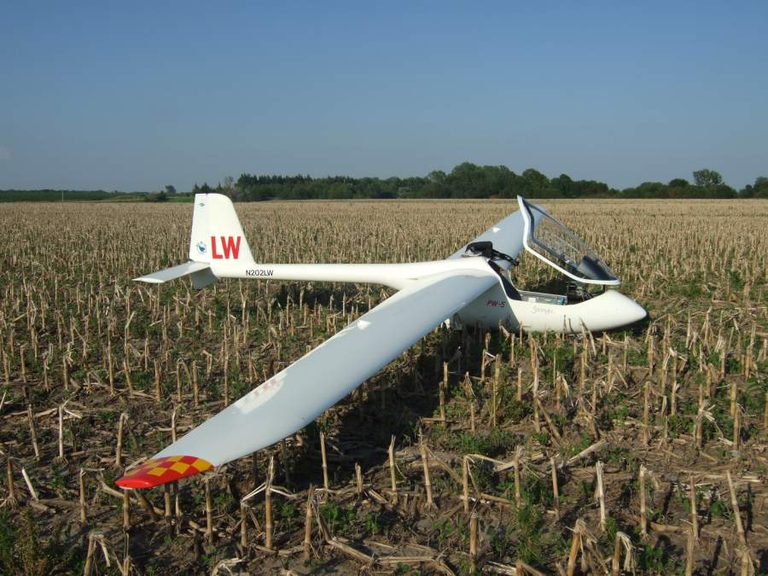

Notes from WSA.
-Reminder, the Ka-6 is available for students to fly once they are checked out in it. See the requirements for this checkout in Mays Variometer.

-When putting the aircraft back into the New hanger we would like to keep it in the following order; 1-34 in the SW coroner, the Grob as far back as it will go, nose first and then the WSA Ka-6 tail first, straight back to the right side of the Grob. Put the Right wing down since the Left one may over hang the boat if it is still there. Then the tow plane tail first.

- The Ka-6 trailer is back up at Sunflower. I replaced a large section of the floor in the aft section, replaced the 6 rusted hold down bolts and put new cross braces on the bottom. There is still an area of floor by the right tire that has rotted away. I tried to brace it but found the floor would not support the deck screws so stay in the center of the trailer when walking wings in or out. I also replaced one of the tires as the bead had rotted in one section and would not hold air. Bottom line, I believe it to be back up to road worthiness, so use the Ka-6 to cross country (remember the rules about permissions) and if you need the trailer just be gentle with it when out in fields.

Rich Stone
WSA Director.

Weekend Warrior Contest
by Andrew Peters

Results for WWC #1 – Climb is King
No task claims were made.

Results for WWC #2 – Modified Assigned Task
No task claims were made.

Results for WWC #3 – Free Distance Task
July 3 was deemed unsafe for the Kowbell, thus July 10th became the day. Several good flights – plus some good off-field landout practice. Here's how the chips fell....
Unofficial |  |  | Task 3: Free Distance
 |  |  | Saturday, July 10 2010
 |  |  | Distance (sm)
Contestant | Glider | Handicap | Actual | Handicap | Score | Bonus
Condon, Tony | Cherokee | 1.543 | 167.3 | 258.1 | 1000
Binder, John | K-6CR | 1.28 | 160.6 | 205.6 | 921 | 125 | Silver, Airport
Leonard, Steve | Zuni II | 0.95 | 170.6 | 162.1 | 653 | 25 | Airport
Holliday, Bob | Ventus 2b | 0.884 | 177.6 | 157.0 | 633 | 25 | Airport
Boone, Jerry | Duster | 1.395 | 85.7 | 119.6 | 588 | 125 | Silver, Airport
Pffieffer, Neal | K-6E | 1.18 | 117 | 138.1 | 535
Smith, Keith | PW-5 | 1.18 | 81.7 | 96.4 | 498 | 125 | Silver, Airport
Peters, Andrew | LS-3 | 0.937 | 8 | 7.5 | 29

WWC Task # 4– Prescribed Area Distance Task (PAD) - August 7-8th
The Prescribed Area Distance Task (PAD) is a type of distance task that was used in US glider competitions. It is a distance task, which means the competitor flying the furthest handicapped distance wins the day. You must stay within the boundaries defined by the turnpoints furthest from Sunflower (Lucas, Ness City, Ulysses, Satanta, Alva, Blackwell, Winfield, Herington.)
You accumulate distance by flying to different turnpoints in the prescribed area. You may only fly to a way point once (Sunflower is both a turn point and a finish point, so you can fly to it, then to one more turnpoint, then return and land.)

For the WWC, here is the PAD task:
- Start Point: Overhead Sunflower
- Maximum Start Height: 3500' AGL x your Handicap
(e.g. 1582' + 3500' x 0.915 = 4785' MSL)
- Must fly to turn points in the task area.
- Must stay wiithin the lateral boundaries of the perscribed Task Area: 28 Lucas, 35 Ness City, 57 Ulysses, 56 Satanta, 2 Alva, 7 Blackwell, 46 Winfield, 19 Herington.
- Repeating turn points is NOT acceptable.
- Photos: Must be taken looking back towards Sunflower.
- GPS: Must go to the far side of the turn point from Sunflower.
Turn point files can be found at http://soaringweb.org/TP/NA.html#US for Hutchinson, KS.

Task Explanation
The start will be over Sunflower (plan to cross the runway or imagine a line from the tower to the wind sock to cross on your way to the first turn point.) Note your time crossing the start line. Also, remember that the maximum start height is 1582 + 3500 x your handicap. You need to cross the line below this altitude. Call in your start time on 123.5. “3T 1540”
Fly to the far side of the turn point (reference Sunflower), take a photo or use GPS. Proceed to the next turn point of your choosing. Make sure you record the turn point name/number and the order that you arrive at them. Repeating turn points is NOT acceptable. Continue to fly to turn points until you land. You do not have to return to Sunflower, however Sunflower is both a turnpoint and a finish point, so its possible to fly over it twice, if you do land there.
Remember, if photos are being used to verify your task, you need to be oriented looking back at Sunflower and the landmarks must be distinguishable on Google Earth or Google Maps. Your distance will be the total of the distances between all the turn points you declare after the flight.
If you land out, your distance will be the total for all the turnpoints achieved, plus the distance from your last valid waypoint to your point of landing. However, you landing point must be within the boundaries of the Prescribed Area.
Low finishes are not going to be encouraged. Therefore, you should plan on arriving back overhead Sunflower no lower than 500' AGL (2082' MSL). If anyone observes unsafe or low finishes, disqualification or penalties may result.
Questions can be submitted to me, at apsoars@yahoo.com.

General Rules:
- Any member has two days to complete the task.
- Tasks can be performed more than once – only the fastest – longest – highest will count.
- Your contest record must be submitted to the Scorer (Andrew Peters, 3T) by midnight on the Monday following the contest weekend. The contestant with the best task will receive 1000 points. Other contestants will receive points as a percentage of their task compared to the winners.
- All speed and distance tasks will be handicapped (SSA handicaps will be used – if one doesn't exist for your glider, one will be assigned based on the experience of the glider owner and other experienced competition pilots.)
- If you don't yet have your Silver badge and you want to compete, you will get a 100 point bonus added to your score.
- If a multi-place glider is used, and you take another pilot with you who has not completed their Silver badge, a 100 point bonus will be earned. Landing at a charted airport will earn a 25 point airfield bonus.
- At least two people need to compete for the weekend to be a valid contest weekend.
- The Weekend Warrior Champion will be the member with the highest cumulative score for any four of the six contest weekends at the end of the season.
- Expensive GPS recorders are not required, although might make it easier on the scorer. A paper record and digital photo's can be used. Just make sure the photo contains sufficient detail that Google Maps can verify your location and orientation to Sunflower. Any GPS that will record your coordinates can also be used – SPOT, running watches, even some smart phones have tracking capability.
Fly safe, fly far, fly fast! - 3T

Gone West
Joe Brewer, a friend to soaring in Kansas, passed away on July 17. His services will be Tuesday, July 27th at 10:30 am at the Carlton, KS Presbyterian Church and at the cemetary in Elmo, KS (intersection fo Hwys 15 and 4.) There will be a community luncheon afterward for everyone to eat, visit, and share stories about Joe. Joe had a passion for flying, as anyone who ever talked to him would soon find out!
Condolences can be sent to Carol Lawson, Joe’s daughter:
6921 NW Hodges Rd
Silver Lake, KS 66539
785-582-4566
785-554-7005 (c)

Scheduled Work Day is 12:00 to 5:00 pm
Sat July 17 | Charles Pate  316-685-5695 | Bryan Pate 524-8829  Linda Pate 524-8829 | Frank O’Donnell  316-788-3224
Sun July 18 | Ben Sorensen  316-655-0257 | Ron Blum  Shea Zuckerman 801-554-7337
Sat July 24 | Jack Seltman  316-636-4218 | Dakota Harms 282-6000  Gary Hurst 620-257-5016 | Tony Condon  515-291-0089
Sun July 25 | Tony Condon  515-291-0089 | Harry Clayton 744-2389  Leah Condon 249-3535
Sat July 31 | Mark Schlegel  316-641-5093 | Leah Condon 249-3535  Ray Girardo 942-0638 | Frank O’Donnell  316-788-3224
Sun Aug 1 | K.C. Alexander  316-943-7461 | Scott Dimmick 733-5678  Neale Eyler 729-0659
Sat Aug 7 | Bob Holliday  316-733-5403 | David Woody 682-1895  Endri Lika 620-474-6445 | Dave Stanko  316-393-6249
Sun Aug 8 | Andrew Peters  316-393-2261 | Gary Hurst 620-257-5016  John Peters 682-4287
Sat Aug 14 | Pat Ensign  816-835- | Shea Zucherman 801-554-7337  Ray Girardo 942-0638 | Mike Westemeir  316-729-2551
Sun Aug 15 | Bob Hall  620-662-9577 | Doug Wilson 733-5537  Ron Blum fly-in-home@att.net
Sat Aug 21 | Bernie Mohr  316-733-4524 | Asok Chathbai 516-9581  David Wilkus 788-0932 | Andrew Peters  316-393-2261
Sun Aug 22 | Tony Condon  515-291-0089 | Christian Maude 620-532-3608  Neal Pfeiffer 686-4306
Sat Aug 28 | Ben Sorensen  316-655-0257 | Bob Blanton 683-9759  Gary Hurst 620-257-5016 | Brian Bird  620-664-7844
Sun Aug 29 | K.C. Alexander  316-943-7461 | Harry Clayton 744-2389  Steve Leonard 729-0356
Sat Sep 4 | Mark Schlegel  316-641-5093 | John Bird 620-728-1341  John Peters 682-4287 | TBD
Sun Sep 5 | Frank O’Donnell  316-788-3224 | Jerry Boone 620-662-5330  Rich Stone 612-2008
Mon Sep 6 | Dennis Brown  316-722-8351 | Ashok Chathbai 516-9581  Christian Maude 620-532-3608
Sat Sep 11 | Charles Pate  316-685-5695 | Bryan & Linda Pate 524-8829 | Dave Stanko  316-393-6249
Sun Sep 12 | Andrew Peters  316-393-2261 | Scott Dimmick 733-5678  Endri Lika 620-474-6445
Sat Sep 18 | Bob Hall  620-662-9577 | David Wilkus 788-0932  Doug Wilson 733-5537 | Brian Bird  620-664-7844
Sun Sep 19 | Mark Schlegel  316-641-5093 | Ray Girardo 942-0638  Ron Blum fly-in-home@att.net
Sat Sep 25 | Tony Condon  515-291-0089 | David Woody 682-1895  Summer Gajewski (620)899-1151 | Andrew Peters  316-393-2261
Sun Sep 26 | Bernie Mohr  316-733-4524 | Dakota Harms 282-6000  Neale Eyler 729-0659
Sat Oct 2 | Pat Ensign  816-835-6580 | Ashok Chathbai 516-9581  Christian Maude 620-532-3608 | Dave Stanko  316-393-6249
Sun Oct 3 | Brian Bird  620-664-7844 | Steve Leonard 729-0356  Rich Stone 612-2008
Sat Oct 9 | Bob Holliday  316-733-5403 | Ray Girardo 942-0638  Ron Blum fly-in-home@att.net | Mike Westemeir  316-729-2551
Sun Oct 10 | Frank O’Donnell  316-788-3224 | John Bird 620-728-1341  Endri Lika 620-474-6445
Sat Oct 16 | Jack Seltman  316-636-4218 | Scott Dimmick 733-5678  John Peters 682-4287 | Brian Bird  620-664-7844
Sun Oct 17 | K.C. Alexander  316-943-7461 | Gary Hurst 620-257-5016  Harry Clayton 744-2389

Tow Tickets
The last page of the Variometer contains Tow Tickets. Now there’s no reason for anyone to show up to Sunflower without some.
Please use the tickets as printed in the Variometer.
Please cut them out so that they are all the same size.
The Tow Pilot’s and Tow Plane Manager’s jobs are easier if they can be neatly stacked. Now is a great time to cut them out and get a stack ready for the summer’s flying.

KSA VARIOMETER

5101 E27TH STREET N
WICHITA, KS 67220
apsoars@yahoo.com

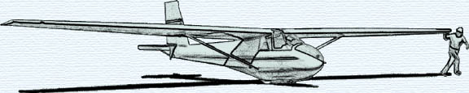

MONTHLY KSA MEETING
Saturday August 14, 2010

COOKOUT MEETING
AT SUNFLOWER
Grills will be lit about 5:30 PM or so….
Please bring some charcoal, lighter fluid and especially matches along with whatever burgers, dogs, etc. you like

