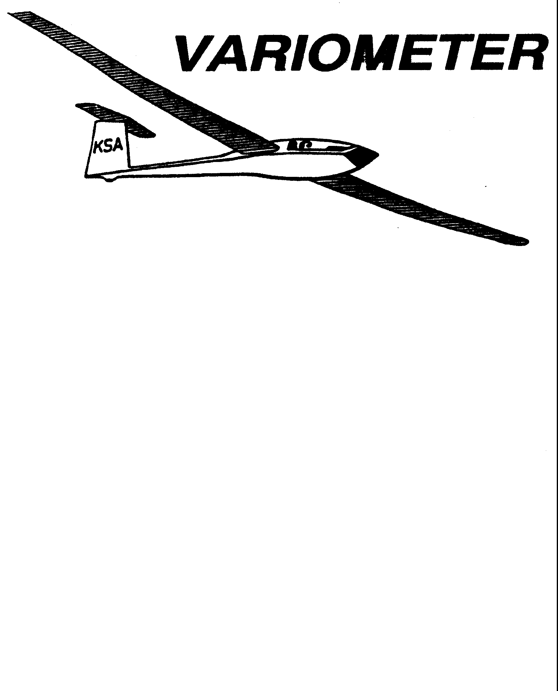

PUBLISHED TO RECORD
THE UPS AND DOWNS
OF THE
KANSAS SOARING ASSOCIATION
October 2010 Editor: Andrew Peters
PRESIDENT – RAY GIRARDO (2009-2010)
SECRETARY/TREASURER – NEALE EYLER (2009-2010)
VICE PRESIDENT EAST – BOB BLANTON (2009-2010)
VICE PRESIDENT WEST – BOB HALL (2009-2010)
TOW PLANE MANAGER – STEVE LEONARD (2009-2010)
DIRECTORS:
K. C. ALEXANDER (PAST PRESIDENT)
NEAL PFEIFFER (2009-2010) DAVE WILKUS (2009-2010)
FRANK O’DONNELL (2010-2011) DAVE WOODY (2010-2011)

NOTES FROM THE PRESIDENT

Well, here it is fall (who came up with name anyway?) and it came much too quickly. With it comes cool weather and the KSA elections. Attached is the ballot for this year’s elections. Please bring your ballot to the October 9 KSA meeting or mail to the name and address shown on the ballot. It sounds like a cliché, and may not hold true in national elections, but here your vote does count. Winners and losers are usually separated by a vote or two.

Below are some of the important dates to remember for the rest of this year. Details will be discussed at the meeting:

- October 9, 2010 KSA Meeting at NIAR – KSA Elections
- October 23 - Fall Cleanup Day
- November 13, 2010 KSA Meeting – NIAR
- December 11, 2010 KSA Meeting – NIAR
- January 8, 2010 Annual Awards Banquet

Finally don’t forget that the season and flying will continue weather permitting. Just because there is not a scheduled tow pilot or line manager, a quick phone call or two can easily fix that. There are a lot of good days ahead, so take advantage of them. Fly Safe.

R

Comments from the Editor

We all have heard about the economy for the past two years, and several of us have been directly affected through layoffs, furloughs, early retirements, and reduced retirement accounts. Fortunately, most have found work again or ways to get by. Sadly, two hard working and generous members of our club found jobs in Texas. Pat Ensign and John Bender have been flying with us for several years. They have purchased several gliders, donated equipment, and mowed lots of grass during this time. They have also been faithful in line manager and tow pilot duties. Pat and John, we wish you good luck and we will miss you. Enjoy those Texas sized thermals!

What else is going on? I could use more material to get us through the winter months. So, please send me your stories, thoughts, ideas. This news letter is only as good as you make it.

3T is standing by….

KSA Calendar
2010
October 9th – 7:30 pm KSA Meeting at NIAR – ELECTIONS!
October 16th - 17th – WWC: Last man down
October 17th – Last Scheduled Duty Day for Flight Operations at Sunflower
October 23rd – Fall Clean Up Day

November 13th – 7:30 pm KSA Meeting at NIAR
December 11th – 7:30 pm KSA Meeting at NIAR
2011
January 8th – Awards Banquet
Sunflower Seeds
September 4th – Mike Westemeir towed, John Bird and John Peters were line managers, Mike Westmeir was the instructor. Summer Gajewski was the first to launch and showed us how it was done. 3T took two tows and flew over 3 hours. John Wells, Matt Colclasure, Dennis Brown, and possibly others flew or visited. Winds were very strong, no one ventured out of gliding distance of the field.
September 5th –
September 6th –
September 11th – Heard some ground launching was conducted. Charles, Linda, Brian Pate, along with Dave Stanko and Bob Park.
September 12th – Summer Gajewski had her longest flight in the WSA Ka-6… over an hour, which completed requirements for her C-badge. Matt Colclasure flew the Ka-6 after Summer. Pat Ensign (HP-11), John Bender (Ka-6), Dennis Brown (Mosquito), Gary Hurst (PIK-20) also took advantage of the nice summer day. Jerry Boone flew his recently acquired Zuni with tips from Steve Leonard. Tony Condon and Shea Zuckerman had two flights in the Grob Astir.
Andrew Peters flew towplane, and Scott Dimick & Keith Smith were line managers. Powered activity… Neale Eyler took his Mini Coupe up for first flight after restoration. Bob Park flew his Ercoupe. Brian Bird showed up in a borrowed Lancair with a guest. Sue McNay and Dave Woody were spectators.
September 18th – Lap Race 1 – Mark Schelgel was the tow pilot. Dave Wilkus was Line Manager. ZS flew a 300k in the 604. 3T flew to Haviland and back, then ran the lap race starting at 5:04. Tony Condon, Leah Condon, Keith Smith, and Jerry Boone flew the lap race task. Dennis Brown attempted a 100k triangle and the lap race triangle. Lift was strong 4-6 kts up to cloud bases around 7000’ MSL. It was a fine, last good soaring day, of the year.
September 19th – Lap Race 2 – No Report
September 25th – Tow Pilot Bob Hall, Line Managers Dave Woody and Summer Gajewski, and Instructor Andrew Peters showed around 12:00. Winds were strong, clouds were low. Lots of good discussion, but no flying. Watched cold front and thunderstorms approach Hutchinson and Wichita around 2 pm.
September 26th – The crew arrived, but no aviators. Probably predictable, with the Vintage meet at the Wichita gliderport and the Thunderbirds at McC. Neale Eyler flew his MiniCoupe, and was encouraged about solving the chronic cooling problem. Dennis Brown, Dave Woody, and Sue McNay arrived to work on their gliders. It would have been a good day to fly. The crew bailed at 3 PM.
October 2nd – Bob Hall, Dave Stanko, Richard Boone, Andrew Peters made the decision not to fly. The winds were 17G24 kts, well above WSA limits. Line managers didn’t show up. Dennis Brown, Lauren Rezac and another gentlemen showed up to fly and visited instead. Keith Smith had an annual performed on his PW-5.
October 3rd – Steve Leonard and Bob Blanton served as line managers. Dennis Brown and Andrew Peters served as tow pilots. Dave Stanko, Andrew Peters, and Brian Bird served as instructors. There were about 12 tows, between the 2-33 and Grob. Richard Boone completed his BFR. Robbie (Bob’s grandson) flew several dual flights. Shea Zuckerman gave a friend two rides. Matt Colclasure flew the Grob. John Bird gave Steve (who flew up in his Tri-Pacer with his son) a ride in the Grob. Summer Gajewski, Bob Park, Sue McNay, and Dave Woody graced us with their presence. Lift was strong up to 5000’ MSL. Winds were light out of the south.

CONFESSIONS OF A GLIDER COLLECTOR
Part Two of a Series
By Steve Leonard, ZS
There’s always a story to how one finds the right glider, girl, job, career, etc. This story covers the 14 year wait Steve experienced from when he first saw the 604 until he flew her. -3T

The year is 1979. KSA is host to the Standard Class Nationals. I am one of the Line Boys, film developers, and assistant crew for Wally Scott. One day during the contest, I happen to be walking among the trailers, and get asked to help assemble a sailplane. It is AJ Smith, and I help him put the wings on the Carbon Fiber Hornet. I have heard some of the scary stories about AJ, but he was just another guy from this encounter. Maybe it was because my Dad was Competition Director at the contest? Probably not. AJ finished second at this contest. He also finished second at the 15 meter Nationals, and third at the Open Class Nationals that year.

The year went on, and I waited for the next issue of SOARING magazine to come out. No internet back then for instant updates. You had to wait. The September issue of SOARING came out with the article on the Open Class Nationals that had been held at Minden, Nevada. There in the center of the magazine, behind the scoresheet, was a foldout poster of AJ Smith flying his 604 at Minden. That was it. One of the most beautiful photos of one of the highest performing sailplanes in the world. I was not yet a glider pilot, but this photo brought about “Love at first sight”. The 604 was a fantastic machine, and someday, I hoped to own one.

1982 brought my next meeting with this 604. My family was on a vacation to visit my Mom’s parents in Corsicana, Texas. The Open Nationals were going on just up the road at Caddo Mills, Texas. We took a day to go up to the contest. There were a couple of 604s flying in the contest, against the brand new Nimbus 3 and ASW-22. The plane that had born the contest number “2”, was now “SS” and being raced by Ron Tabery. AJ had retired from sailplane racing, but by some stroke of luck, happened to fly in that day in his little racer. Dad got to visit with his friend, and I just stood back and listened.

1983 brought another meeting with “SS”, but this time in New Mexico. Bob Park, Dad, Ron and I all took a few days to go visit the World Championships. While there, I noticed “SS” sitting down past where all the contestants were parking. It seems Ron Tabery had flown from Uvalde to Hobbs, spent a few days watching the World Championships, then got a tow and flew home. One way distance for the trip was about 370 miles.

Flash forward to about 1990. Ron Tabery has moved on to his own ship (he had been borrowing the ship, as had AJ) and the 604 is listed for sale. A friend attempts to buy the plane, but the owner changes his mind and decides not to sell. The plane goes back on the market in late 1991. Another friend is looking for a sailplane re-finish project. The 604 fits the bill, but he doesn’t really want to fly the plane. He just wants a project to work on. A partnership is born! Aaron Einsel from Greensburg and I buy the 604. We spend the next year working on re-finishing the plane and re-enclosing the trailer

I make my first flight in the plane in June 1993, two weeks before the Open Nationals are to start at Littlefield, Texas. I have all of three flights in the 604 before the contest starts. I end up about where you would expect, but had a great time.

Since then, I have logged over 600 hours in the 604, won a Sports Class Regionals, won a day in the 2006 US Open Class Nationals, and been to 24,000 feet in her. I first saw her in 1979 and finally met her in 1992. We have been the best of friends ever since. Some things are just worth waiting for.

Weekend Warrior Contest
by Andrew Peters

Results from September 18-19th – Lap Race (WSA Triangle)
The day could not have been better for a contest. Strong lift, clouds above 6,000 MSL, and a willing cadre of contest pilots (3T, Keith, Tony, Dennis, and Jerry.) Here are the results.
Overall WWC Scores

October 16-17th – Last Man (or Woman) Down
Last Man Down contest - object it so be the last glider to land back at Sunflower at the conclusion of the day.
Rules:
1. Must takeoff and land at Sunflower. All tows shall not exceed 2000' AGL.
2. Official Observer (he/she that has possession of the Official Clipboard) shall record takeoff and landing time. Pilot should also record start and stop time.
3. Discrepancies between time keeping devices will be settled by ground observation of landings.
5. Flight Time must be longer than 30 minutes.
6. Launch line closes at 1630, according to the OO, LLM or TP's time keeping device. All contestants must on the runway, ready to launch by 1630. Launch will continue until all contestants have received a tow.
7. Normal radio calls shall be made in the traffic pattern.
8. Traffic Pattern Altitude is 800’ AGL (2382’ MSL). Thermaling below this altitude will not be permitted.
Scoring:
1. Last Man Down will receive 1000 points.
2. There will be a 5 pt/min deduction for landing within 30 minutes before the LMD.
3. There will be an additional 1 pt/min deduction for landing greater than 31 minutes before LMD.
4. Since WSA/KSA club ships are limited to 1 hour flights (if more than one member wants to fly), the club ships will be handicapped. They will receive a 5 pt/min bonus for flight time exceeding 30 minutes but not exceeding 60 minutes. If the flight time exceeds 60 minutes and a member has to wait, the bonus will not be awarded.
5. 100 point bonuses are available for pilots or passengers that do not have a Silver badge (at the beginning of the season.)
6. The highest score between the two days shall be used.
Task Explanation:
The name really says it all. The last person to land after flying 30 minutes wins. For the KSA/WSA gliders, there are some bonus points available for flying longer than 30 minutes. This task will require some help from the Official Observer. Someone needs to man the clip board to record takeoff and landing times. If you are under the sun shade, please offer to help out.

General WWC Rules:
- Any member has two days to complete the task.
- Tasks can be performed more than once – only the fastest – longest – highest will count.
- Your contest record must be submitted to the Scorer (Andrew Peters, 3T) by midnight on the Monday following the contest weekend. The contestant with the best task will receive 1000 points. Other contestants will receive points as a percentage of their task compared to the winners.
- All speed and distance tasks will be handicapped (SSA handicaps will be used – if one doesn't exist for your glider, one will be assigned based on the experience of the glider owner and other experienced competition pilots.)
- If you don't yet have your Silver badge and you want to compete, you will get a 100 point bonus added to your score.
- If a multi-place glider is used, and you take another pilot with you who has not completed their Silver badge, a 100 point bonus will be earned. Landing at a charted airport will earn a 25 point airfield bonus.
- At least two people need to compete for the weekend to be a valid contest weekend.
- The Weekend Warrior Champion will be the member with the highest cumulative score for any four of the six contest weekends at the end of the season.
- Expensive GPS recorders are not required, although might make it easier on the scorer. A paper record and digital photo's can be used. Just make sure the photo contains sufficient detail that Google Maps can verify your location and orientation to Sunflower. Any GPS that will record your coordinates can also be used – SPOT, running watches, even some smart phones have tracking capability.
Fly safe, fly far, fly fast! - 3T

KSA ELECTION BALLOT
October 2010

President
□ Andrew Peters
□ Other __________________________
Vice-President East
□ Bob Blanton
□ Other __________________________
Vice President West
□ Bob Hall
□ Other __________________________
Secretary/Treasurer
□ Neale Eyler
□ Other __________________________
Tow Plane Manager
□ Steve Leonard
□ Other __________________________
Director
□ Summer Gajewski
□ Other __________________________
Director
□ David Stanko
□ Other __________________________

Please bring this ballot to the October 9, 2010 KSA Meeting or
Mail by October 9, 2010 to:

KSA Nominating Chairman
6515 University
Wichita, Kansas 67209
Scheduled Work Day is 12:00 to 5:00 pm
Sat Oct 2 | Pat Ensign  816-835-6580 | Ashok Chathbai 516-9581  Christian Maude 620-532-3608 | Dave Stanko  316-393-6249
Sun Oct 3 | Brian Bird  620-664-7844 | Steve Leonard 729-0356  Rich Stone 612-2008
Sat Oct 9 | Bob Holliday  316-733-5403 | Ray Girardo 942-0638  Ron Blum fly-in-home@att.net | Mike Westemeir  316-729-2551
Sun Oct 10 | Frank O’Donnell  316-788-3224 | John Bird 620-728-1341  Neale Eyler 729-0659
Sat Oct 16 | Jack Seltman  316-636-4218 | Scott Dimmick 733-5678  John Peters 682-4287 | Brian Bird  620-664-7844
Sun Oct 17 | K.C. Alexander  316-943-7461 | Gary Hurst 620-257-5016  Harry Clayton 744-2389

Tow Tickets
The last page of the Variometer contains Tow Tickets. Now there’s no reason for anyone to show up to Sunflower without some.
Please use the tickets as printed in the Variometer.
Please cut them out so that they are all the same size.
The Tow Pilot’s and Tow Plane Manager’s jobs are easier if they can be neatly stacked. Now is a great time to cut them out and get a stack ready for the summer’s flying.

KSA VARIOMETER
5101 E27TH STREET N
WICHITA, KS 67220
apsoars@yahoo.com

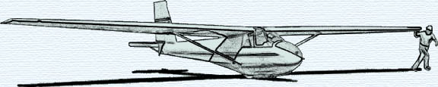

MONTHLY KSA MEETING
7:30 PM Saturday October 9, 2010
AT NIAR, Wichita State University
PROGRAM
Vintage and Classic Glider Meet
at the Wichita Gliderport
by
Neal Pfeiffer

