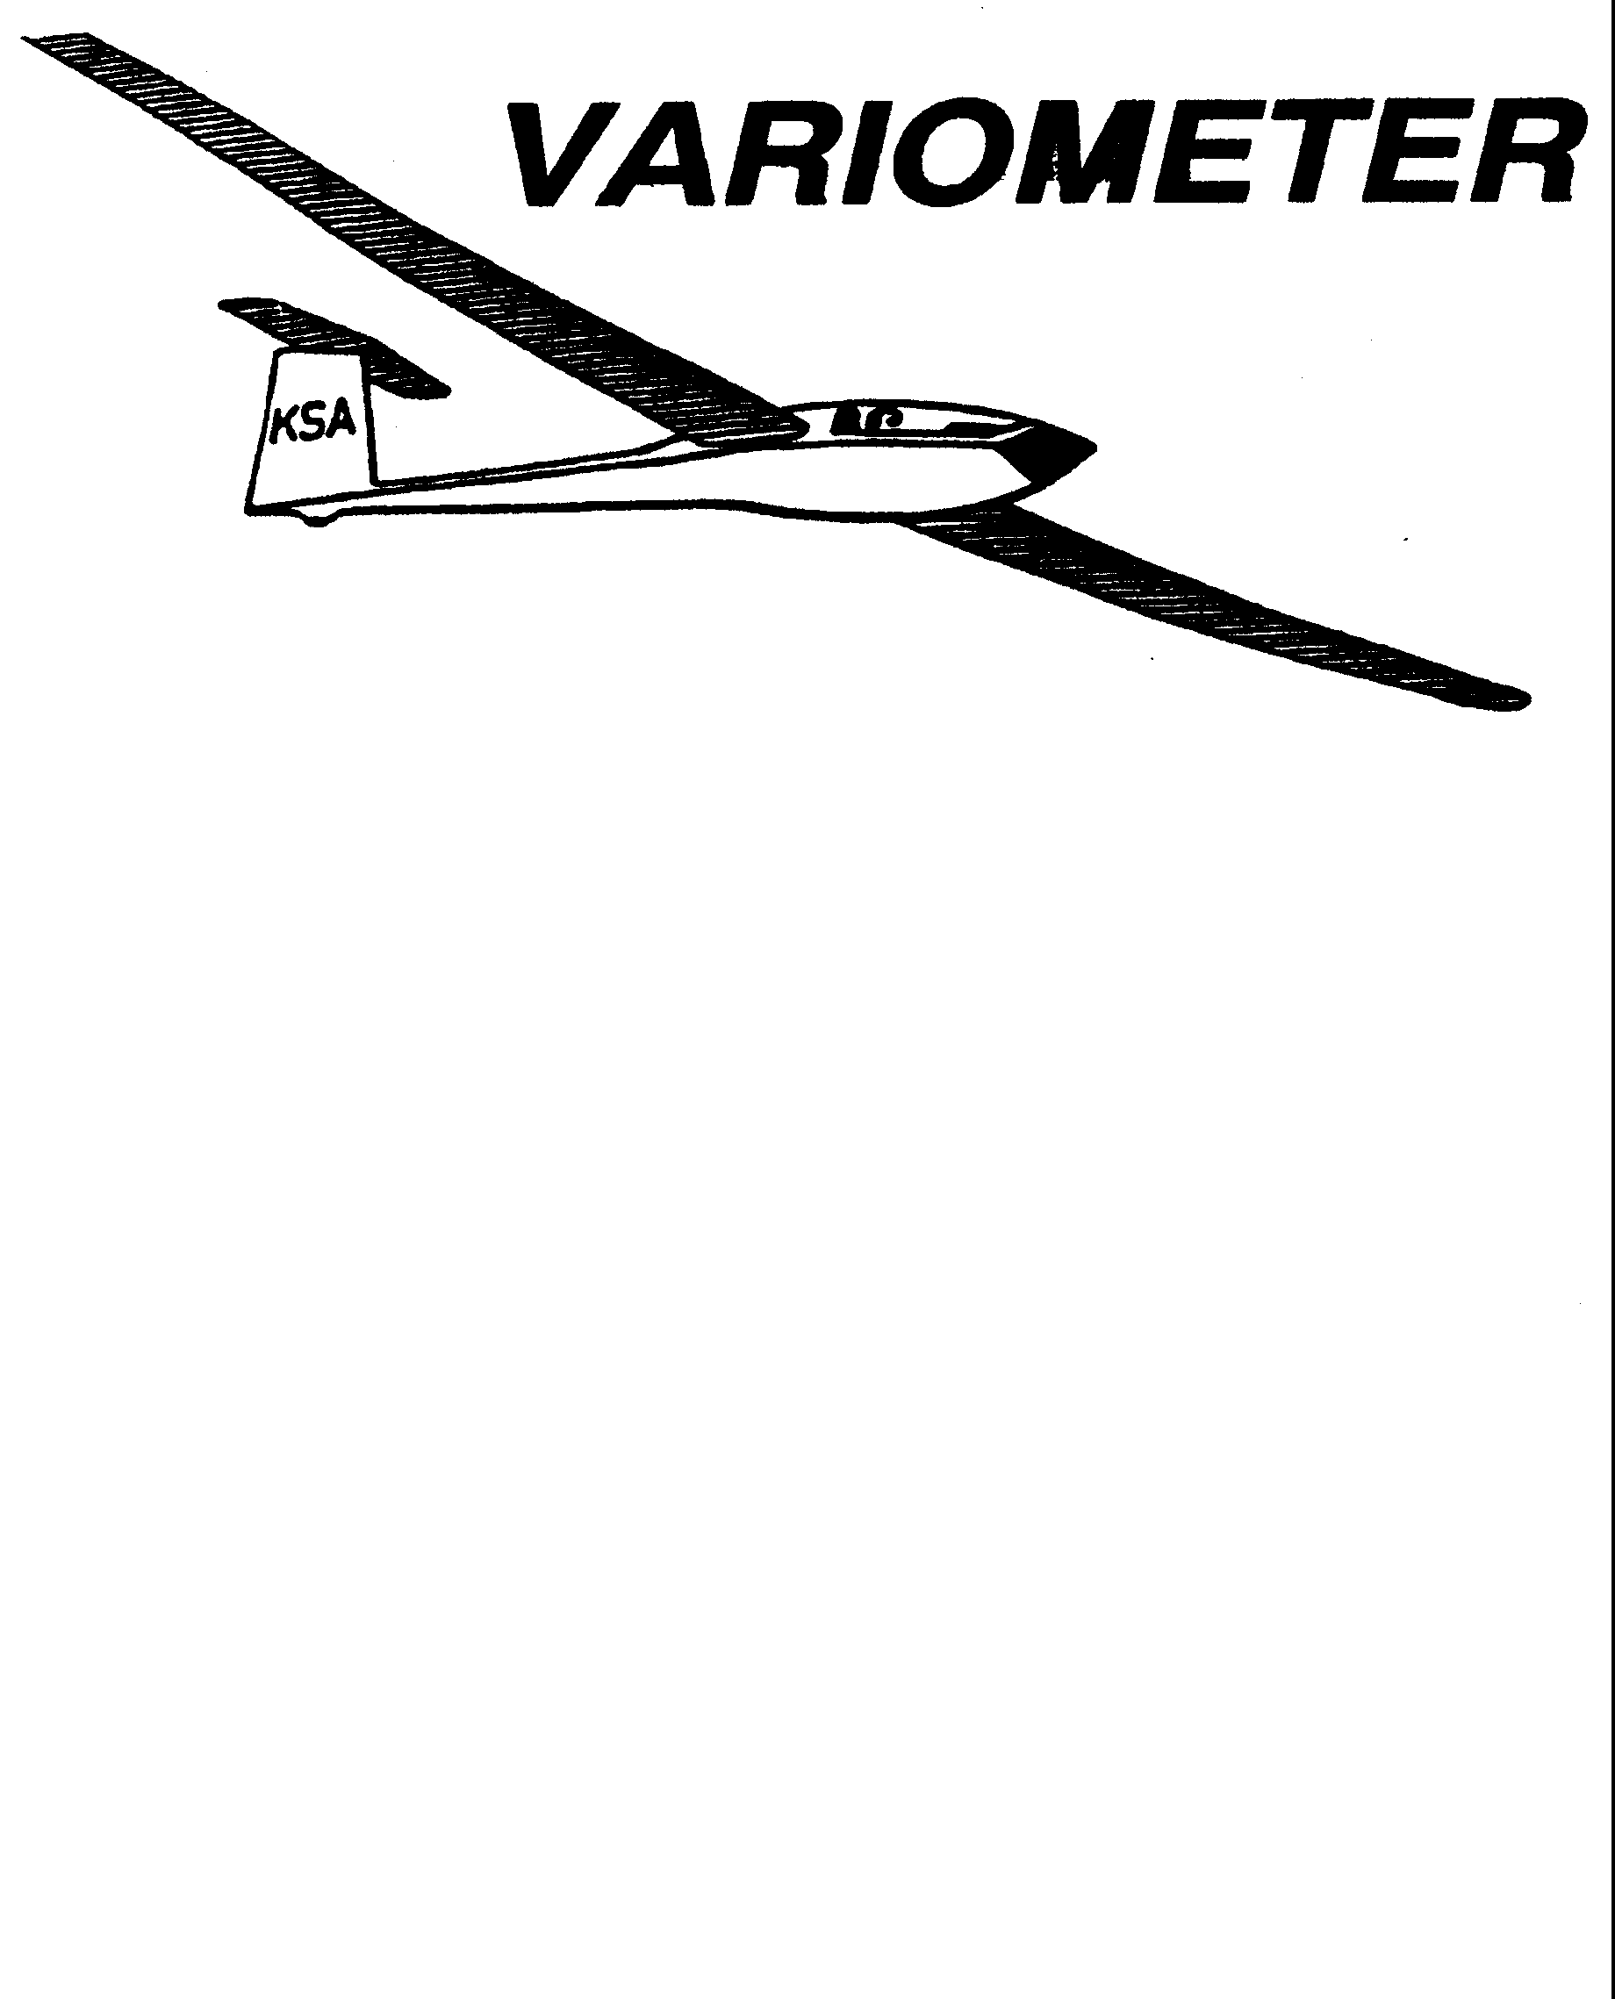

PUBLISHED TO RECORD
THE UPS AND DOWNS
OF THE
KANSAS SOARING ASSOCIATION
November 2010 Editor: Andrew Peters
PRESIDENT – RAY GIRARDO (2009-2010)

SECRETARY/TREASURER – NEALE EYLER (2009-2010)

VICE PRESIDENT EAST – BOB BLANTON (2009-2010)

VICE PRESIDENT WEST – BOB HALL (2009-2010)

TOW PLANE MANAGER – STEVE LEONARD (2009-2010)

DIRECTORS:

K. C. ALEXANDER (PAST PRESIDENT)
NEAL PFEIFFER (2009-2010) DAVE WILKUS (2009-2010)
FRANK O’DONNELL (2010-2011) DAVE WOODY (2010-2011)

NOTES FROM THE PRESIDENT

Thanks to all who helped at the October clean up day. Your efforts are really appreciated. The Fall KSA elections were held last month. Congratulations to the following:

President: Andrew Peters
Vice-President East Bob Blanton
Vice President West Bob Hall
Secretary/Treasurer Neale Eyler
Tow Plane Manager Steve Leonard
Director Summer Gajewski
Director David Stanko

Please see the notice on the Annual Awards Banquet to be held January 8, 2011. Reservations are required, and the earlier we know the count the more it helps the food crew. The notice has details on location and who to contact for reservations. Times and the menu are being finalized and will be published next month. Please review the detail on the awards and how to submit for them that is included in this month’s Variometer.

Important dates of note:

• December 11, 2010 KSA Meeting – NIAR
• January 1, 2011 – First Flights of the Year at Sunflower (weather permitting)
• January 8, 2011 Annual Awards Banquet

Finally don’t forget that even though the holiday season is fast approaching, the season and flying will continue weather permitting. Just because there is not a scheduled tow pilot or line manager, a quick phone call or two can easily fix that.

- R

Comments from the Editor
Some of you might not be aware of the discussion that’s been taking place regarding bringing FLARM to the US. I won’t go into all the details, there’s plenty of websites to go to learn more.

Midair collisions represent a significant risk to our lives as pilots. FLARM is a glider specific technology developed in Europe to alert equipped gliders of potential collisions. Jets, and even new single engine aircraft have similar technologies based on transponders.

There have been several mid-air collisions in the US, at competitions as well as at busy gliderports, which has spurred the soaring community to act. I am purchasing a unit, and I know several others. Significant savings can be had for units purchased in the same geographic location. Retail price is $1700, early bird special price is $1500, and group discounts can get the cost down even more. The deadline is December 31st, 2010 for the discounts. I would be happy to collect orders from anyone interested, to get us the best price.

Its been a great year. Still could use some of your stories about great flights or other fun experiences you have had. This news letter is only as good as the material contributed.

3T is standing by….

KSA Calendar
2010
November 13th – 7:30 pm KSA Meeting at NIAR
December 11th – 7:30 pm KSA Meeting at NIAR
2011
January 1st – First Flights of the Year (Sunflower)
January 8th – Awards Banquet – Woodlawn Baptist Church
February 12th – 7:30 pm KSA Meeting at NIAR
March 12th – 7:30 pm KSA Meeting at NIAR
April 9th – 7:30 pm KSA Meeting at NIAR
May 14th – Evening KSA Cookout Meeting at Sunflower (5:30 pm)
June 11th – Evening KSA Cookout Meeting at Sunflower (5:30 pm)
July 9th – Evening KSA Cookout Meeting at Sunflower (5:30 pm)
August 13th – Evening KSA Cookout Meeting at Sunflower (5:30 pm)
September 10th – Evening KSA Cookout Meeting at Sunflower (5:30 pm)
October 8th – 7:30 pm KSA Meeting at NIAR (Elections)
November 12th – 7:30 pm KSA Meeting at NIAR
December 10th – 7:30 pm KSA Meeting at NIAR

Sunflower Seeds
Don’t have any specific details, but there was some flying taking place in October. For the most part tow pilots, line managers, and instructors were present.

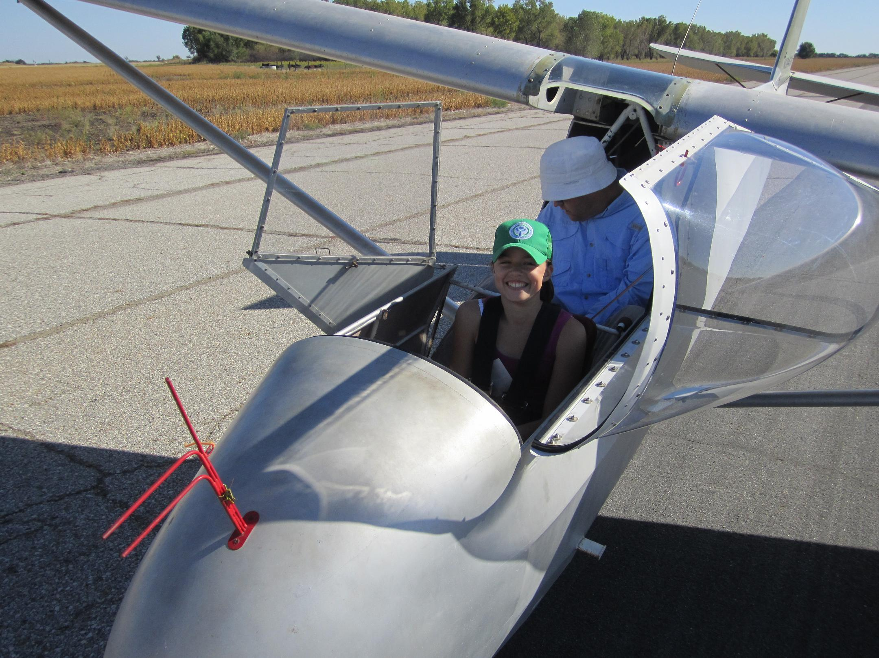
June Baldessari about to launch on her first glider ride.

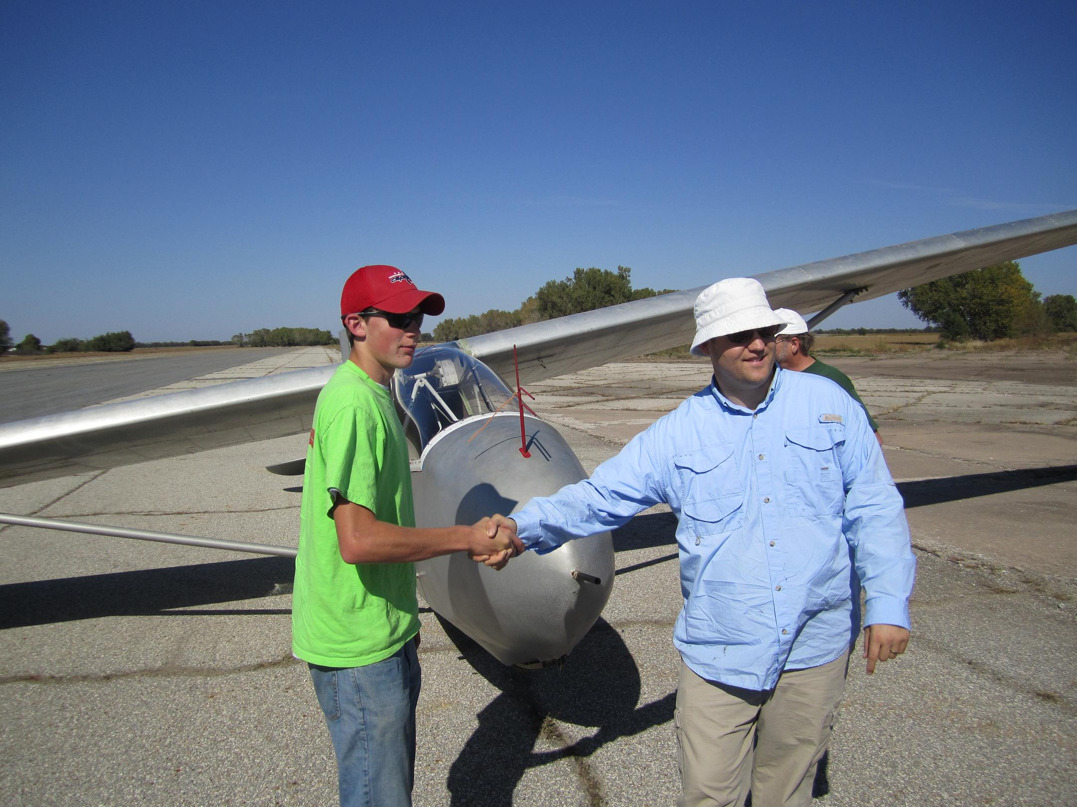
Robbie Grabendike after his first solo flight.
(Instructor is trying to avoid the pending bucket of water.)
KSA ANNUAL AWARDS BANQUET

JANUARY 8, 2011

WOODLAWN BAPTIST CHURCH
960 S. WOODLAWN
WICHITA, KANSAS

$12.50 PER PERSON

Time: To be announced
Menu: To be announced

Reservations needed.
Please contact one of the following to make your reservations:

rayandginisharp@juno.com
Neale Eyler – 729-0659
Ray Girardo – 942-0638

RULES FOR KSA FLYING AWARDS, 2010
Unless otherwise noted, the following applies to all awards:

Awards are to be made for flights with departure points in Kansas.
All distance and speed flights must start at an altitude of 1000 meters (3281 feet) or less AGL, except the Kowbell Klassic.
No altitude gate is required.
Handicaps, when they are used to evaluate competing pilot accomplishments while flying different sailplanes, will be the current handicaps used by SSA. For sailplanes without a SSA handicap, a handicap will be established by the KSA Board of Directors. For the 2010 season, the SSA 2010 Handicap list, as amended/added to below, will be used (the 20109 list is available on the SSA web page, www.ssa.org):

Schreder HP-18 1.02

When handicaps are used, an additional factor will be applied to any flight if the aircraft is carrying inflight disposable ballast (water) at takeoff. The additional factor will be multiplying the original handicap by .92

Turnpoints will be photographed
The camera does not need to be mounted. Handheld is OK.
No specific film type or processing is required.
Only photographs pertinent to the flight need be submitted. An uncut film strip is not required.
Contest style turnpoint photos can be used for any turnpoint in the KSA turnpoint book.
FAI style photos can be used for any turnpoint.

GPS ground tracks may be submitted in lieu of photographs for any task. The track must have the date and pertinent times displayed on it. It is preferred that the track be submitted in the IGC format. On declared tasks, the ground track must show that the flight path went around the outside of the turnpoint. On pilot selected tasks, the ground track must show that the glider passed within ¼ mile of the turnpoint, in the location for a proper turnpoint photo.

Speed tasks- Allowed methods for time recording:
Start/Finish gate (ground timed)
Data back photos of start/finish
Pilot timed task

Wooden Wings Award
Awarded for the longest flight in a wooden winged sailplane. The task may be free distance, or if turnpoint are to be used, they must be declared in advance of the flight and in the sequence to be used. The task declaration may be written or verbal. The turnpoints need not form a closed course. A remote finish point can be used.

If the course is abandoned before all turnpoints are made, the flight will be scored as the distance for the achieved turnpoints, plus the distance to the next declared turnpoint, minus the distance from the landing point to the next attempted turnpoint, but not less than the distance to the last achieved turnpoint.

Mamie Cup
Awarded for the greatest distance flown from a Kansas departure. The task may be free distance, or if turnpoint are to be used, they must be declared in advance of the flight and in the sequence to be used. The task declaration may be written or verbal. The turnpoints need not form a closed course. A remote finish point can be used.

If the course is abandoned before all turnpoints are made, the flight will be scored as the distance for the achieved turnpoints, plus the distance to the next declared turnpoint, minus the distance from the landing point to the next attempted turnpoint, but not less than the distance to the last achieved turnpoint.

KSA Flying Horse (Silver)
Awarded for the best speed achieved around a 100 KM pre-declared closed course with a maximum of two turnpoints.

KSA 200 KM
Awarded for the best speed achieved around a 200 KM pre-declared closed course with a maximum of two turnpoints.

KSA Flying Horse (Gold)
Awarded for the best speed achieved around a 300 KM pre-declared closed course with a maximum of two turnpoints.

KSA Handicap Score Trophy
Awarded for the best combined score in four tasks - Duration (not handicapped, but 6 hours max scored), Altitude Gain (not handicapped), Distance, and Speed. Distance and speed are handicapped per SSA Handicaps or the KSA amended/added handicap. Departure point for all flights must be in Kansas. Data must be taken from four flights (i.e., one flight per task).

The distance task may be free distance, or if turnpoint are to be used, they must be declared in advance of the flight and in the sequence to be used. The task declaration may be written or verbal. The turnpoints need not form a closed course. A remote finish point can be used.

If the course is abandoned before all turnpoints are made, the flight will be scored as the distance for the achieved turnpoints, plus the distance to the next declared turnpoint, minus the distance from the landing point to the next attempted turnpoint, but not less than the distance to the last achieved turnpoint.

The speed task must be a closed course of at least 100 KM. However, a predeclared 200 KM (minimum) non-closed course may be used if you are flying a sailplane with a handicap factor of 1.36 or greater (Examples: 2-22, 1-26, 2-33, Swallow, etc.) In this case, a wind correction factor of 15 MPH will be subtracted from the achieved speed prior to scoring.

A score of 1000 points will be awarded the best performance in each task. Each contestant’s performance will be ratioed according to the best performance in the task being evaluated. The sum of each contestant’s scores will be compared, the highest being the winner.

Cumulative Speed Trophy (Charles Henning Award)

The intent of this trophy is to encourage more people to fly cross country. All a person needs to compete is a sailplane, a databack camera or a recording GPS, a KSA turnpoint book, and a tow.

1) The cross country task will be a Pilot Selected Task, or PST with a minimum time of 2 Hours.
2) Speed will be determined by the time on course as indicated by the databack camera or recording GPS, or 2 Hours, whichever is greater.
3) Scoring for the trophy will use the SSA handicap or the KSA amended/added handicap.
4) There is no limit on start or finish altitude.
5) The task can consist of any turnpoints in the KSA turnpoint book. Contest style photographs will be used. Turnpoints can be flown in any order. However, if a turnpoint is used more than once, two other turnpoints must be photographed in between. If a GPS Flight log is used for documentation, the flight log must show the glider passed within ¼ mile of the turnpoint, in the location for a proper turnpoint photo.
6) The first picture for the task must include the date. Note: More than one task can be on the same roll of film. Only one task per flight.
7) The second picture for the task will be the start point. This picture determines the Start Time.
8) To finish a task, the pilot must take a picture of the finish point, or take a picture when the glider comes to a stop after landing. If a landing photo is used, the next photo on the film must show the glider and an easily recognizable landmark. No more than 30 minutes should elapse between the landing photo and the glider ID photo. Note: The Start Point and the Finish Point Must be the same point.
9) The winner will be determined by averaging the two best tasks of the year for each pilot. The averaging will be accomplished by adding the two speeds and dividing by 2.

Lead C
Awarded to the pilot or soaring supporter who makes the most noteworthy non-achievement during the calendar year.

Preying Mantis
Awarded to the pilot who makes the most significant advance in his or her soaring ability during the calendar year. To be eligible for this award, the pilot must not yet have his or her Silver Badge at the beginning of the calendar year.
Weekend Warrior Contest
by Andrew Peters

Results from October 16-17th – Last Man Down
Late fall thermals are typically blue and not very strong, but as the results show, there’s enough lift to have some wonderful flights. Congratulations to Keith Smith, the last man down on both days. However, due to the bonus points available for flying a club ship, Summer Gajweski is the contestant with the most points for the weekend. Thanks to everyone that made it a fun, safe weekend.

Overall WWC Scores
And now for the final results. The winner of the 2010 Weekend Warrior contest, with a total score of 3008 points, is Tony Condon. Congratulations Tony!
All in all I think it was a great contest. We flew 4 of the 6 tasks, had 10 pilots compete, including 5 that didn’t have their Silver Badge at the beginning of the year.
I am already thinking about tasks for the 2011 WWC. If anyone has any suggestions, changes, etc., that they wish to see, Please let me know. Fly safe, fly far, fly fast! - 3T

2010 KSA AWARDS
INFORMATION SHEET

Pilot’s Name____________________________________ Date______________

AWARD | DATE  OF FLIGHT | SAILPLANE | SPECIFICS
Preying Mantis
(Nominate Someone)
Towing Operations
(Nominate Someone)
Club Maintenance
(Nominate Someone)
Wooden Wings |  |  | Distance Flown
Flying Horse Silver  (100 KM Speed Task) |  |  | Speed in MPH
Flying Horse Crystal  (200 KM Speed Task) |  |  | Speed in MPH
Flying Horse Gold  (300 KM Speed Task) |  |  | Speed in MPH
Charles Henning Memorial Award (two flights required) | Flight 1 Date  Flight 2 Date | Flight 1 Sailplane  Flight 2 Sailplane | Flight 1 Speed (and time)  Flight 2 Speed (and time)
Kansas Kowbell Klassic | Landing Location |  | Distance
Kansas Kowbell Klassic Konsolation | Pre-declared Task (must have been completed to count!) |  | Distance
Mamie Cup |  |  | Distance
Pilot of the Year by Handicap Score | Altitude  Duration  Speed*  Distance* |  | (feet)  (hours:minutes)  (MPH)  (Statute miles)
Rex Hamilton Memorial Award |  |  | (Nominate Someone)
Other Significant Accomplishments (First Solo, First soaring flight, FAI Badge Leg, completion of an FAI Badge, 100th flight, 1000th tow, etc.

Documentation required for all flights, per rules published in The Variometer.
*If you had disposable ballast on board at takeoff of the Speed or Distance flight for consideration, you must put a “B” next to your claimed speed or distance. This affects the handicap number used for evaluating you performance.

“I certify that all flight claims made above were launched in Kansas and are properly documented (does not apply to “Other Significant Accomplishments” category).

Signed__________________________________________

November Meeting Speaker Bio

Donald H. Feld, Colonel, U.S. Air Force (Ret.) serves as an Associate at Commonwealth Consulting.

Mr. Feld served twenty-six years in the U. S. Air Force with the latter part of his career focused on program and resource management.

His last position in the Air Force was as Chief of the Flying Training Division of the Air Education and Training Command. He was responsible for planning, policy development, and resource allocation and acquisition for the largest flying training system in the world — a $650 million per year operation involving 13 bases, 1600 aircraft and thousands of personnel.

Previously, Mr. Feld served as the Director of Operations for the Air Force Center for Studies and Analyses, where he was responsible for supporting Operations Research efforts of the Air Force. A command pilot, Mr. Feld has over 3,000 hours of military flying time including 300 hours of fighter combat missions and 1,200 hours of tactical and strategic reconnaissance missions in the U-2 aircraft.

He is a computer and systems analysis expert and is well-versed in several computer languages. Since joining Commonwealth Consulting he has focused on military training and simulation issues as well as operations research. Mr. Feld has a BS in Electrical Engineering from Iowa State University, and a Masters in Operations Research from the University of Florida.

2011 SSA Calendars Now Available, Just $9!
See Neale Eyler to pick yours up at a KSA meeting.

KSA VARIOMETER

5101 E27TH STREET N
WICHITA, KS 67220
apsoars@yahoo.com

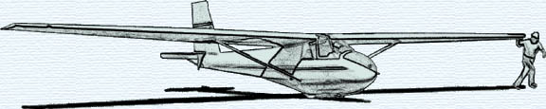

MONTHLY KSA MEETING
7:30 PM Saturday November 13, 2010
AT NIAR, Wichita State University
PROGRAM
Colonel Donald Feld
Stories of a U2 Pilot
Sponsored by
Neale Eyler

