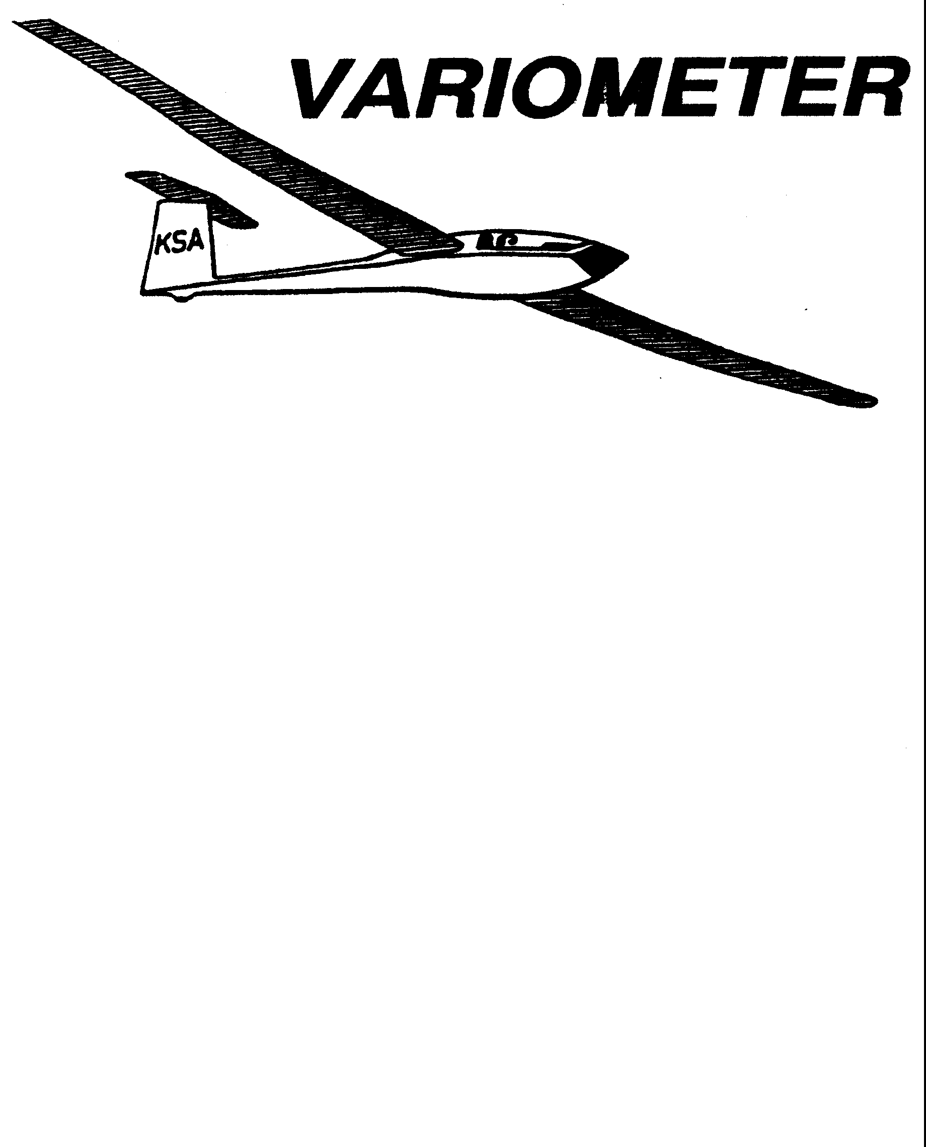

PUBLISHED TO RECORD
THE UPS AND DOWNS
OF THE
KANSAS SOARING ASSOCIATION
December 2010 Editor: Andrew Peters
PRESIDENT – RAY GIRARDO (2009-2010)
SECRETARY/TREASURER – NEALE EYLER (2009-2010)
VICE PRESIDENT EAST – BOB BLANTON (2009-2010)
VICE PRESIDENT WEST – BOB HALL (2009-2010)
TOW PLANE MANAGER – STEVE LEONARD (2009-2010)
DIRECTORS:
K. C. ALEXANDER (PAST PRESIDENT)
NEAL PFEIFFER (2009-2010) DAVE WILKUS (2009-2010)
FRANK O’DONNELL (2010-2011) DAVE WOODY (2010-2011)

Notes from the President

As this is my last newsletter, I want to first and foremost wish everyone a safe and happy holiday season. There is no doubt that next year will be another great flying season that may of you are already looking forward to. Below are a few points of note:

The KSA Grob is officially in storage until April 2, 2011 (no in motion insurance coverage).

The December KSA Meeting has a great program with Ron Blum talking about the 1911 Wright Glider 1911 project.

The Annual Awards Banquet is set with another great menu and a guaranteed good time. Please get your reservation in early to the contacts noted on the included flyer.

Remember January 1, 2011 as the first day of flying up at Sunflower (weather permitting).

Thanks,
R

KSA Calendar
2010
December 11th – 7:30 pm KSA Meeting at NIAR
2011
January 1st – First Flights of the Year (Sunflower)
January 8th – Awards Banquet – Woodlawn Baptist Church
February 12th – 7:30 pm KSA Meeting at NIAR
March 12th – 7:30 pm KSA Meeting at NIAR
April 9th – 7:30 pm KSA Meeting at NIAR
May 14th – Evening KSA Cookout Meeting at Sunflower (5:30 pm)
June 11th – Evening KSA Cookout Meeting at Sunflower (5:30 pm)
July 9th – Evening KSA Cookout Meeting at Sunflower (5:30 pm)
August 13th – Evening KSA Cookout Meeting at Sunflower (5:30 pm)
September 10th – Evening KSA Cookout Meeting at Sunflower (5:30 pm)
October 8th – 7:30 pm KSA Meeting at NIAR (Elections)
November 12th – 7:30 pm KSA Meeting at NIAR
December 10th – 7:30 pm KSA Meeting at NIAR

SSA 2011 Calendars Are Available!
Neale Eyler has calendars available for $9. Get yours today!

Sunflower Seeds

I am not aware of any activity up at Sunflower in the past month. However, I saw that Leah Condon passed her private pilot glider checkride in November. Congratulations Leah! Now its Tony's turn to chase you to Nebraska.

KANSAS PowerFLARM Group Order

I am I mentioned the PowerFLARM in last month's newsletter. More information can be found at the following websites:

http://www.powerflarm.aero/
http://www.gliderpilot.org/FLARM

If you order before December 31st 2010, the units cost $1495 ($1695 January 1st 2011). Group discounts are also available, saving additional $$ for tow fees! I am coordinating a group order for Kansas pilots. So far, we have 8 units ($1420.25 each) for the following pilots: Steve Leonard, Andrew Peters, Neal Pfeiffer (2), Bob Holiday, John Wells, Keith Smith and Dave Wilkus. Two more units and we can all save an additional $45 ($1375.40 each).

Please contact me if you'd like to order a unit. They should start arriving in April 2011, just in time for the soaring season. Neal, Steve and I are happy to answer any questions you might have.

Andrew Peters – apsoars @yahooo.com or 316-393-2261
KSA ANNUAL AWARDS BANQUET

JANUARY 8, 2011

WOODLAWN BAPTIST CHURCH
960 S. WOODLAWN
WICHITA, KANSAS

$12.50 PER PERSON

Time: 6:00 Social
6:30 Dinner
Awards after Dinner

MENU
Fresh Salad on the Table
Beef Brisket
Potatoes
Seasonal Vegetable
Rolls
Assorted Dessert
Coffee, Tea, Water

Reservations needed. Please contact one of the following to make your reservations:
rayandginisharp@juno.com
Neale Eyler – 729-0659
Ray Girardo – 942-0638
RULES FOR KSA FLYING AWARDS, 2010
Unless otherwise noted, the following applies to all awards:

Awards are to be made for flights with departure points in Kansas.
All distance and speed flights must start at an altitude of 1000 meters (3281 feet) or less AGL, except the Kowbell Klassic.
No altitude gate is required.
Handicaps, when they are used to evaluate competing pilot accomplishments while flying different sailplanes, will be the current handicaps used by SSA. For sailplanes without a SSA handicap, a handicap will be established by the KSA Board of Directors. For the 2010 season, the SSA 2010 Handicap list, as amended/added to below, will be used (the 20109 list is available on the SSA web page, www.ssa.org):

Schreder HP-18 1.02

When handicaps are used, an additional factor will be applied to any flight if the aircraft is carrying inflight disposable ballast (water) at takeoff. The additional factor will be multiplying the original handicap by .92

Turnpoints will be photographed
The camera does not need to be mounted. Handheld is OK.
No specific film type or processing is required.
Only photographs pertinent to the flight need be submitted. An uncut film strip is not required.
Contest style turnpoint photos can be used for any turnpoint in the KSA turnpoint book.
FAI style photos can be used for any turnpoint.

GPS ground tracks may be submitted in lieu of photographs for any task. The track must have the date and pertinent times displayed on it. It is preferred that the track be submitted in the IGC format. On declared tasks, the ground track must show that the flight path went around the outside of the turnpoint. On pilot selected tasks, the ground track must show that the glider passed within ¼ mile of the turnpoint, in the location for a proper turnpoint photo.

Speed tasks- Allowed methods for time recording:
Start/Finish gate (ground timed)
Data back photos of start/finish
Pilot timed task

Wooden Wings Award
Awarded for the longest flight in a wooden winged sailplane. The task may be free distance, or if turnpoint are to be used, they must be declared in advance of the flight and in the sequence to be used. The task declaration may be written or verbal. The turnpoints need not form a closed course. A remote finish point can be used.

If the course is abandoned before all turnpoints are made, the flight will be scored as the distance for the achieved turnpoints, plus the distance to the next declared turnpoint, minus the distance from the landing point to the next attempted turnpoint, but not less than the distance to the last achieved turnpoint.

Mamie Cup
Awarded for the greatest distance flown from a Kansas departure. The task may be free distance, or if turnpoint are to be used, they must be declared in advance of the flight and in the sequence to be used. The task declaration may be written or verbal. The turnpoints need not form a closed course. A remote finish point can be used.

If the course is abandoned before all turnpoints are made, the flight will be scored as the distance for the achieved turnpoints, plus the distance to the next declared turnpoint, minus the distance from the landing point to the next attempted turnpoint, but not less than the distance to the last achieved turnpoint.

KSA Flying Horse (Silver)
Awarded for the best speed achieved around a 100 KM pre-declared closed course with a maximum of two turnpoints.

KSA 200 KM
Awarded for the best speed achieved around a 200 KM pre-declared closed course with a maximum of two turnpoints.

KSA Flying Horse (Gold)
Awarded for the best speed achieved around a 300 KM pre-declared closed course with a maximum of two turnpoints.

KSA Handicap Score Trophy
Awarded for the best combined score in four tasks - Duration (not handicapped, but 6 hours max scored), Altitude Gain (not handicapped), Distance, and Speed. Distance and speed are handicapped per SSA Handicaps or the KSA amended/added handicap. Departure point for all flights must be in Kansas. Data must be taken from four flights (i.e., one flight per task).

The distance task may be free distance, or if turnpoint are to be used, they must be declared in advance of the flight and in the sequence to be used. The task declaration may be written or verbal. The turnpoints need not form a closed course. A remote finish point can be used.

If the course is abandoned before all turnpoints are made, the flight will be scored as the distance for the achieved turnpoints, plus the distance to the next declared turnpoint, minus the distance from the landing point to the next attempted turnpoint, but not less than the distance to the last achieved turnpoint.

The speed task must be a closed course of at least 100 KM. However, a predeclared 200 KM (minimum) non-closed course may be used if you are flying a sailplane with a handicap factor of 1.36 or greater (Examples: 2-22, 1-26, 2-33, Swallow, etc.) In this case, a wind correction factor of 15 MPH will be subtracted from the achieved speed prior to scoring.

A score of 1000 points will be awarded the best performance in each task. Each contestant’s performance will be ratioed according to the best performance in the task being evaluated. The sum of each contestant’s scores will be compared, the highest being the winner.

Cumulative Speed Trophy (Charles Henning Award)

The intent of this trophy is to encourage more people to fly cross country. All a person needs to compete is a sailplane, a databack camera or a recording GPS, a KSA turnpoint book, and a tow.

1) The cross country task will be a Pilot Selected Task, or PST with a minimum time of 2 Hours.
2) Speed will be determined by the time on course as indicated by the databack camera or recording GPS, or 2 Hours, whichever is greater.
3) Scoring for the trophy will use the SSA handicap or the KSA amended/added handicap.
4) There is no limit on start or finish altitude.
5) The task can consist of any turnpoints in the KSA turnpoint book. Contest style photographs will be used. Turnpoints can be flown in any order. However, if a turnpoint is used more than once, two other turnpoints must be photographed in between. If a GPS Flight log is used for documentation, the flight log must show the glider passed within ¼ mile of the turnpoint, in the location for a proper turnpoint photo.
6) The first picture for the task must include the date. Note: More than one task can be on the same roll of film. Only one task per flight.
7) The second picture for the task will be the start point. This picture determines the Start Time.
8) To finish a task, the pilot must take a picture of the finish point, or take a picture when the glider comes to a stop after landing. If a landing photo is used, the next photo on the film must show the glider and an easily recognizable landmark. No more than 30 minutes should elapse between the landing photo and the glider ID photo. Note: The Start Point and the Finish Point Must be the same point.
9) The winner will be determined by averaging the two best tasks of the year for each pilot. The averaging will be accomplished by adding the two speeds and dividing by 2.

Lead C
Awarded to the pilot or soaring supporter who makes the most noteworthy non-achievement during the calendar year.

Preying Mantis
Awarded to the pilot who makes the most significant advance in his or her soaring ability during the calendar year. To be eligible for this award, the pilot must not yet have his or her Silver Badge at the beginning of the calendar year.

If you were the luck recipient of a travel trophy last year, please bring it with you to the December Meeting. - 3T

If you'd like to nominate someone to receive a certificate of achievement, please contact Ray Girardo at 942-0638 or italycasserole@cox.net. Solo, badge flights, personal records, etc. are all worthy of recognition.

2010 KSA AWARDS
INFORMATION SHEET

Pilot’s Name____________________________________ Date______________

AWARD | DATE  OF FLIGHT | SAILPLANE | SPECIFICS
Preying Mantis
(Nominate Someone)
Towing Operations
(Nominate Someone)
Club Maintenance
(Nominate Someone)
Wooden Wings |  |  | Distance Flown
Flying Horse Silver  (100 KM Speed Task) |  |  | Speed in MPH
Flying Horse Crystal  (200 KM Speed Task) |  |  | Speed in MPH
Flying Horse Gold  (300 KM Speed Task) |  |  | Speed in MPH
Charles Henning Memorial Award (two flights required) | Flight 1 Date  Flight 2 Date | Flight 1 Sailplane  Flight 2 Sailplane | Flight 1 Speed (and time)  Flight 2 Speed (and time)
Kansas Kowbell Klassic | Landing Location |  | Distance
Kansas Kowbell Klassic Konsolation | Pre-declared Task (must have been completed to count!) |  | Distance
Mamie Cup |  |  | Distance
Pilot of the Year by Handicap Score | Altitude  Duration  Speed*  Distance* |  | (feet)  (hours:minutes)  (MPH)  (Statute miles)
Rex Hamilton Memorial Award |  |  | (Nominate Someone)
Other Significant Accomplishments (First Solo, First soaring flight, FAI Badge Leg, completion of an FAI Badge, 100th flight, 1000th tow, etc.

Documentation required for all flights, per rules published in The Variometer.
*If you had disposable ballast on board at takeoff of the Speed or Distance flight for consideration, you must put a “B” next to your claimed speed or distance. This affects the handicap number used for evaluating you performance.

“I certify that all flight claims made above were launched in Kansas and are properly documented (does not apply to “Other Significant Accomplishments” category).

Signed__________________________________________
Confessions of a Glider Collector
Part Three in a Series
by Steve Leonard

Ever bought something and then said “Why did I buy this? Yeah, it is cool, but I really didn’t need it.” I suspect this has been said much more often in the last 20 years than it had been said in the 20 years before! But once you get the item, and start to learn a bit more about it, you feel a real connection, and that “Why did I buy this” feeling just goes completely away.

It is about 2003. I have joined the Glasflugel Kestrel Sailplanes Yahoo Group, as I own a 604 and was asked if I would like to join. I have always watched the classified ads in SOARING, Wings and Wheels, etc, keeping my eyes peeled for interesting planes. There have been quite a few Kestrel 17s on the market, and one shows up asking a pretty penny. One of the guys in the group inquires about it, and goes to see it. It was not at all as advertised. Log books were missing, the plane wasn’t all there, but he was assured the missing control surfaces were “in the shop”. The trailer had been rolled, so the formerly beautiful Eberle trailer was now an open trailer with very short side walls. The family was desperate to sell the plane, but he wasn’t interested in a project.

I contacted the sellers, made a low offer, and they took it. “Why did I buy this plane? It is in California and I am in Kansas! The trailer isn’t roadworthy, the glider is a mess, and did I really need another project?”

Well, what is done is done. They accepted my offer, so I need to figure out how to go get the plane and bring it back to flying condition. Thanks for going with me, Dad. I couldn’t have made the trip without you!

It turns out the seller was the family of former SSA Executive Director Forrest Blossom. The original owner of the plane was Lawrence Wood. I had purchased my 604 from Lawrence, and the connection with this plane started to form. I asked around on some of the glider forums, and found out even more about it. The feelings of “Why did I buy this plane” started to go away.

The plane has led a very “interesting” life. Soon after Lawrence got the plane, he got his 604. The Kestrel 17 was too small to race in the Open Class, so Lawrence and AJ Smith came up with the plan to cut the wings down to 15 meters span, and race the ship in the newly created 15 meter racing class! It flew this way for a number of years, undergoing various other modifications, before having the tips re-attached, returning it to its original 17 meter span.

The plane has undergone about a 60% restoration (Fuselage, tail, flaps, and ailerons), and is currently on display in the US Southwest Soaring Museum. The trailer frame resides in my back yard, top and side skins removed.

Now, if I will just stop adding to my collection (BS-1, BSK, HP14 project all accumulated in 2010, for example. - 3T) so I can finish re-building the trailer…

Notes from the Incoming President

My fellow Kansas glider pilots, I am honored to have been chosen to lead the Kansas Soaring Association for the next two years. I am excited to welcome Summer and Dave onto the Board of Directors, and want thank the out going directors (Neal and Dave) and officers (Ray, KC) for their service.

As I survey the club, I see several 10-kt thermals marked with cu: a corps of young CFIG's, many private trailers with gliders added to the line, new pilots and new faces at the gliderport. At the same time, I see several areas of sink: facilities that are being neglected, a lack of higher ratings being earned (Commercial, CFIG), no defined plan for attracting and keeping new members.

Over the next couple of months, I plan on meeting with the other officers and directors to discuss the many different areas that form the KSA. I also will work the them to develop a vision looking forward 1 year, 2 years, 5 years and 10 years and create a plan to achieve that vision.

Ultimately, KSA exists to serve its members, so I will be relying on your input and experience to help the Board lead KSA into 2020 and beyond. The KSA has a remarkable history, existing I believe since the 1960's, nurturing several generations of glider pilots. But the KSA also has a remarkable future ahead of it.

Its winter now, colds and windy. I spend my evenings replaying flights I have had in my glider and dreaming of the coming season. I enjoy flying. Jets, piston singles, and gliders. Its a passion that I share with everyone. But I love soaring (just ask my wife.) The experience of climbing up to the top of a thermal, then striking out on course to some far off turnpoint, and then achieving final glide and coming home. Just writing about the experience gives me a thrill.

All of that to say, the one thing I bring with me to this presidency is my passion for glider flying at Sunflower. - Andrew Peters

Really, I was just trying to fill a page, to make the printing and folding of the mailed version of this month's Variometer easier. I guess that's the benefit of wearing multiple hats. But hopefully you might be inspired to share some of your ideas for the club and the areas I mentioned. I certainly can't do it all by mysefl. - 3T

KSA VARIOMETER
5101 E27TH STREET N
WICHITA, KS 67220
apsoars@yahoo.com

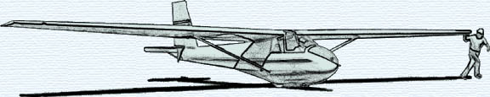

MONTHLY KSA MEETING
7:30 PM Saturday December 11, 2010
AT NIAR, Wichita State University
PROGRAM
1911 Wright Glider Project
Ron Blum

PLEASE BRING ANY TRAVELING TROPHIES IN YOUR POSESSION WITH YOU TO THE MEETING.

